States of matter: Johnstone’s triangle

This resource is from the **Johnstone’s triangle** series which can be viewed at: [rsc.li/43jMfSn](https://rsc.li/43jMfSn). It will help learners to understand the different ways you need to think in chemistry, building their mental models and understanding.

Learning objectives

1. Recall the three states of matter.
2. Compare the properties of solids, liquids and gases.
3. Use the particle model to explain why different states of matter have different properties.

How to use Johnstone’s triangle

Use Johnstone’s triangle to develop learners’ thinking about scientific concepts at three different conceptual levels:

* 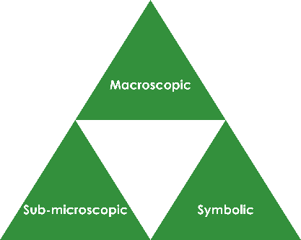Macroscopic – what we can see. Think about the properties you can observe, measure and record.
* Sub-microscopic – smaller than we can see. Think about the particle or atomic level.
* Symbolic – representations. Think about how we represent chemical ideas including symbols and diagrams.

For learners to gain a deeper awareness of a topic, they need to understand it at all three levels.

When introducing a topic, do not try to introduce the three levels of thinking at once. This will overload working memory. Instead complete the triangle over a series of lessons, beginning with the macroscopic level before introducing the sub-microscopic and then the symbolic levels, once understanding of the previous stages is secure.

The three levels are interrelated, for example, learners need visual representation of the sub-microscopic level to develop mental models of the particle or atomic level.

Find further reading about Johnstone’s triangle and how to use it in your teaching at: [rsc.li/4lr2Iwy](https://rsc.li/4lr2Iwy).

Scaffolding

It is important to share the structure of the triangle with learners prior to use. Tell them why you want them to use the triangle and how it will help them to develop their understanding. Use an ‘I try, we try, you try’ approach when you are introducing Johnstone’s triangle for the first time.

More resources

To further develop learner’s thinking in all areas of Johnstone’s triangle, try our **Developing understanding of states of matter** worksheet ([rsc.li/4dR3vUc](https://rsc.li/4dR3vUc)). This includes icons in the margin referring to the conceptual level of thinking needed to answer the question.

Use this demonstration of the three states of matter to encourage learners to observe and describe the shape and compressibility of substances in different states.

Teacher demonstration

Equipment for teacher

* Beaker of water
* Ice cube
* Boiling kettle
* Three syringes filled with plasticine or sand (solid state), water (liquid state) and air (gas state)

Method

1. Show learners the three examples of water in different states and discuss the shape of each (fixed for the solid state, non-fixed for liquid and gas states).
2. Demonstrate the compressibility of each state of matter using the syringes filled with different substances (only the gas can be compressed).

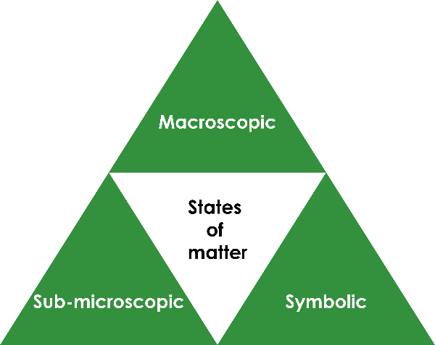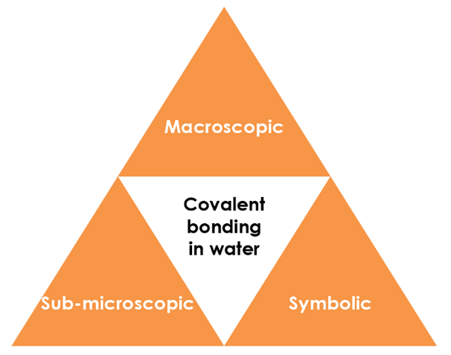

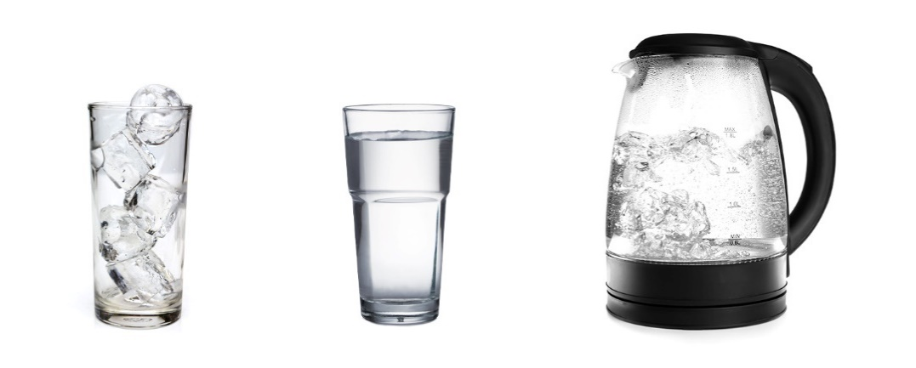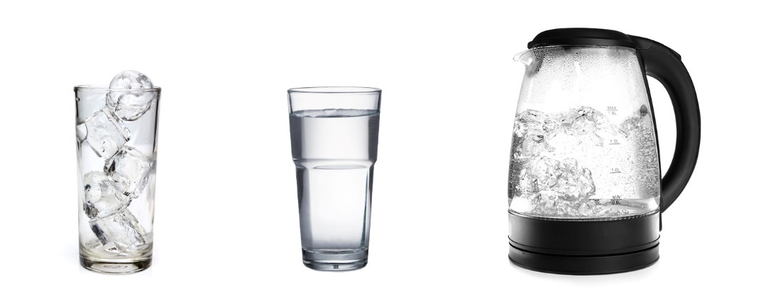

Macroscopic – what we can see

Watch the demonstration. Complete the table for the three states of matter using your observations:

|  |  |  |
| --- | --- | --- |
| **State** | **Does it have a fixed shape?** | **Can it be compressed?** |
| Gas | **No** | **Yes** |
| Liquid | **No** | **No** |
| Solid | **Yes** | **No** |

Image adapted from © Shutterstock

Symbolic – representations

The solid, liquid and gas state can be represented using particle diagrams.

Complete the diagrams to show how the particles are arranged in each state:

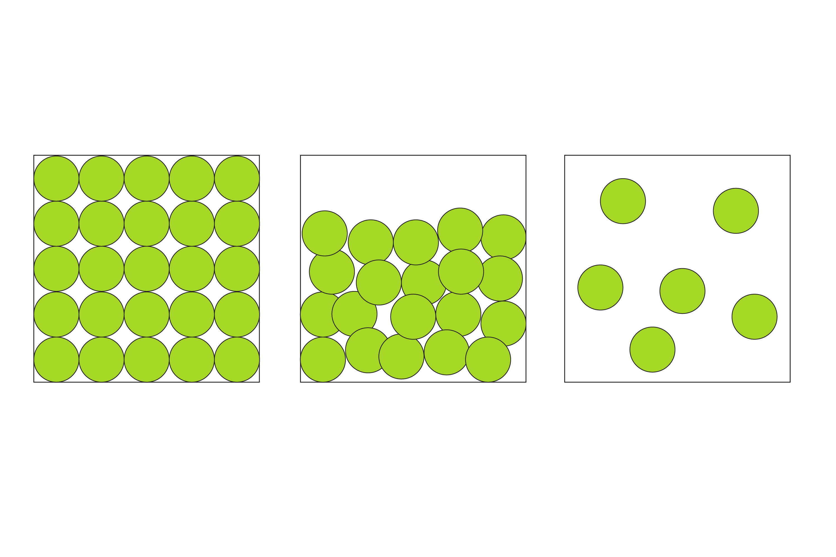

Solid Liquid Gas

Sub-microscopic – smaller than we can see

Using your knowledge of how the particles are arranged in the different states, explain why gases can be compressed but liquids and solids can’t:

**In the gaseous state the particles are far apart and there is lots of space between them. A force can push the particles closer together (compressing them).**

**In the liquid and solid states, the particles are already packed closely together so they can’t be pushed any closer together. This means that they can’t be compressed.**