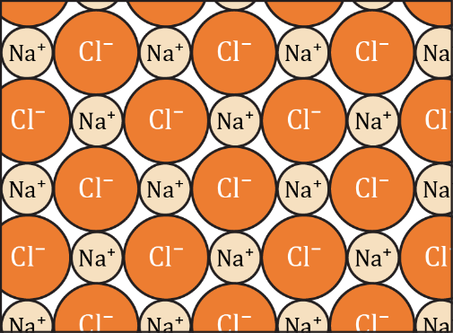Ionic bonding: true or false?

The statements below refer to the diagram of the structure of sodium chloride. The diagram shows part of a slice through the three-dimensional crystal structure.

Read each statement carefully and decide if it is correct or not. **Circle your answer.**

|  |  |
| --- | --- |
| 1. A positive ion will be attracted to any negative ion. | **True / False** |
| 1. A sodium ion is only bonded to the chloride ion it donated its electron to. | **True / False** |
| 1. A sodium ion can only form one ionic bond, because it only has one electron in its outer shell to donate. | **True / False** |
| 1. A bond is formed between chloride ions and sodium ions because an electron has been transferred between them. | **True / False** |
| 1. In the diagram, a chloride ion is attracted to one sodium ion by a bond and up to three other sodium ions just by forces. | **True / False** |
| 1. In the diagram, each molecule of sodium chloride contains one sodium ion and one chloride ion. | **True / False** |
| 1. An ionic bond is the attraction between a positive ion and a negative ion. | **True / False** |
| 1. A positive ion can be bonded to any neighbouring negative ions, if it is close enough. | **True / False** |
| 1. A negative ion can be attracted to any positive ion. | **True / False** |
| 1. You cannot identify ionic bonds, unless you know which chloride ions accepted electrons from which sodium ions. | **True / False** |
| 1. A chloride ion is only bonded to the sodium ion it accepted an electron from. | **True / False** |
| 1. A chlorine atom can only form one ionic bond, because it can only accept one more electron into its outer shell. | **True / False** |
| 1. There is a bond between the ions in each molecule, but no bonds between the molecules. | **True / False** |
| 1. A negative ion can only be attracted to one positive ion. | **True / False** |
| 1. A bond is formed between chloride ions and sodium ions because they have opposite charges. | **True / False** |
| 1. In the diagram, a sodium ion is attracted to one chloride ion by a bond and is attracted to other chloride ions just by forces. | **True / False** |
| 1. A positive ion can only be attracted to one negative ion. | **True / False** |
| 1. An ionic bond is when one atom donates an electron to another atom, so that they both have full outer shells. | **True / False** |
| 1. A negative ion can be bonded to any neighbouring positive ions, if it is close enough. | **True / False** |
| 1. There are no molecules shown in the diagram. | **True / False** |