Representing elements and compounds: knowledge check

1. This diagram shows the chemical symbols of the first twenty elements in the periodic table.

Label the diagram with the names of the elements.

This is the first part of the Periodic Table with elements to be labelled in column 1 row 3,  column 2 row 3,  column 14 row 1,  column 17 row 1, column 17 row 2 and column 18 row 3.

1. This model shows a molecule of the element chlorine.

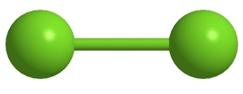

Give the definition of an element.

How many naturally occurring elements are there?

What element does the chemical symbol **Ne** represent?

If an element naturally exists as two or more atoms bonded together, what is this called?

A molecule of chlorine gas has the chemical formula Cl2. What does the subscript ‘2’ mean in this formula?

Give the definition of a compound.

What type of bonds do molecules contain?

In a molecule of NH3, how many atoms of nitrogen and hydrogen are there? Nitrogen: __________________ Hydrogen: __________________

This is a ball and stick model of C2H5OH.

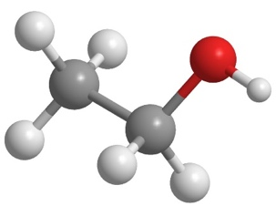

What type of particle is represented by the ball and stick model?

How many hydrogen atoms are contained in one molecule of C2H5OH?

1. Complete the sentences.

Compounds with __________________ bonding form ionic structures. The model shows part of the ionic structure of sodium chloride.

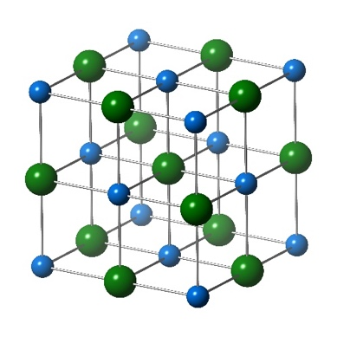

The ionic structure consists of many __________________ ions and many __________________ ions, but its chemical formula is NaCl. This shows there is __________________ sodium ion to every chloride ion. NaCl is the __________________ formula for sodium chloride. The compound magnesium chloride also has ionic bonding. Its chemical formula is MgCl2. An ionic structure of magnesium chloride contains __________________ magnesium ion to every __________________ chloride ions.

Representing elements and compounds: test myself

1. The chemical formula for naturally occurring sulfur is S8. What type of particle is S8?
2. Which of these chemical formulas represents an element?

**CaO Ni NO NaOH SO2 Ca(OH)2 CO**

1. Which of these chemical formulas represents an element that exists as single atoms?

**N2 HCl Ar NO I2 H2 CO**

1. Which two of these chemical formulas represent compounds?

**NO N2 NH3 He Br2 Co C Pb**

1. If the blue sphere in this image represents a nitrogen atom and the white spheres represent hydrogen atoms, what is the formula?

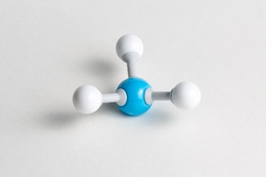

1. How many atoms of hydrogen are contained in one molecule of CH3COOH?
2. Magnesium oxide has ionic bonding. Its chemical formula is MgO. What is the ratio of magnesium ions to oxide ions in a particle of magnesium oxide?
3. Sodium oxide also has ionic bonding. Its chemical formula is Na2O. What is the ratio of sodium ions to oxide ions in a particle of sodium oxide?
4. Which of these images shows a model of an element? Circle the correct answer.

**A B**

[[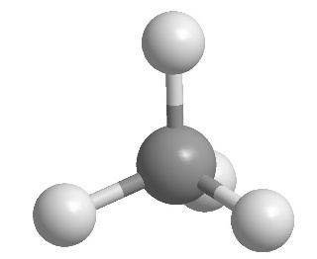](https://www.shutterstock.com/image-vector/methane-ch4-gas-molecule-stick-model-1738448798)](https://www.shutterstock.com/image-vector/methane-ch4-gas-molecule-stick-model-1738448798) 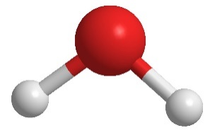

**C D**

[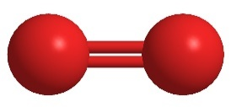](https://www.shutterstock.com/image-illustration/elemental-oxygen-o2-molecular-model-atoms-131939321) 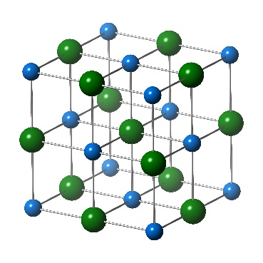

**2.10** Look at the models in **question 2.9** again. Which image shows an ionic compound?

Representing elements and compounds: feeling confident?

1. Polymers, like poly(ethene), consist of large molecules. These are chains of atoms with repeating units. The formula for polyethene is written as:

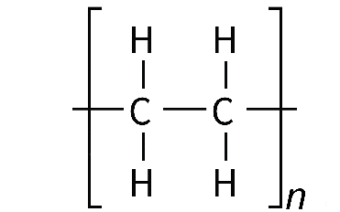

where *n* stands for a large number.

Draw a length of poly(ethene) chain six carbon atoms long.

1. The table shows four different ways of representing a molecule of the compound ammonia, NH3. The blue spheres represent nitrogen atoms and the white spheres represent hydrogen atoms.

Complete the table by adding a ✓ or a 🗶.

|  |  |  |  |  |
| --- | --- | --- | --- | --- |
|  | NH3 | A diagram representing ammonia. There is a letter N in the centre with three linking lines to three letters H. Above the letter N are two small dots.. | A ball and stick model of ammonia - a larger central blue ball has three smaller white balls attached with sticks. | A model representing ammonia. It has one large blue sphere with three smaller white half spheres attached to it. |
| Does it show the different types of atoms? |  |  |  |  |
| Does it show how the atoms are arranged? |  |  |  |  |
| Does it show the molecule in three dimensions? |  |  |  |  |
| Does it show the chemical bonds? |  |  |  |  |

Representing elements and compounds:   
what do I understand?

Think about your answers and confidence level for each mini-topic. Decide whether you understand it well, are unsure or need more help. Tick the appropriate column.

|  |  |  |  |
| --- | --- | --- | --- |
| **Mini-topic** | **I understand  this well** | **I think I understand this** | **I need more  help** |
| I can write names of the elements from their chemical symbols. |  |  |  |
| I can write chemical formulas of elements. |  |  |  |
| I can write chemical formulas of simple molecular compounds. |  |  |  |
| I can write chemical formulas of ionic compounds. |  |  |  |
| I can use models to represent elements and compounds. |  |  |  |
| **Feeling confident? topics** | **I understand  this well** | **I think I understand this** | **I need more  help** |
| I can write the chemical formula of a polymer. |  |  |  |
| I can compare different types of representation. |  |  |  |