**Amino acids: knowledge check**

1. Amino acids contain two different functional groups. The image shows the general structural formula of an amino acid.

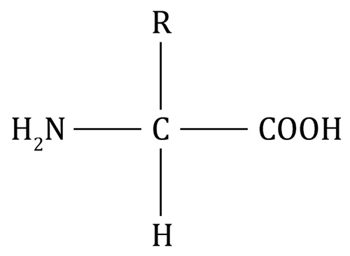

Circle the two functional groups and select words from those provided to name them.

**hydroxyl group carboxylic acid group amine group alkene group**

1. The images show the structure of two amino acids – glycine and alanine.

|  |  |
| --- | --- |
| There is a diagram showing a capital letter C in the middle. There are four single lines connected to two capital letters H, a carboxyl group and an amino group. | There is a diagram showing a capital letter C in the middle. There are four single lines connected to a capital letter H, a carboxyl group, a methyl group and an amino group. |
| **glycine** | **alanine** |

Use these images, along with the image shown in **question** **1.1**,to circle the correct ending of each sentence from the options provided in the brackets.

* 1. The ‘R’ in the general structure represents a [**functional**/**side**] group.
  2. All amino acids have the same general structure but different [**functional**/**side**] groups.
  3. The acidic functional group of the amino acid is the [**/COOH**] group.
  4. The group of the amino acid is [**acidic**/**basic**].
  5. The ‘R’ in glycine represents the [**H atom**/ **group**].
  6. The ‘R’ in alanine represents the [**H atom**/ **group**].

1. The diagram shows the polymerisation reaction that occurs when two amino acids join together.

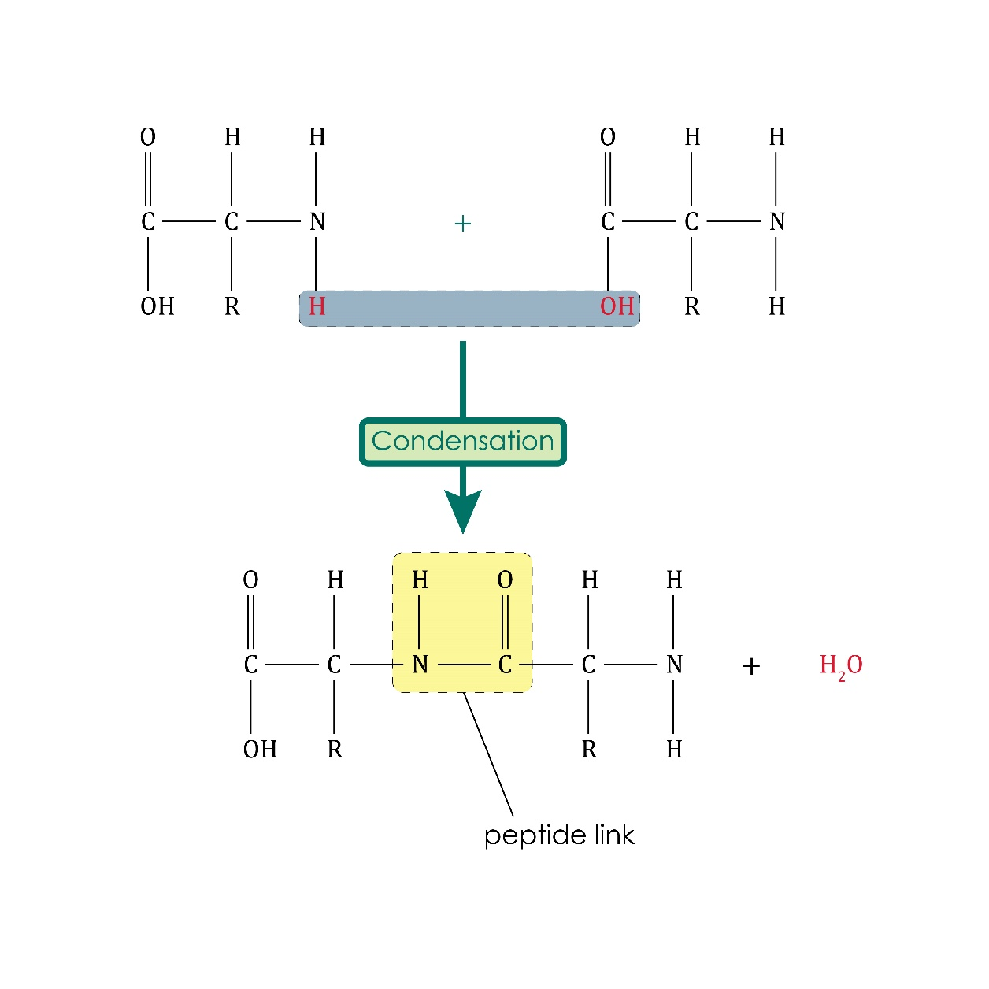

Using the diagram, choose the correct word from those provided to complete the sentences describing this reaction.

**proteins peptide nitrogen carboxylic acid**

**condensation monomers water polymers**

Proteins, or polypeptides, are biological __________________ produced when many amino acid __________________ join together in a __________________ polymerisation reaction.

A molecule of __________________ is also produced in the reaction.

Different amino acids make different __________________ .

The link between two amino acid monomers is a __________________ link where the carbon atom of the __________________ group joins with the __________________ atom of the amine group.

**Amino acids: test myself**

1. Which statement is correct? Circle the correct answer.
2. Amino acid have only acidic properties.
3. Amino acid have only basic properties.
4. Amino acids have both acidic and basic properties.
5. Amino acids do not have acidic or basic properties.
6. Which statement is correct? Circle the correct answer.
7. All proteins have COOH groups.
8. All proteins have groups.
9. All proteins have OH groups.
10. All proteins have peptide links.
11. The image shows the amino acid alanine.

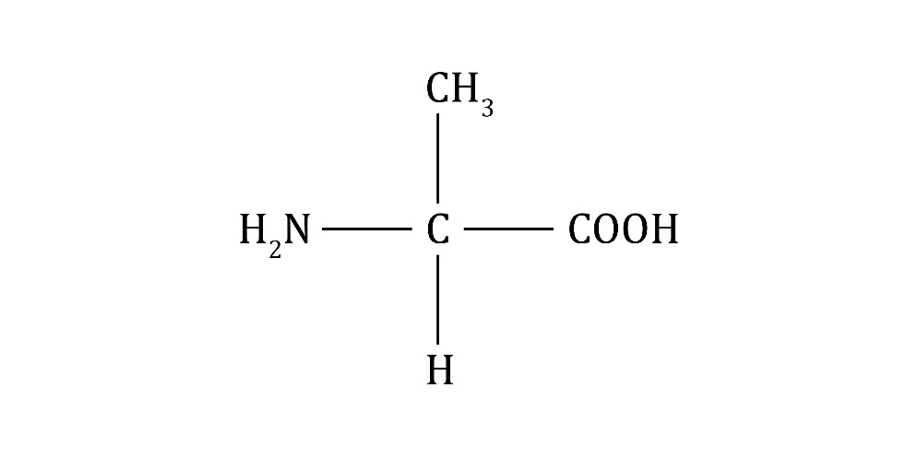

What is the correct structural formula for alanine? Circle the correct answer.

1. What is produced when amino acids polymerise? Circle the correct answer.

**a carbohydrate a polypeptide a hydrocarbon a monomer**

1. Why is the polymerisation of amino acids described as a condensation reaction? Circle the correct answer.

**water is a product water is a reactant**

**water is a catalyst water is not required**

1. The equation represents the polymerisation of an amino acid.

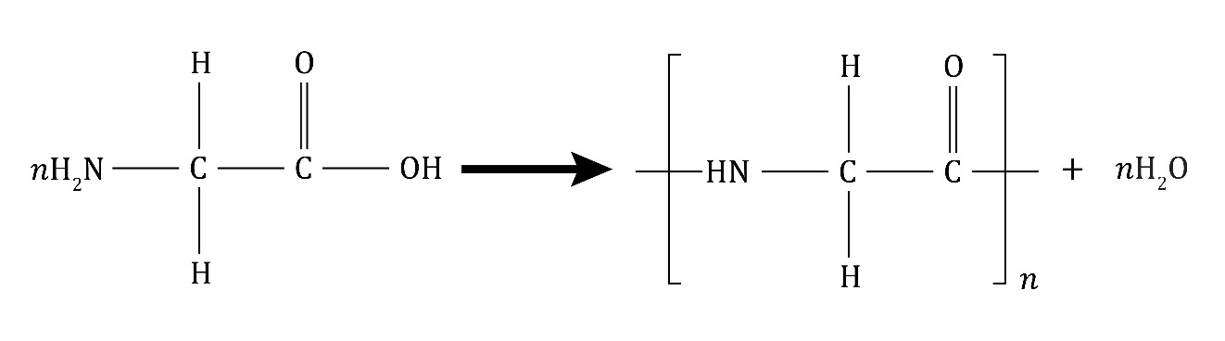

glycine polypeptide water

What does the ‘*n*’ represent? Circle the correct answer.

**a large number a small number nitrogen nickel**

1. What is the repeating unit in **question** **2.6**? Circle the correct answer.

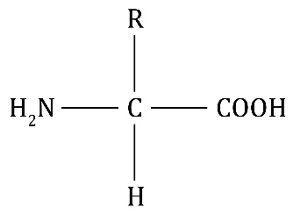 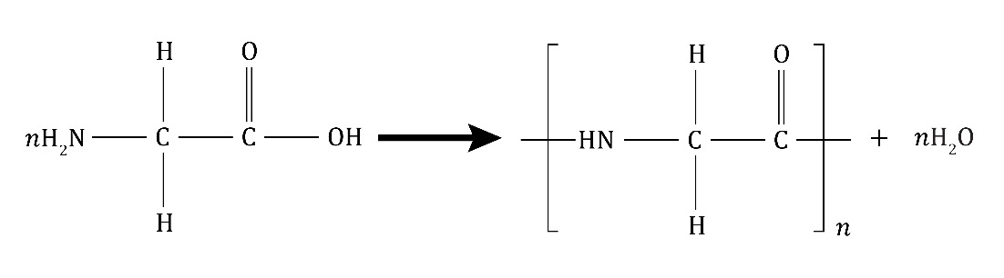 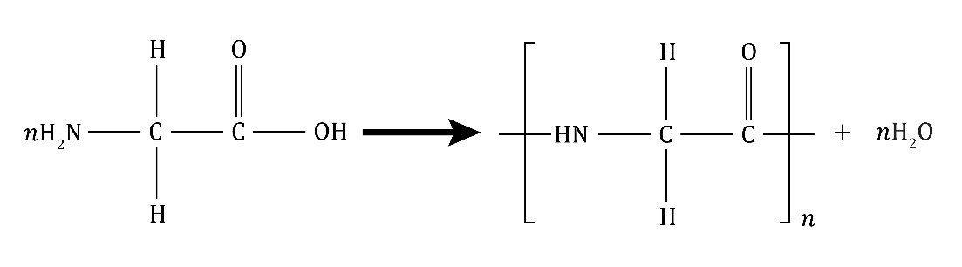

**Amino acids: feeling confident?**

1. (a) Complete the equation to represent the polymerisation of alanine.

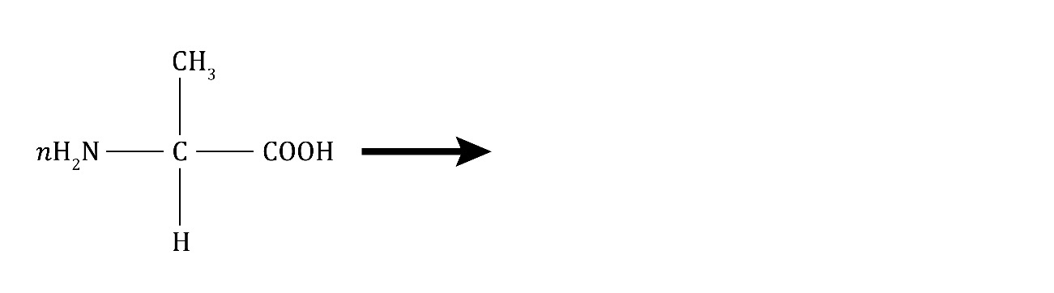

+

* 1. Label the monomer and the repeating unit.

1. The image represents the polymerisation of amino acids to form a protein.

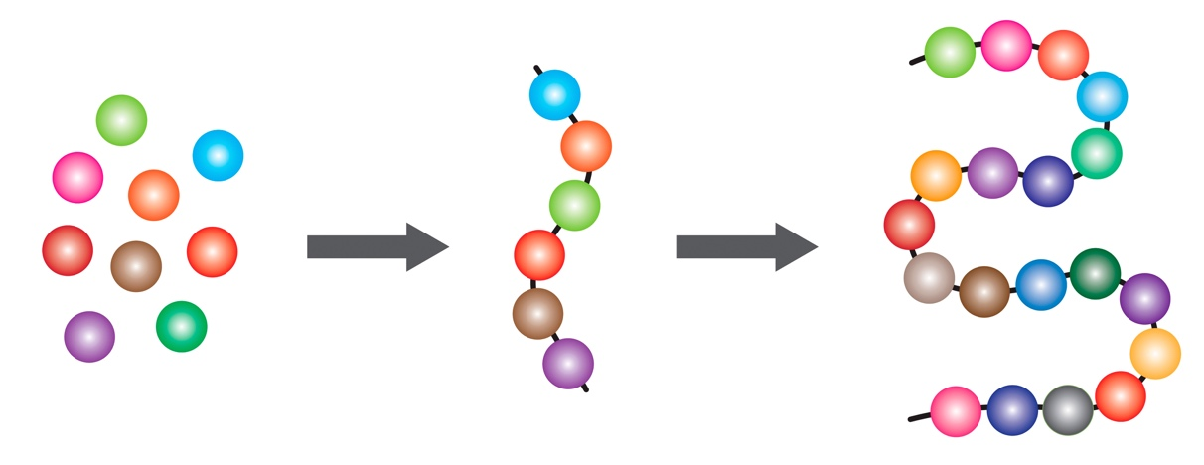

Use the words provided to complete the table describing the image.

**a protein** **peptide links amino acids a polypeptide**

**different amino acids**

|  |  |
| --- | --- |
| **Part of image** | **What does it represent?** |
| individual spheres |  |
| different shaded spheres |  |
| the chain of six spheres |  |
| the twisted chain of spheres |  |
| the lines connecting the spheres |  |

**Amino acids: what do I understand?**

Think about your answers and confidence level for each mini-topic. Decide whether you understand it well, are unsure or need more help. Tick the appropriate column.

|  |  |  |  |
| --- | --- | --- | --- |
| **Mini-topic** | **I understand  this well** | **I think I understand this** | **I need more  help** |
| I can describe the general structure of amino acids. |  |  |  |
| I can interpret the structure of glycine and alanine. |  |  |  |
| I can describe the polymerisation of amino acids to form polypeptides and proteins. |  |  |  |
| I can use equations to represent the polymerisation of amino acids. |  |  |  |
| **Feeling confident? topics** | **I understand  this well** | **I think I understand this** | **I need more  help** |
| I can complete equations to represent the polymerisation of amino acids. |  |  |  |
| I can understand diagrams that explain protein formation. |  |  |  |