Covalent structure and bonding

This resource is from the **Johnstone’s triangle** series, which can be viewed at: [rsc.li/4fElNbx](https://rsc.li/4fElNbx). In this series you will also find our **Covalent bonding: Johnstone’s triangle** worksheet which introduces the triangle in the context of covalent bonding in water: [rsc.li/4fzQHSr](https://rsc.li/4fzQHSr)

Learning objectives

|  |  |  |
| --- | --- | --- |
| **LO** | **Objective** | **Where assessed** |
| **1** | Recognise a diagram that shows the structure of a given covalent compound. | Q1 and 2 |
| **2** | Draw and connect a dot and cross diagram with a molecular diagram. | Q3 |
| **3** | Use dot and cross diagrams to explain the construction of molecular models. | Q4 |
| **4** | Draw dot and cross diagrams and 3D models from the formula of a given covalent compound. | Q5 |
| **5** | Explain why silicon dioxide forms a giant covalent structure. | Q6 |

How to use the resource

This resource aims to develop learners’ understanding of covalent structures. The questions encourage learners to visualise covalent molecules in different ways and think about how this relates to the sub-microscopic level. As a result, learners should develop more secure mental models to support their thinking about this topic.

|  |  |  |  |  |
| --- | --- | --- | --- | --- |
| **When to use?** | Enter with solid fill Introduce | Watering pot with solid fill **Develop** | Arrow circle with solid fill **Revise** | Clipboard Mixed with solid fill Assess |
| Use after initial teaching or discussion of this topic to develop ideas further. You can also use as a revision activity. | | | |
| **Group size?** | Head with gears with solid fill **Independent** | Group brainstorm with solid fill **Small group** | Classroom with solid fill **Whole class** | Work from home house with solid fill **Homework** |
| Suitable for independent work either in class or at home. Or use the questions for group or class discussions. | | | |
| **How long?** | Stopwatch 25% with solid fillArrow Right outlineStopwatch 50% with solid fill | | 15–30 mins | |

Johnstone’s triangle

Johnstone’s triangle is a model of the three different conceptual levels in chemistry: macroscopic, symbolic and sub-microscopic. You can use Johnstone’s triangle to build a secure understanding of chemical ideas for your learners.

Find further reading about Johnstone’s triangle and how to use it in your teaching at [rsc.li/3BPw6ds](https://rsc.li/3BPw6ds).

Johnstone’s triangle and this resource

The icons in the margin indicate which level of understanding each question is developing to help prompt learners in their thinking.

|  |  |
| --- | --- |
| An icon used to indicate the Macroscopic part of Johnstone's triangle. | **Macroscopic:** what we can see. Think about the properties that we can observe, measure and record. |
| An icon used to indicate the Sub-microscopic part of Johnstone's triangle. | **Sub-microscopic:** smaller than we can see. Think about the particle or atomic level. |
| An icon used to indicate the Symbolic part of Johnstone's triangle. | **Symbolic:** representations. Think about how we represent chemical ideas including symbols and diagrams. |

The levels are interrelated, for example, learners need visual representation of the sub-microscopic in order to develop mental models of the particle or atomic level. Our approach has been to apply icons to questions based on what the learners should be thinking about.

Questions may be marked with two or all three icons, indicating that learners will be thinking at more than one level. However, individual parts of the question may require learners to think about only one or two specific levels at a time.

Support

This worksheet is ramped so that the earlier questions are more accessible. The activity becomes more challenging in the later questions. You can give extra explanations for the more challenging questions. If completing as an in-class activity it is best to pause and check understanding at intervals, as often one question builds on the previous one.

It is useful for learners to observe macroscopic properties first-hand. You could circulate examples of substances in the classroom, run a class practical of a chemical reaction or show a teacher demonstration of properties.

Give learners physical models to use and manipulate, such as a Molymod™ kits or counters.

Additional support may be needed for any learners still lacking in confidence in the required symbolic representation, for example by sharing and explaining a diagram or a simulation that can show movement of the particles.

Answers

1. Guidance: This question assumes that learners are already familiar with basic particle diagrams and the reason for using different colours.
2. **B** Carbon dioxide is in the gas state (diagram A or B) and is a compound (so must be diagram B)
3. **D** Silicon dioxide is in the solid state (diagram C or D). It is made of silicon and oxygen so the circles should not be the same colour as for carbon dioxide in diagram B, (so not diagram C).



1. Guidance: This question supports learners to connect the already familiar particle representation with the alternative representation that shows the element symbols and covalent bonds (as lines).
2. In diagram A, a hydrogen atom is shown by a white circle. In diagram B it is shown by the element symbol H.
3. In diagram A the covalent bonds are not shown. Circles that are touching are bonded. In diagram B the covalent bonds are shown as lines.



1. Guidance: This question supports learners to explain the number of bonds a carbon or hydrogen atom can make in a displayed formula diagram using an alternative representation (dot-and-cross diagram). This illustrates how different symbolic representations can help in different ways.
2. **B**
3. 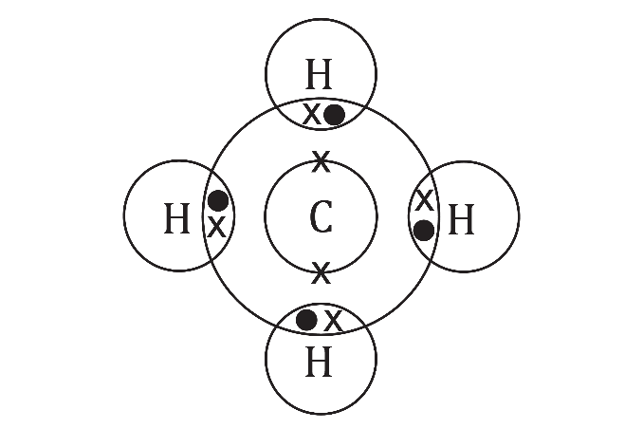
4. This diagram shows hydrogen atoms that form two covalent bonds. A hydrogen atom is only able to form one covalent bond.



1. Guidance: This question uses learners’ dot-and-cross diagrams to explain the construction of Molymod components. The number of holes matches the number of bonds each type of atom can form. The question also supports learners to compare a 2D displayed formula representation with a 3D physical model.
2. The black balls are made with four holes because they represent carbon atoms. Each carbon atom can form four covalent bonds.
3. The ball and stick model shows the 3D shape of a methane molecule.
4. Either of the following arrangements is acceptable:

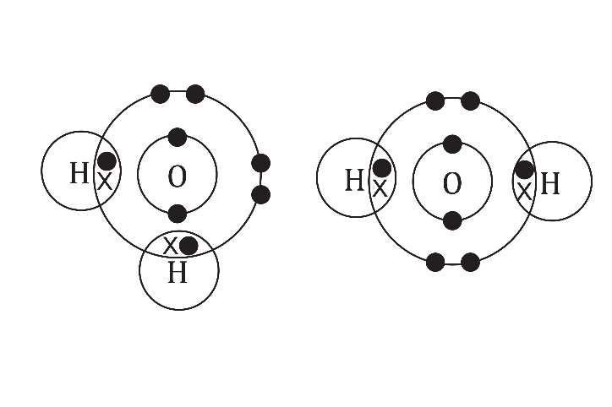

1. Each red ball should be made with two holes, because an oxygen atom can form two covalent bonds.
2. In a three-dimensional molecule the hydrogen molecules are not arranged in a straight line because the bonds are in the same position as two of the bonds in methane. (The remaining pairs of electrons are in roughly the same position as the other two bonds in methane but this is beyond the scope of the question).



1. Guidance: This supports learners to connect 2D dot and cross diagrams with the 3D shape of a molecule made with a physical kit.

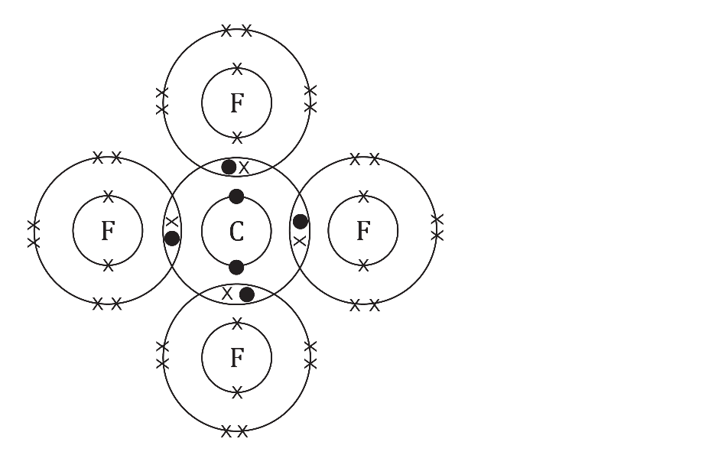

1. **B**



1. Guidance: This question challenges learners to use representations of silicon dioxide to explain why it forms a giant structure.
2. For every atom of silicon there are **two oxygen atoms.**
3. Seven (7)
4. One (1)
5. Silicon can form four covalent bonds with four oxygen atoms. Each oxygen atom can form two bonds. This means that each oxygen atom can bond with another silicon atom. This means that a giant covalent structure can be formed.