Making a crystal garden | Chemistry and art
Student handout

In this practical I will be:
- Setting up a practical enquiry for growing crystal gardens, ensuring that the experiment is fair.
- Reporting on the size, colour and rate of growth for the different crystals.
- Using my scientific knowledge and understanding to explain the results of the experiment.

Introduction

You are an ancient Roman science-artist living in the town of Herculaneum. Whilst walking by the docks, you notice that there are salt crystals growing on the hull of a few of the boats. Not only this, but the crystals vary in size and on a particularly dirty boat, there are crystals of different colours.

Like all good science-artists, you decide to investigate further…

Equipment

Apparatus

- Eye protection (goggles) for handling the sodium silicate solution
- Disposable gloves
- Beaker, 500 cm³
- Watch glass
- Glass stirring rod
- Forceps
- A piece of card, to cover the beaker

Chemicals

- Sodium silicate solution (water glass) (CORROSIVE)
- A few crystals of some metal sulfates or nitrates, such as:
  - Iron(III) nitrate (OXIDISING, IRRITANT)
  - Magnesium nitrate (OXIDISING)
  - Manganese(II) sulfate (HARMFUL, DANGEROUS FOR THE ENVIRONMENT)
- Hot deionised water

Procedure

- Pour sodium silicate solution (CORROSIVE – wear goggles) into the beaker to a depth of about 3 cm.
- Add hot deionised water to this solution, stirring well with a glass rod, until the final depth is about 12 cm.
- Continue stirring until the sodium silicate and water are thoroughly mixed, and no separate layers are visible.
- Allow the mixture to stand until the liquid is completely still.
- Use a pair of forceps to drop one or two crystals of each of the metal salts supplied into the mixture. Try to ensure that the crystals do not fall close to each other.
- Cover the beaker with a piece of card and leave overnight.

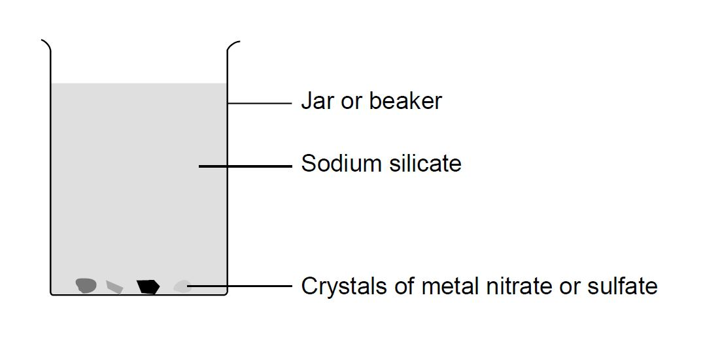

Going further

If time allows you could try using different dilution strength solutions of water glass and describe any differences between the results of using different dilution strengths.

Theory

A ‘garden’ can be grown from crystals.

The water glass is a solution of sodium silicate and is known as ‘water glass’. By adding more water you are forming a dilute solution of sodium silicate. When you put the crystals of metal salts into the sodium silicate solution they seem to act like seeds and grow long shoots. These long shoots are long tubes of the metal silicate and the colour depends upon the metal being used.

