Diffusion

This resource is part of the Structure strips series of resources, designed to support literacy in science teaching. More resources in this series can be found at: rsc.li/4aXYgzt

Learning objectives
- Define diffusion.
- Explain how and why different factors affect the rate of diffusion.
- Draw and interpret particle diagrams of the diffusion process.
- Write independently about diffusion.

Introduction

Diffusion occurs in many areas of everyday life. We depend on it for making a cup of tea and exploit it to make ourselves smell nice with perfumes. Crucially, diffusion is how substances move in and out of our cells and so is essential to life.

How to use structure strips

Structure strips are a type of scaffolding that support learners to retrieve information independently. Use them to take an overview at the start of a topic, to activate prior knowledge, or to summarise learning at the end of a teaching topic. Visit rsc.li/3EszCfr for more ideas on how to use structure strips with your learners.

Structure strips have sections containing prompts, sized to suggest the amount that learners must write. Ask learners to glue the strips into the margin of an exercise book and write their answers next to the sections, in full sentences or in bullet points. When learners have finished using the structure strip, they will have an A4 page set of notes and examples.

Scaffolding
- Encourage learners to use the suggested key words in their answers. These link with our key terms support resources for particle model.
- To further support learners, include additional prompts in the structure strip. If learners are struggling to engage with the task, supply them with sentence starters created from the example answers.
- As learners grow in confidence, ask them to attempt the extension question first and then use the structure strip to improve or self-assess their answer.

Metacognition

This resource supports learners to develop their metacognitive skills in three key areas.
- Planning: the strips provide scaffolding to plan the written response. Learners will decide where to gather information from (textbooks, own notes, revision websites). Ask learners: is the source of information you are using reliable?
- Monitoring: learners are prompted by the questions in the structure strip and can check their own answers against the prompts. Ask learners: have you covered all of the prompts in the space provided? Do you need to change anything to complete the task?
- Evaluation: learners can self-assess or ask a peer to check their work against the answers. Ask learners: did you achieve what you meant to achieve? What might you do differently another time?

Example answers for the structure strip are on page 3.

Structure strip  diffusion | Example answer
Define the term diffusion and state which states of matter it occurs in. | Diffusion is the movement of a substance from an area of high concentration to an area of low concentration. It occurs in liquids and gases.
Briefly explain what is happening to the particles when a substance diffuses. | Diffusion happens as particles move around and collide with each other.
Use diagrams to show how diffusion would progress in this sample.  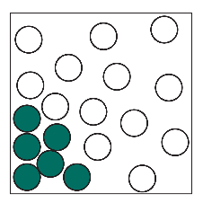 | 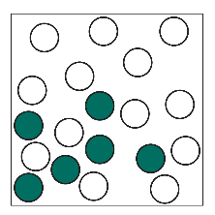  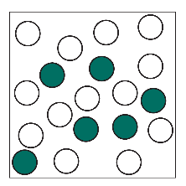  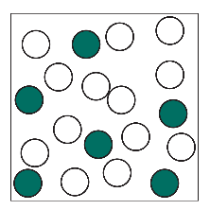  Diagrams should show particles moving from high to low concentration and the final diagram being evenly spread.
Explain how and why the following factors affect the rate of diffusion:  - the state of matter of the substance  - the temperature. | Diffusion occurs more quickly in gases than in liquids. This is because the particles in a gas are more spread out and move faster than the particles in a liquid. Diffusion cannot occur in solids because the particles aren’t moving, they only vibrate around a fixed point.  Diffusion occurs quicker at higher temperatures even within the same physical state (so when liquids are heated up but don’t change state). This is because the particles move faster as the temperature increases.
Some particles are heavier than others. Suggest how this might affect diffusion. | The heavier particles might diffuse more slowly than the lighter particles.

Extension question: body spray

Get learners to answer the question after they have attempted the structure strip. The structure strip activates the required knowledge which learners then apply to the question.

Consider re-framing the context of this question to one your learners are more familiar with, to empower them to unlock their existing science capital. Find more information at rsc.li/40FAMLP

Example answer to extension question

Look for scientific reasoning in the creative writing.
- Jack, your teacher will smell your body spray because of diffusion!
- The scent particles will be concentrated where you spray it (e.g. under your shirt). However, as the scent is in aerosol form it will diffuse (learners may not use the term aerosol but look for some understanding that the scent is in gas form or evaporates from a warm body).
- When it diffuses the scent particles spread out as they move from an area of high concentration to an area of low concentration. The rest of the classroom is an area of low concentration so eventually the smell will spread throughout the room, even to the teacher.
- The good news is that diffusion happens in all directions because the movement of particles in gases is random, so your teacher won’t necessarily know it was you!

