Atoms and ions

Introduction

These questions are designed to help you to develop your mental models (pictures in your mind) of atoms and ions. Being able to think about the protons and electrons and their charges will help to develop your understanding of atoms and ions. Use the icon in the margin to find out which level of understanding the question is developing.

|  |  |
| --- | --- |
| An icon used to indicate the Macroscopic part of Johnstone's triangle. | **Macroscopic:** what we can see. Think about the properties that we can observe, measure and record. |
| An icon used to indicate the Sub-microscopic part of Johnstone's triangle. | **Sub-microscopic:** smaller than we can see. Think about the particle or atomic level. |
| An icon used to indicate the Symbolic part of Johnstone's triangle. | **Symbolic:** representations. Think about how we represent chemical ideas including symbols and diagrams. |

Representing charge using a number line

An atom has an equal number of positive protons and negative electrons. The overall charge of an atom is zero.

A lithium atom at has three positive protons and three negative electrons. The number line below uses arrows to show why a lithium atom has no overall charge.

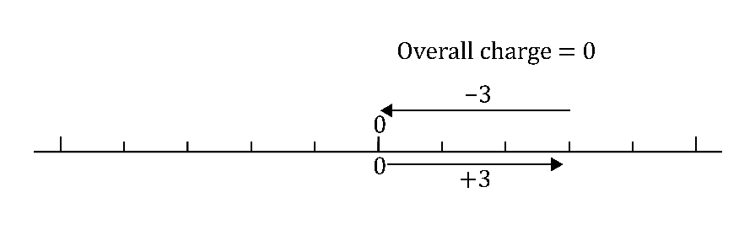

In an ion the number of positive protons does not equal the number of negative electrons. An ion can have an overall positive or negative charge.

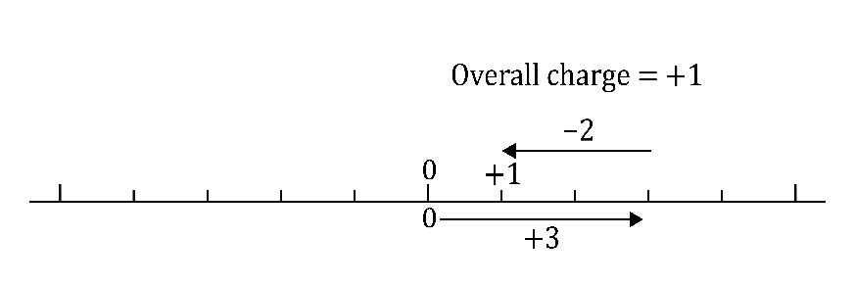A lithium ion has three positive protons but only two negative electrons. The number line below uses arrows to show why a lithium ion has a charge of +1.

Questions

1. Complete the number line diagrams by adding arrows to show the following:
2. A sodium atom has no overall charge. A sodium atom has 11 protons and 11 electrons.

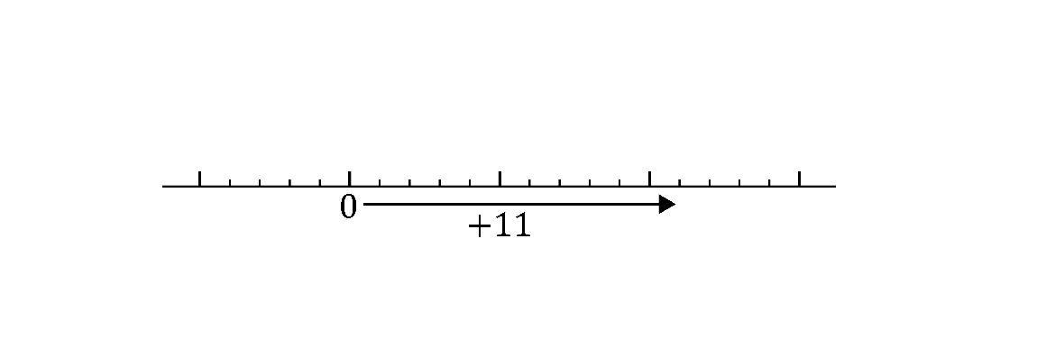

1. A sodium ion has a charge of +1. A sodium ion has 11 protons and 10 electrons.

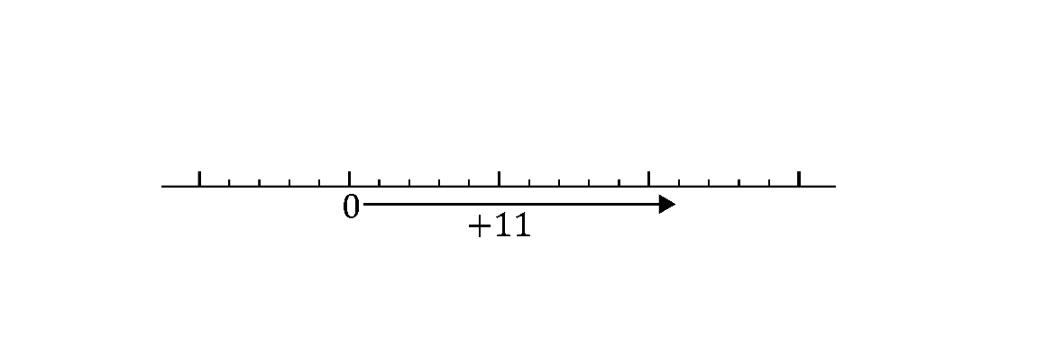

1. A fluorine atom has no overall charge. A fluorine atom has 9 protons and 9 electrons.

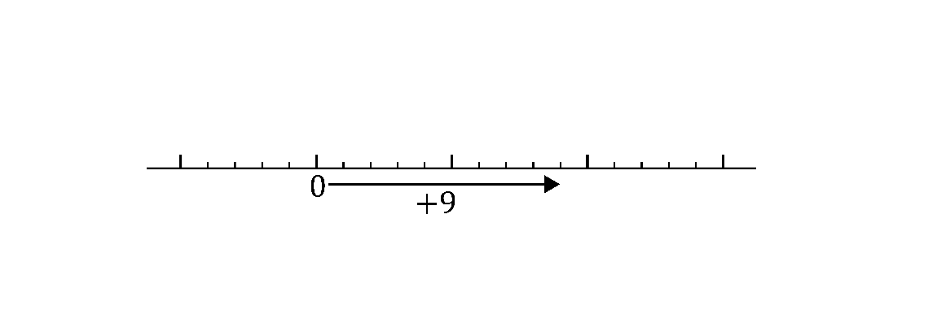

1. A fluoride ion has a charge of -1. A fluoride ion has 9 protons and 10 electrons.



1. Explain why the atom and ion of an element always have the same number of protons.

__________________________________________________________________________________

__________________________________________________________________________________

__________________________________________________________________________________

__________________________________________________________________________________

__________________________________________________________________________________



1. The number of protons and electrons can be used to work out whether they belong to an atom or an ion.

Complete the table to show the number of protons and electrons in different atoms or ions. The first row has been completed as an example.

|  |  |  |  |  |  |
| --- | --- | --- | --- | --- | --- |
| **Number of protons** | **Number of electrons** | **Total positive charge** | **Total negative charge** | **Overall charge** | **Atom or ion** |
| 6 | 6 | +6 | -6 | 0  (+6 – 6 = 0) | atom |
| 3 | 3 |  |  |  |  |
| 3 | 2 |  |  |  |  |
| 9 | 10 |  |  |  |  |
| 8 | 10 |  |  |  |  |

The atomic number of an element is equal to the number of protons in each atom. The atomic number of each element can be found in the periodic table.

Below are two rows of the periodic table which you can use to answer Q3, 4 and 5.

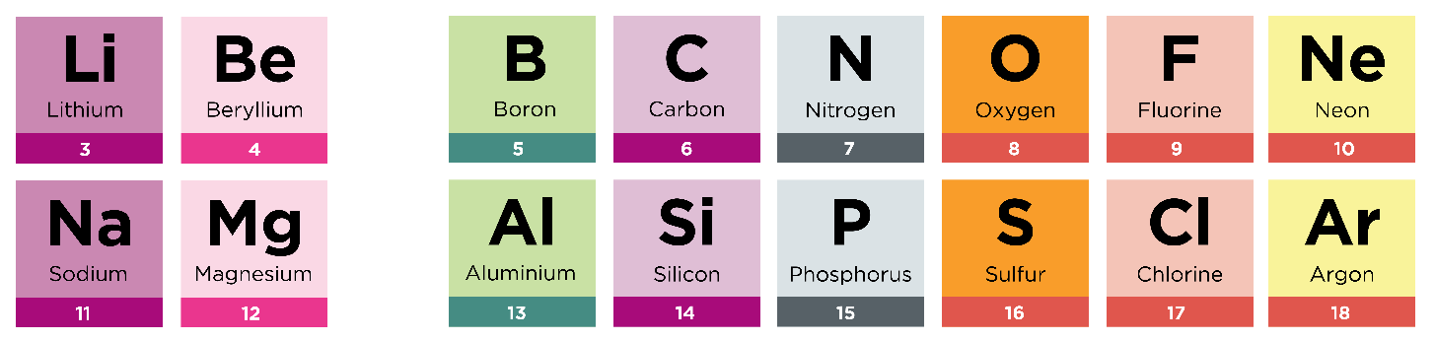



1. (a) What is the atomic number of lithium? Use the periodic table. ______

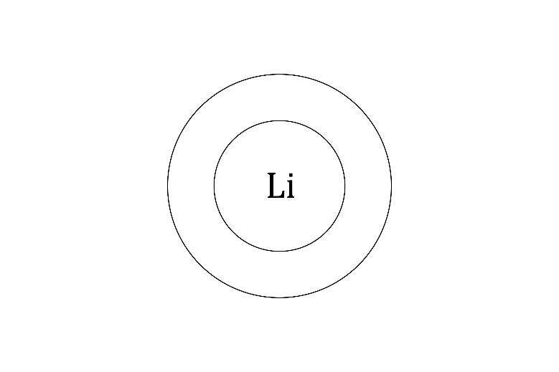(b) Draw the electronic structure diagram for a lithium atom.

1. Draw the electronic structure diagram for a lithium ion.

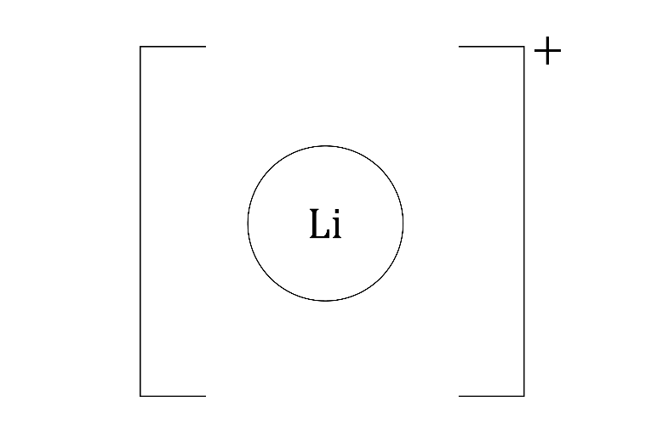

1. Complete the sentence:

A lithium atom becomes a positive ion when the atom _____________ its outer electron.

1. (a) What is the atomic number of magnesium? Use the periodic table. _______
2. Draw the electronic structure diagram for a magnesium atom.

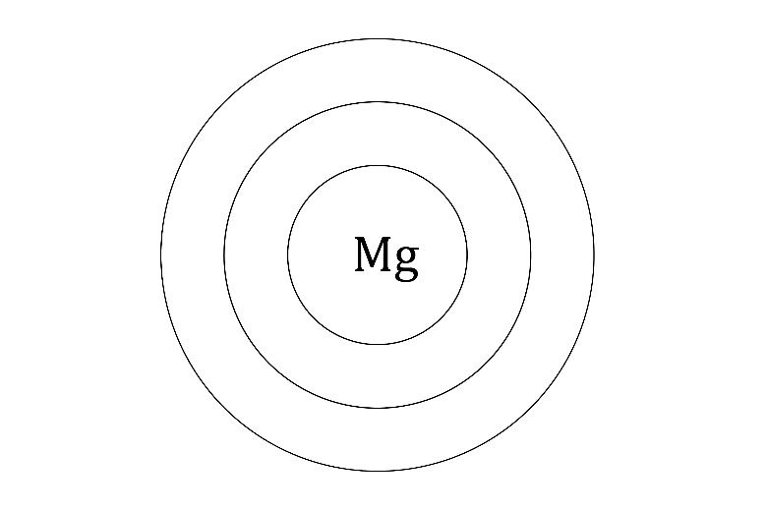

1. 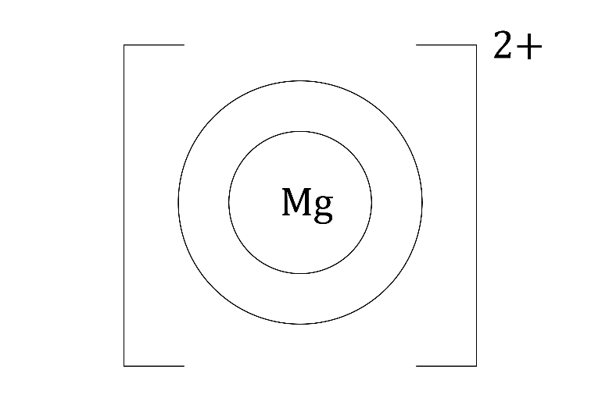Draw the electronic structure diagram for a magnesium ion (2+ charge).
2. Describe how a magnesium atom becomes a magnesium ion.

__________________________________________________________________________________

__________________________________________________________________________________

1. (a) What is the atomic number of chlorine? Use the periodic table. ______
2. 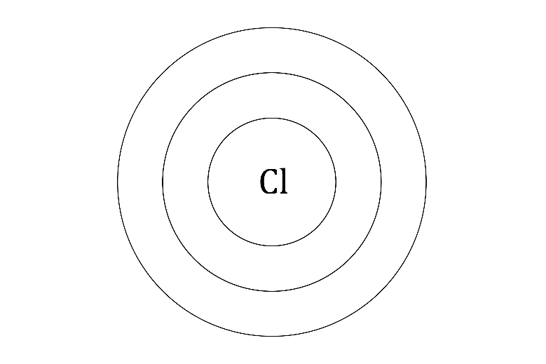Draw the electronic structure diagram for a chlorine atom.
3. 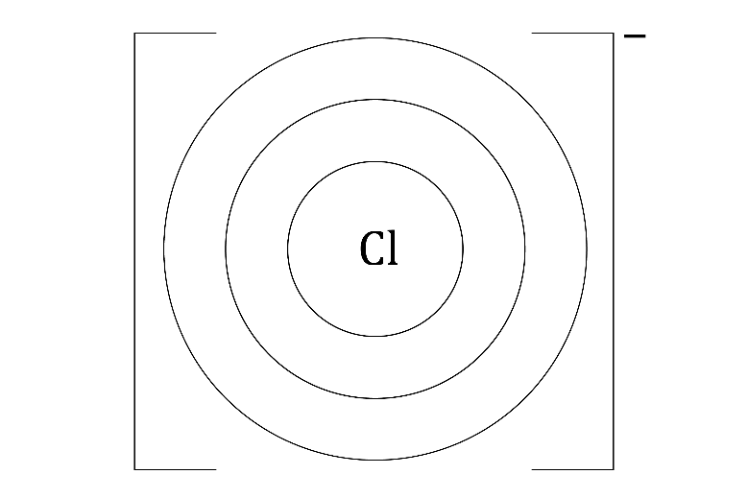Draw the electronic structure diagram for a chloride ion (1− charge).
4. Describe how a chlorine atom becomes a chloride ion.

____________________________________________________________________________________________________________________________________________________________________

1. 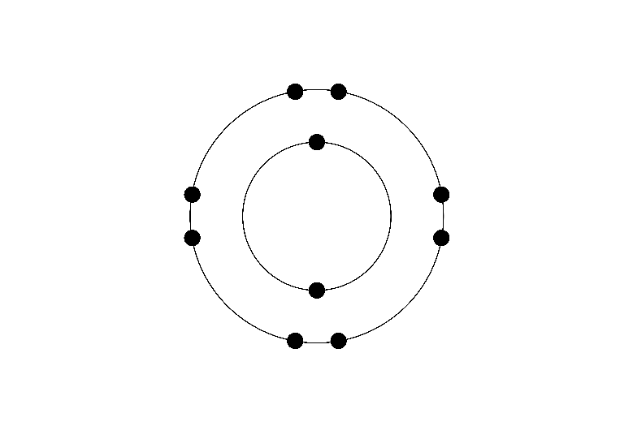An electronic structure diagram is drawn to show 10 electrons.

Using the periodic table in Q3 to help you, give the symbol of the atom or ion

with this electronic structure that has:

1. 10 protons _____
2. 11 protons _____
3. 12 protons _____
4. 9 protons _____
5. 8 protons _____