States of matter

Learning objectives

1. Name the three states of matter and the processes of changing states of matter.
2. Describe, draw and recognise the particle arrangements of the three states of matter.
3. Describe the difference in the forces between particles in solids, liquids and gases.
4. Explain the properties of solids, liquids and gases using the particle model.
5. Write independently about states of matter.

Introduction

Matter is all around us and is classified into three states: solid, liquid and gas. All matter is made of tiny particles. The arrangement of these particles in different states of matter explains the properties of solids, liquids and gases.

Instructions

1. Stick the structure strip in the margin of your exercise book/paper.
2. Reflect on what you already know about states of matter, and where you have seen the key words before. Follow the prompts and use your knowledge to write a summary of states of matter. If you'd like more support, what other sources could you use to find the information, e.g. a textbook, online?
3. Answer the extension question to apply your knowledge of states of matter to a new context.

Key words

Use these key words in your responses:

· solid · liquid · gas

|  |  |  |  |  |
| --- | --- | --- | --- | --- |
| **Structure strip**  **States of matter** | **Structure strip**  **States of matter** | **Structure strip**  **States of matter** | **Structure strip**  **States of matter** | **Structure strip**  **States of matter** |
| Describe how particles are represented in the particle model. | Describe how particles are represented in the particle model. | Describe how particles are represented in the particle model. | Describe how particles are represented in the particle model. | Describe how particles are represented in the particle model. |
| Draw a diagram of the particles in a solid and write a bullet point description. | Draw a diagram of the particles in a solid and write a bullet point description. | Draw a diagram of the particles in a solid and write a bullet point description. | Draw a diagram of the particles in a solid and write a bullet point description. | Draw a diagram of the particles in a solid and write a bullet point description. |
| Draw a diagram of the particles in a liquid and write a bullet point description. | Draw a diagram of the particles in a liquid and write a bullet point description. | Draw a diagram of the particles in a liquid and write a bullet point description. | Draw a diagram of the particles in a liquid and write a bullet point description. | Draw a diagram of the particles in a liquid and write a bullet point description. |
| Draw a diagram of the particles in a gas and write a bullet point description. | Draw a diagram of the particles in a gas and write a bullet point description. | Draw a diagram of the particles in a gas and write a bullet point description. | Draw a diagram of the particles in a gas and write a bullet point description. | Draw a diagram of the particles in a gas and write a bullet point description. |
| State the order of the strength of the forces between particles in solids, liquids and gases. | State the order of the strength of the forces between particles in solids, liquids and gases. | State the order of the strength of the forces between particles in solids, liquids and gases. | State the order of the strength of the forces between particles in solids, liquids and gases. | State the order of the strength of the forces between particles in solids, liquids and gases. |
| Use the particle model to explain the following properties:   * solids hold their shape * liquids take the shape of the container * gases fill the space. | Use the particle model to explain the following properties:   * solids hold their shape * liquids take the shape of the container * gases fill the space. | Use the particle model to explain the following properties:   * solids hold their shape * liquids take the shape of the container * gases fill the space. | Use the particle model to explain the following properties:   * solids hold their shape * liquids take the shape of the container * gases fill the space. | Use the particle model to explain the following properties:   * solids hold their shape * liquids take the shape of the container * gases fill the space. |

Extension question: particle portraits

Draw a portrait of the particles in a gas or a solid and write a pen portrait to go alongside this. An example for a liquid is given below:

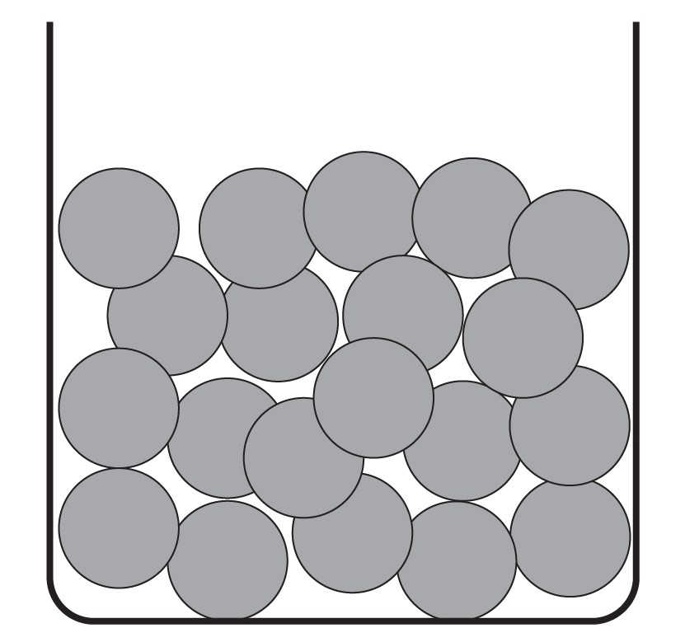

I am a liquid particle. I am attracted to the other liquid particles and can roll over them. I am in contact with the other particles, I can’t break free. Because we can move, me and my fellow liquid particles can fit to the shape of any container we are placed in.