Atomic structure

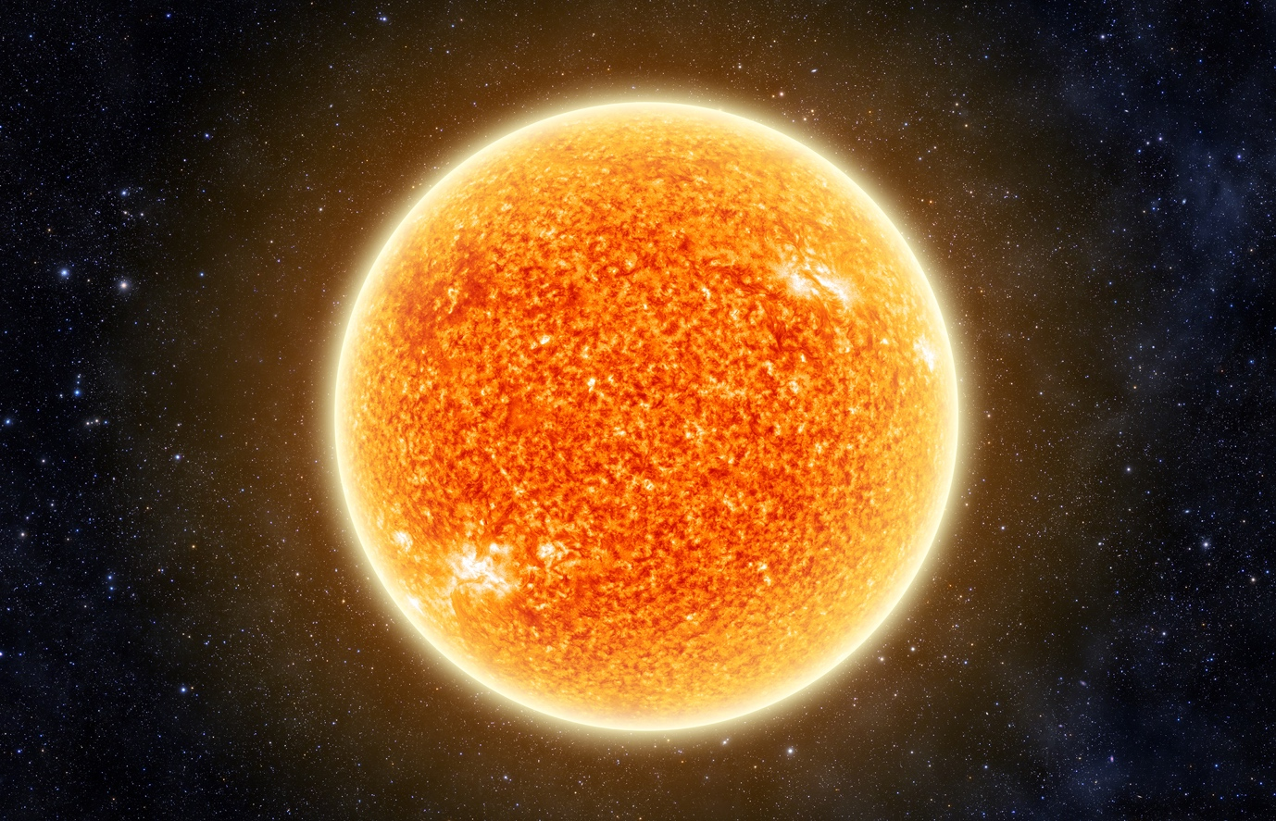

Source: © Shutterstock

The Sun is our star. Most stars in our galaxy, including the Sun, are 74% hydrogen, 24% helium with the other 2% being made up of other elements such as carbon, nitrogen and oxygen.

1. Hydrogen has three isotopes. All three isotopes are found in the Sun.

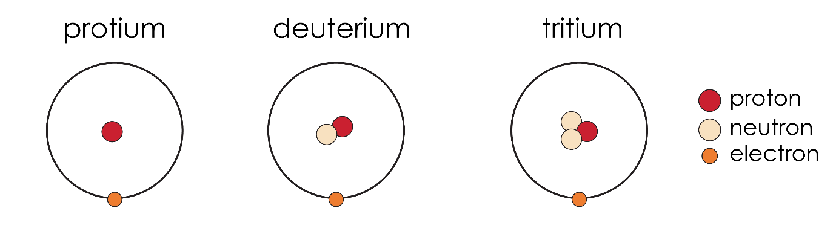

* 1. Write the symbols for the three isotopes. One has been done for you:

1. protium
2. deuterium __________________________________________________________
3. tritium ______________________________________________________________
   1. Explain why protium is the odd one out in terms of its atomic structure.
4. Chemistry happens in the Sun’s high temperature that would not normally take place on earth. Hydrogen atoms lose their electrons and become hydrogen nuclei. Hydrogen nuclei combine to form nuclei of heavier atoms.
   1. Complete the equation to show how a hydrogen atom forms a positive hydrogen nucleus.

H ⟶ __________________ + __________________

* 1. Write the symbol for a:

1. protium nucleus _____________________________________________________
2. deuterium nucleus __________________________________________________
3. tritium nucleus ______________________________________________________
   1. Which of the following is likely to be the radius of a deuterium nucleus? Circle the correct answer.
4. 1 × 10-9 m
5. 1 × 10-10 m
6. 1 × 10-14 m
7. 0.1 nm
   1. How many times heavier is a deuterium nucleus than a protium nucleus?
   2. When two deuterium nuclei combine, a helium nucleus is produced. State the number of sub-atomic particles in a helium nucleus.
8. protons __________________
9. neutrons __________________
10. electrons __________________
    1. Complete the equation for a deuterium nucleus combining with a tritium nucleus to form a helium nucleus.

+ + __________________ __________________

1. Reactions between nuclei in the Sun are called fusion reactions. They are very exothermic. Scientists are attempting to develop fusion reactions using deuterium and tritium as a source of energy on Earth.
   1. One out of every 6420 hydrogen atoms on Earth is deuterium. What percentage of naturally occurring hydrogen is deuterium? Give your answer to three significant figures.
   2. Deuterium has the same chemical reactions as protium. Explain why.
   3. Water containing deuterium is sometimes called heavy water. Scientists predict using sea water as a source of deuterium.

Calculate the percentage by mass of deuterium in heavy water. Assume the water molecules contain two atoms of deuterium.

*Ar* oxygen 16; *A*r deuterium 2

* 1. The boiling point of heavy water is 101.4 °C.

Suggest a method scientists can use to separate heavy water from water.

1. When stars get old and start to run out of hydrogen, scientists think that heavier elements start to form. When a helium nucleus combines with a tritium nucleus, the nucleus of a new element is produced.
   1. How many protons will the new nucleus have? ________________________
   2. Name the nucleus produced. ________________________
   3. When three helium nuclei combine to form one new nucleus, how many protons will the new nucleus have?
   4. Name the nucleus produced.
   5. Suggest how oxygen nuclei could be produced in a star.
   6. Elements up to iron, *A*r 26, form in similar exothermic reactions in stars like the Sun. Elements with *A*r values greater than 26 are formed in endothermic reactions in larger stars.

Name two elements that will not be produced in the Sun.

1. ____________________________________________________________________

2. ____________________________________________________________________

Which question(s) did you get wrong? Why?

What will you do next time you’re asked a similar question?