Bonding bingo!

Learning objectives

1. Describe the structure and bonding of ionic, simple covalent, giant covalent and metallic structures.
2. Explain how the physical properties associated with these substances relate to their structure and bonding.

Introduction

You will be working in **teams of two** for this task.

Each team will be given:

|  |  |
| --- | --- |
|  |  |
| A substance card | A bingo grid |

Your goal is to correctly identify which substance your opposing team has on their card by asking them questions.

* You will only be told ‘yes’ or ‘no’ as the answer.
* You will only have **one guess** to correctly identify the substance.

If you guess correctly, the other team will cross the substance off from your bingo grid and initial the square. Work your way round the teams in the class until you have correctly identified **all nine substances** on your bingo grid. The first team to do this wins.

**JK**

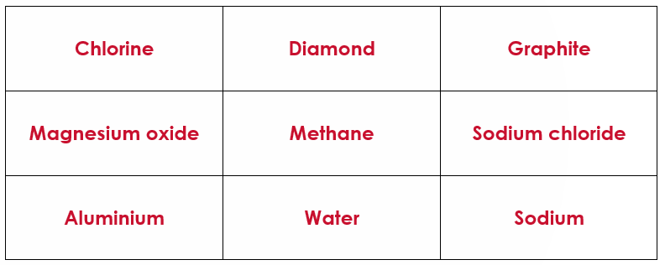

**DS**

**KP**

**CR**

**EK**

**KH**

The rules

1. Your team will be given a bingo grid and a substance card with one of:
   * Chlorine
   * Diamond
   * Graphite
   * Sodium
   * Magnesium oxide
   * Methane
   * Sodium chloride
   * Water
   * Aluminium

**Do not tell other teams the name of your substance.**

1. Before the game starts, write down some questions that have a yes/no answer about the bonding or properties of materials.

*Examples:*

* Does the bonding involve atoms sharing electrons?
* Does the substance have a high melting point?

1. To play, join up with another team. Decide who asks questions first.
2. Ask questions until you find out what the other team’s substance is. Discuss the answers that you are getting with your partner. If you think you know the other team’s substance, make a guess.

If you are correct, the other team must initial that square on your bingo card.

**Remember, you only have one chance to guess!**

1. Now, do the reverse with the other team. They ask questions, but you can only answer ‘yes’ or ‘no’. If they work out your substance correctly, initial that square on their bingo card. They only have one go at guessing the substance.
2. Now, find another team and repeat the process.
3. Keep going with yet more teams. Watch out! More than one team may have the same substance. Some teams may have the same substance as you!
4. When all of the squares on your bingo card have an initial, shout ‘**bingo**’! The first team to do this will win!

The questions my team will ask:

* ______________________________________________________________________________

__________________________________________________________________________________

_______________________________________________________________________**?** Yes or no

* ______________________________________________________________________________

__________________________________________________________________________________

_______________________________________________________________________**?** Yes or no

* ______________________________________________________________________________

__________________________________________________________________________________

_______________________________________________________________________**?** Yes or no

* ______________________________________________________________________________

__________________________________________________________________________________

_______________________________________________________________________**?** Yes or no

* ______________________________________________________________________________

__________________________________________________________________________________

_______________________________________________________________________**?** Yes or no

* ______________________________________________________________________________

__________________________________________________________________________________

_______________________________________________________________________**?** Yes or no

* ______________________________________________________________________________

__________________________________________________________________________________

_______________________________________________________________________**?** Yes or no