Ionic structure and bonding: teacher guidance

**These Knowledge check worksheets**provide a series of questions to assess learners’ knowledge and understanding of this topic at the end of a period of teaching or as revision. They are available at Foundation and Higher level and as fully editable versions, so you can adapt them to suit learners’ needs. Use for individual student work in class or at home. Find the full set of answers below.

Also available to assess this topic:

* **Review my learning** **worksheets**: available with three levels of scaffolded support to help build confidence in every learner. Use before, during or after teaching the relevant topic, to understand progress and identify misconceptions, **rsc.li/44igB7V**.
* **In context worksheets** ask learners to apply their knowledge to interesting contexts from everyday life, helping them develop their skills and prepare for examination, including calculation questions to practise mathematical skills within a genuine chemical context, **rsc.li/3xhIC3C**.

Answers

Foundation

1. (a) i. 2, 8, 1

ii. 2, 8, 7

iii. 2, 8

iv. 2, 8, 8 [4 marks]

* 1. **B** A chloride ion has more electrons than protons. [1 mark]
  2. A sodium atom has **one** (1) electron in its outer shell. A chlorine atom has **seven** (1) electrons in its outer shell. The outer electron from a sodium atom is transferred to a chlorine atom. The sodium ion formed has a **positive** (1) charge. The chloride ion has a **negative** (1) charge. Both ions have a **stable** (1) electronic configuration. [5 marks]

(d)

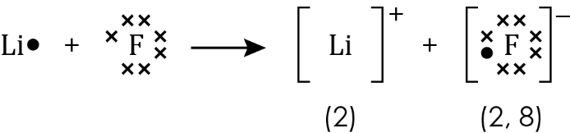

One mark for correct electrons on left of equation, one mark for correct electrons on right of equation, one for the charges correctly added to the ions. [3 marks]

1. (a) 2 [1 mark]
   1. 2 [1 mark]

(c)

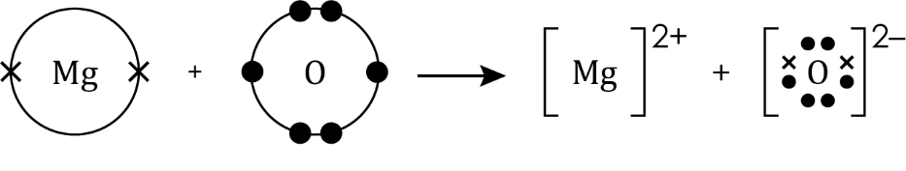

One mark for correct Mg2+ ion and one mark for correct O2– ion. [2 marks]

(d)

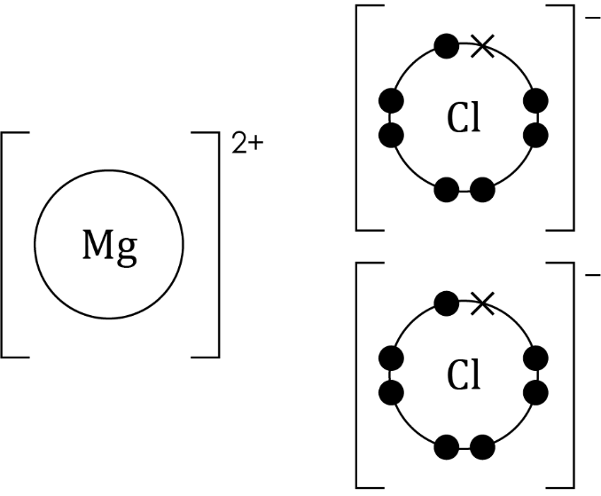

One mark for correct Mg and one for each correct Cl. [3 marks]

1. (a) **C** electrostatic forces [1 mark]
   1. i. ionic bonding [1 mark]

ii. Sodium chloride has a giant lattice and therefore has strong electrostatic forces of attraction between oppositely charged ions. [1] Lots of energy is needed to overcome the electrostatic forces of attraction between oppositely charged ions. [1]

[2 marks]

1. (a) **B** The ions are free to move and carry the charge. [1 mark]
   1. The ions are free to move in liquid zinc chloride [1] and carry the electric charge [1]. [2 marks]

[Total: 27 marks]

Higher

1. (a) **C** A sodium ion has fewer electrons than protons. [1 mark]

(b) Row D [1 mark]

1. (a)



One mark for correct atoms (both Mg and O), one mark   
for correct Mg2+ ion and one mark for correct O2– ion.

[3 marks]

(b) Magnesium atoms each lose two outer electrons [1] to form magnesium ions with a 2+ charge [1]. Chlorine atoms each gain one electron [1] to form chloride ions with a charge [1] [4 marks]

(c) [1 mark]

1. (a) electrostatic forces [1 mark]

(b) One of:

* The representation shows the spheres separated by lines to represent ‘ionic bonds’, whereas the sodium ions and chloride ions should be touching.
* Ionic bonds operate in all directions; they are not directional.

[1 mark]

* 1. It has a giant structure (of ions) [1] (with) strong electrostatic forces of attraction between oppositely charged ions [1] in all directions. [1]   
     A large amount of energy is needed to overcome (the forces of attraction). [1]   
      [4 marks]
  2. i. One mark per correct row. [2 marks]

|  |  |  |
| --- | --- | --- |
| **Metal** | **Which ions are present?**  **[give the formula]** | **Melting point/°C** |
| sodium chloride | **Na+, Cl‒** | 801 |
| magnesium oxide | **Mg2+, O2‒** | 2852 |

ii. ionic bond [1 mark]

iii. Mg2+ and O2‒ have more charges than Na+ and Cl‒ and form stronger ionic bonds. [1] More energy is needed to break the bonds in magnesium chloride. [1] [2 marks]

1. (a) The ions in solid zinc chloride are not free to move so they cannot carry an electrical charge. [1] The ions in zinc chloride solution are free to move and can carry an electrical charge. [1] The ions in molten zinc chloride are free to move and carry an electrical charge. [1] [3 marks]

(b)

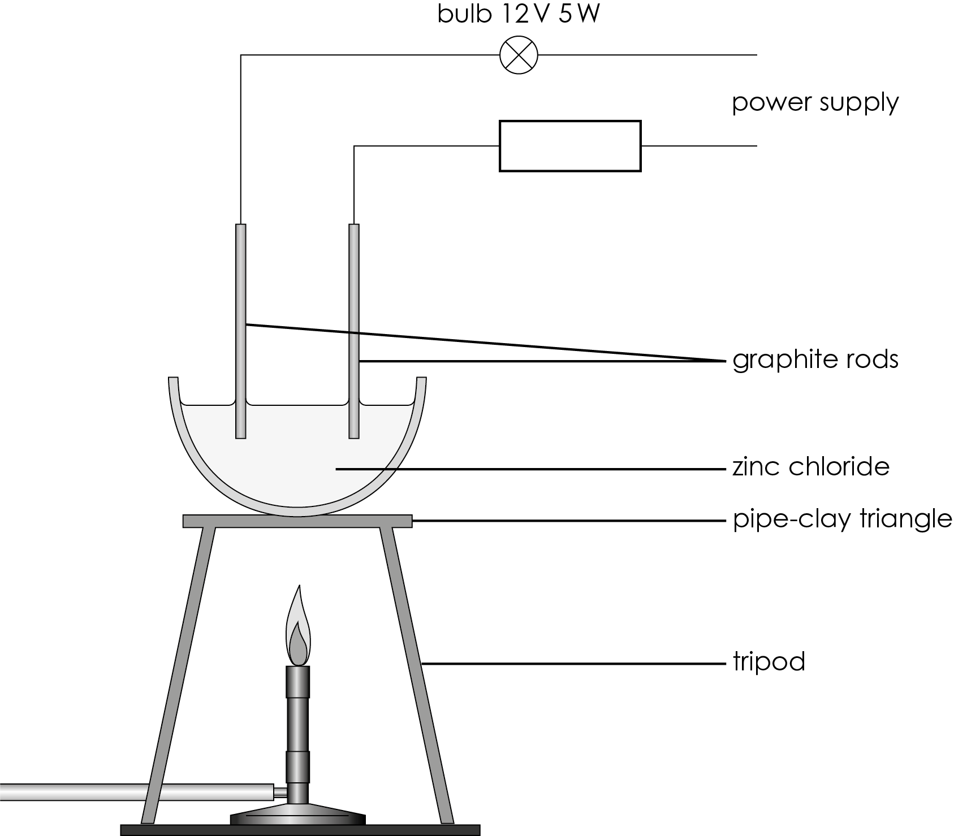

[method to melt zinc chloride [1]; suitable electrodes [1]; electrical circuit [1]]

[3 marks]

[Total: 27 marks]