Changes of state

This resource is part of the Structure strips series of resources, designed to support literacy in science teaching. More resources in this series can be found at: rsc.li/3UJSDOK

Learning objectives
- Define the terms melting point and boiling point.
- Explain how the amount of energy a substance has relates to its temperature.
- Describe the link between purity and melting point.
- Write independently about melting and boiling points.

Introduction

The physical state (solid, liquid or gas) of a substance depends on the melting point and boiling point of that substance. Different substances have different melting and boiling points.

How to use structure strips

Structure strips are a type of scaffolding that support learners to retrieve information independently. Use them to take an overview at the start of a topic, to activate prior knowledge, or to summarise learning at the end of a teaching topic. Visit rsc.li/4f33jAP for more ideas on how to use structure strips with your learners.

Structure strips have sections containing prompts, sized to suggest the amount that learners must write. Ask learners to glue the strips into the margin of an exercise book and write their answers next to the sections, in full sentences or in bullet points. When learners have finished using the structure strip, they will have an A4 page set of notes and examples.

Scaffolding
- Encourage learners to use the suggested key terms in their answers.
- To further support learners, include additional prompts in the structure strip. If learners are struggling to engage with the task, supply them with sentence starters created from the model answers.
- As learners grow in confidence, ask them to attempt the extension question first and then use the structure strip to improve or self-assess their answer.

Metacognition

This resource supports learners to develop their metacognitive skills in three key areas.
- Planning: the strips provide scaffolding to plan the written response. Learners will decide where to gather information from (textbooks, own notes, revision websites). Ask learners: is the source of information you are using reliable?
- Monitoring: learners are prompted by the questions in the structure strip and can check their own answer against the prompts. Ask learners: have you covered all of the prompts in the space provided? Do you need to change anything to complete the task?
- Evaluation: learners can self-assess or ask a peer to check their work against the answers. Ask learners: did you achieve what you meant to achieve? What might you do differently another time?

Example answers for the structure strip are on page 3.

Structure strip  Changes of state | Example answer
Define the state changes that happen at the:  - melting point  - boiling point. | At the melting point of a substance a solid turns into a liquid.  At the boiling point of a substance a liquid turns into a gas.
Explain how a thermometer works to measure an increase in temperature. | When a thermometer is heated, the particles in the liquid inside the thermometer move further apart. This causes the volume of the liquid to increase. As the thermometer liquid is in a thin tube the height of the liquid increases.
State the usual scale for temperature and give the melting and boiling points for water. | Temperature is usually measured in degrees Celsius (°C).  Water melting point = 0°C  Water boiling point = 100°C
Sketch a graph to show what happens to temperature as the energy of a substance is increased. Your graph should have:  - Energy as the x axis  - Temperature as the y axis  - The melting point labelled  - The boiling point labelled  - The different states (solid, liquid and gas) labelled. | 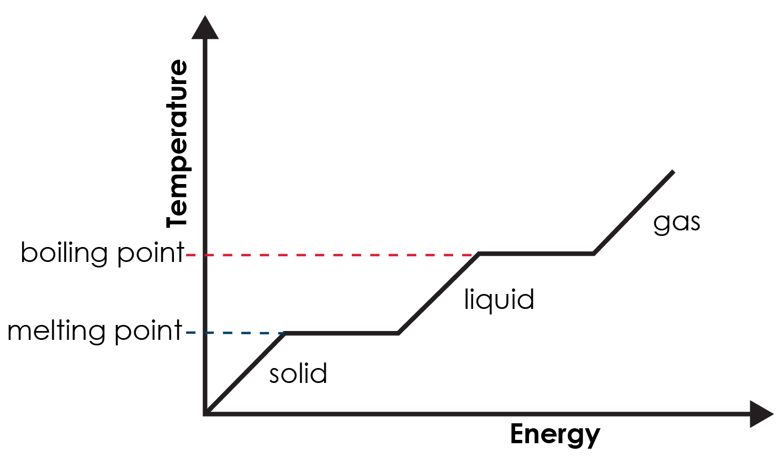
Suggest how this graph might be different for a substance that isn’t pure. Explain your answer. | There wouldn’t be such uniformly horizontal lines in the graph for the melting and boiling points.  Pure substances have precise melting points. Mixtures have a wider range of melting points, over a few degrees.

Extension question: correcting Chef George

Get learners to answer the question after they have attempted the structure strip. The structure strip activates the required knowledge which learners then apply to the question.

Consider re-framing the context of this question to one your learners are more familiar with, to empower them to unlock their existing science capital. More information – rsc.li/40FAMLP

Example answer to extension question

It would be better if you heated the mixture gently to around 42°C, which is in the melting range of two of the chocolate types and close to the other one.

Chocolate is a mixture. Because it isn’t a pure substance it does not have a sharp melting point, instead chocolate melts over a range of a few degrees.

If you go ahead with your plan to heat the mixture above the top melting point of any of the chocolate, then the mixture will split and be unstable at this temperature.

