Covalent structure and bonding in our bodies

Covalent bonds are far more common in the human body than other types of bonds. That is because about 96% by mass of our bodies is made from four non-metallic elements: carbon, hydrogen, oxygen and nitrogen.

Source: © Shutterstock

1. (a) Non-metals combine together with covalent bonds. Which statement about covalent bonds is correct? Circle the correct answer.
2. Electrons are shared in a covalent bond.
3. Electrons are transferred in a covalent bond.
4. Ions are formed in covalent bonds.
5. Electrons are delocalised in a covalent bond.

Approximately 60% of our body is made up of water ().

The diagrams show two ways of representing a molecule of water:

|  |  |
| --- | --- |
| Photograph of a molymod representing a molecule of water. One red ball in the centre is joined to two smaller white balls with sticks. | Dot and cross diagram for a water molecule showing a central oxygen atom with a hydrogen atom on each side. The outer shells of each hydrogen atom overlaps with the oxygen and one dot and one cross, representing electrons are shown in each. A further four dots are shown on the outline of the oxygen atom. |
| **A** | **B** |

(b) Give one limitation of diagram A.

____________________________________________________________________________

(c) Give one limitation of diagram B.

____________________________________________________________________________

1. Ammonia is produced by cells throughout the body.
   1. Complete the dot and cross diagram for an ammonia atom.

Hint: Hydrogen has one outer shell electron and nitrogen has five.

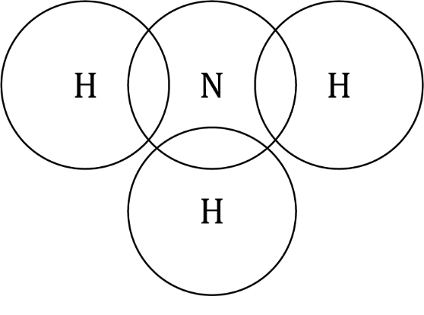

* 1. State the molecular formula of ammonia.
  2. Calculate the relative formula mass () of ammonia.

nitrogen 14 hydrogen 1

* 1. Calculate the percentage by mass of nitrogen in ammonia. Give your answer to one decimal place.

1. 24% of atoms in our bodies are oxygen atoms. Oxygen gas is absorbed into the blood in our lungs.
   1. Calculate how many oxygen molecules () can be made from 100 oxygen atoms.

____________________________________________________________________________

____________________________________________________________________________

* 1. Explain why oxygen is a gas at room temperature.

Use these words in your answer:

simple molecules weak forces

energy intermolecular forces

1. Starch molecules contain oxygen and are part of our diet. Starch is a natural polymer. The table shows the approximate sizes of oxygen and starch molecules:

|  |  |
| --- | --- |
| **Molecule** | **Approximate size /nm** |
| oxygen molecule | 0.35 |
| typical starch molecule | 70.0 |

* 1. Calculate how many times larger a typical starch molecule is than an oxygen molecule.
  2. State which molecule has stronger intermolecular forces.
  3. Describe the effect stronger intermolecular forces have on the melting point of starch compared to oxygen.

____________________________________________________________________________

____________________________________________________________________________

1. Silicon dioxide is present in small amounts in our bodies. It is essential for skeletal health. The diagram shows the structure of silicon dioxide.

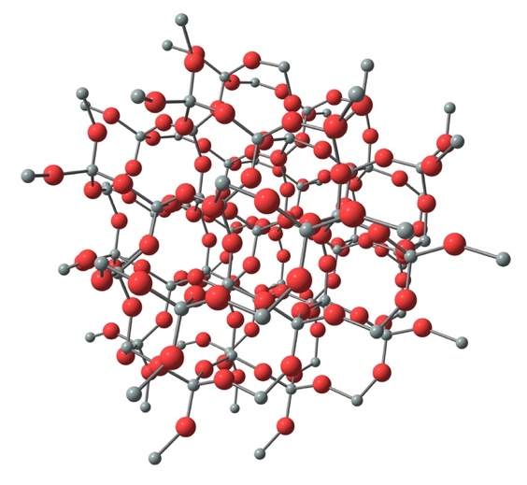

Source: © Shutterstock

* 1. Label the diagram to show:
* a silicon atom
* an oxygen atom
* a single covalent bond.

The melting point of silicon dioxide is 1710°C.

* 1. Name the type of bonds that are broken when silicon dioxide melts.

____________________________________________________________________________

* 1. Which of the following explain why silicon dioxide has a high melting point. Circle the **two** correct answers.

1. Silicon dioxide is a simple molecule.
2. Silicon dioxide has strong bonds.
3. It requires a lot of energy to break the bonds of silicon dioxide.
4. Silicon dioxide has weak bonds.

Which question(s) did you get wrong? Why?

What will you do next time you’re asked a similar question?