Melting and boiling points

Introduction

These questions are designed to help you connect your understanding of melting and boiling points, changes of state and the particle model.

|  |  |
| --- | --- |
| An icon used to indicate the Macroscopic part of Johnstone's triangle. | **Macroscopic:** what we can see. Think about the properties that we can observe, measure and record. |
| An icon used to indicate the Sub-microscopic part of Johnstone's triangle. | **Sub-microscopic:** smaller than we can see. Think about the particle or atomic level. |
| An icon used to indicate the Symbolic part of Johnstone's triangle. | **Symbolic:** representations. Think about how we represent chemical ideas including symbols and diagrams. |

Questions

1. A jeweller melts some silver. The silver does not melt at a single sharp temperature. It melts over a temperature range.

Select the statement (or statements) that explain this observation.

|  |  |
| --- | --- |
| **A** | The silver needed to be heated higher than its melting point for it all to melt. |
| **B** | The silver was impure. |
| **C** | The sliver had another metal mixed in with it. |
| **D** | The silver started to melt before it reached its melting point. |



1. All metals have a melting point.

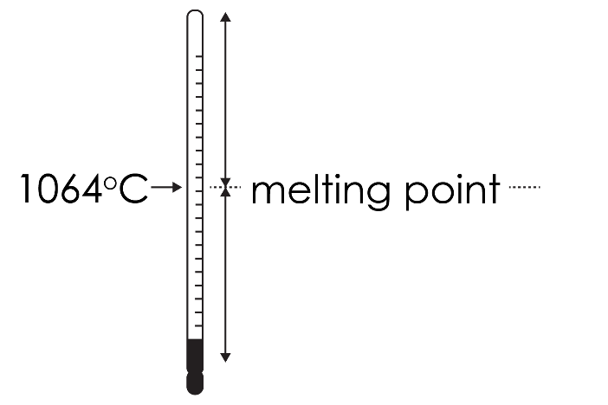The thermometer diagram shows the melting point of gold. Complete the labels to give the state of gold above and below this melting point.

1. Above the melting point gold is in the ________________ state.
2. Below the melting point gold is in the ________________ state.
3. The table lists four metals and their melting points. Complete the table to show the state of each metal at 1000°C.

|  |  |  |
| --- | --- | --- |
| **Metal** | **Melting point (°C)** | **State at 1000°C** |
| Copper | 1084 |  |
| Aluminium | 660 |  |
| Silver | 961 |  |
| Titanium | 1670 |  |



1. Water exists in the solid, liquid and gas state. The thermometer diagram shows the melting point and boiling point of water.

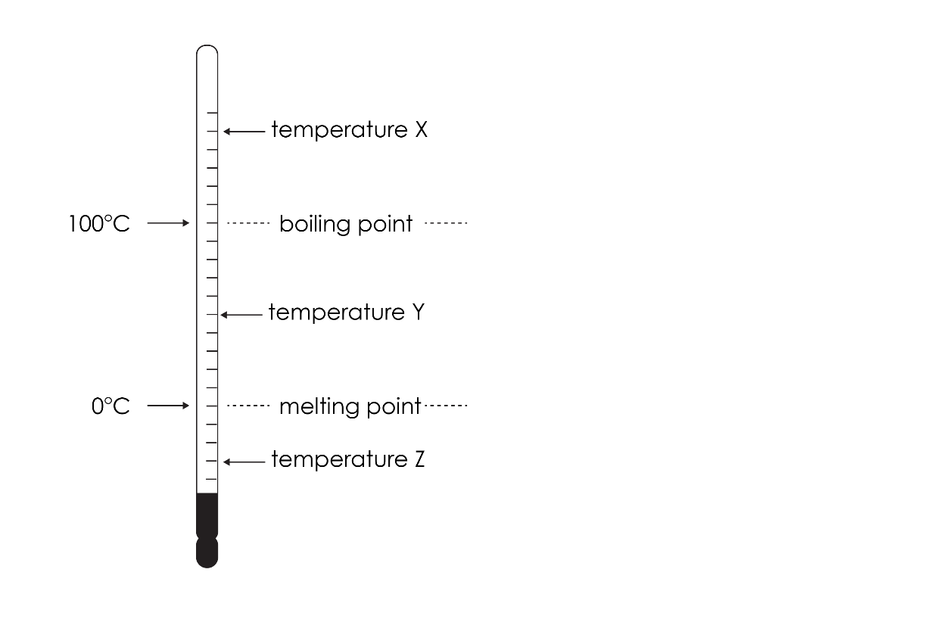

Give the state of water at:

1. temperature X ______________
2. temperature Y ______________
3. temperature Z ______________
4. Some iron is heated until it melts. The iron changes from the solid state to the liquid state.

The diagrams below shows a particle diagram for iron in the solid and liquid state.

|  |  |
| --- | --- |
| A square containing dark green circles arranged in a regular structure of five columns and five rows with all the circles touching. | A square containing dark green circles arranged in an irregular pattern with all the circles touching and overlapping. |
| **solid state** | **liquid state** |

1. State two similarities between the particle model for the solid and liquid states.

__________________________________________________________________________________

__________________________________________________________________________________

__________________________________________________________________________________

__________________________________________________________________________________

1. State two differences between the particle model for the solid and liquid states.

__________________________________________________________________________________

__________________________________________________________________________________

__________________________________________________________________________________

__________________________________________________________________________________

1. The basic particle model can be used to explain why copper and silver have a fixed shape when they are in the solid state.

The diagram below shows particle diagrams for copper and silver.

|  |  |
| --- | --- |
| A square containing mid green circles arranged in a regular structure of five columns and five rows with all the circles touching. An arrow points towards one of the circles from the label 'copper particle'.  copper particle | A square containing light green circles arranged in a regular structure of five columns and five rows with all the circles touching. An arrow points towards one of the circles from the label 'sliver particle'.  silver particle |
| **copper** | **silver** |

This basic particle model does not include forces between the particles.

Explain why the basic particle model cannot demonstrate why copper and silver have different melting points.

__________________________________________________________________________________

__________________________________________________________________________________

__________________________________________________________________________________

__________________________________________________________________________________

__________________________________________________________________________________

1. The more advanced version of the particle model does include forces of attraction between particles.

Explain why you need this to demonstrate why copper has a higher melting point than silver.

__________________________________________________________________________________

__________________________________________________________________________________

__________________________________________________________________________________

__________________________________________________________________________________

__________________________________________________________________________________