Solutions

This resource is part of the Structure strips series of resources, designed to support literacy in science teaching. More resources in this series can be found at: rsc.li/4aXYgzt

Learning objectives
- Correctly use key words related to solutions.
- Describe how mass is conserved when solutions are formed.
- Draw/interpret particle diagrams for solutions.
- Write independently about solutions.

Introduction

Most chemical reactions, including the ones in our bodies, are carried out in solutions. We drink solutions, use them to preserve our food and clean our houses. Solutions are all around us.

How to use structure strips

Structure strips are a type of scaffolding that support learners to retrieve information independently. Use them to take an overview at the start of a topic, to activate prior knowledge, or to summarise learning at the end of a teaching topic. Visit rsc.li/3EszCfr for more ideas on how to use structure strips with your learners.

Structure strips have sections containing prompts, sized to suggest the amount that learners must write. Ask learners to glue the strips into the margin of an exercise book and write their answers next to the sections, in full sentences or in bullet points. When learners have finished using the structure strip, they will have an A4 page set of notes and examples.

Scaffolding
- Encourage learners to use the suggested key words in their answers. These link with our key terms support resources for particle model.
- To further support learners, include additional prompts in the structure strip. If learners are struggling to engage with the task, supply them with sentence starters created from the example answers.
- As learners grow in confidence, ask them to attempt the extension question first and then use the structure strip to improve or self-assess their answer.

For the extension question, spend a little time helping learners to understand the idea of ratios e.g. 1 in 4 vs 1 in 10 for dilution.

Learners may also use the terms ‘strong’ and ‘weak’ instead of concentrated and dilute. These are terms that they might use in their everyday life and represent an alternative conception rather than misconception. Explain to learners that, as they go through their learning in chemistry, the terms weak and strong will have different meanings and so they should put aside those descriptions and instead use more scientific terms like concentrated and dilute, more concentrated etc.

Metacognition

This resource supports learners to develop their metacognitive skills in three key areas.
- Planning: the strips provide scaffolding to plan the written response. Learners will decide where to gather information from (textbooks, own notes, revision websites). Ask learners: is the source of information you are using reliable?
- Monitoring: learners are prompted by the questions in the structure strip and can check their own answer against the prompts. Ask learners: have you covered all of the prompts in the space provided? Do you need to change anything to complete the task?
- Evaluation: learners can self-assess or ask a peer to check their work against the answers. Ask learners: did you achieve what you meant to achieve? What might you do differently another time?

Example answers for the structure strip are on page 3.

Structure strip  Solutions | Example answer
Define the following key terms, giving examples where possible:  - solute  - solvent  - solution  - soluble  - insoluble | Solute – a substance that dissolves in a solvent to make a solution. It is usually a solid but is sometimes a gas, e.g. salt is the solute in salt water, carbon dioxide is the solute in carbonated water.  Solvent – a substance that dissolves the solute to make a solution. It is usually a liquid and the solute is usually a solid (but could also be a gas), e.g. water is a good solvent.  Solution – the mixture produced when a solute dissolves in a solvent, e.g. brine used to preserve food is a solution of salt in water.  Soluble – describes a substance which dissolves in a particular solvent, e.g. salt is soluble in water.  Insoluble – describes a substance which does not dissolve in a particular solvent, e.g. sand is insoluble in water.
Describe the difference between what you observe when you add an insoluble solid to water compared to a soluble solid. | When an insoluble solid is added to water it makes the water cloudy/opaque and the solid can be seen at the bottom.  When a soluble solid is added to water the solution will be clear (see-through). It might be clear and coloured, e.g. copper sulfate.
Describe how mass is conserved when a solution is formed from a soluble solid and a solvent. | Mass of solution = mass of solid dissolved + mass of solvent  For example, if 9 g of salt is added to 100 g of water (100 cm³) then the final solution will have a mass of 109 g.  If the water is evaporated, 9 g of salt would be recovered from the solution.
Draw a labelled particle diagram showing a dilute solution. Briefly explain how the diagram shows it is dilute. | Look for a diagram with solvent and solute particles labelled with a key, significantly more solvent particles than solute particles. For example –  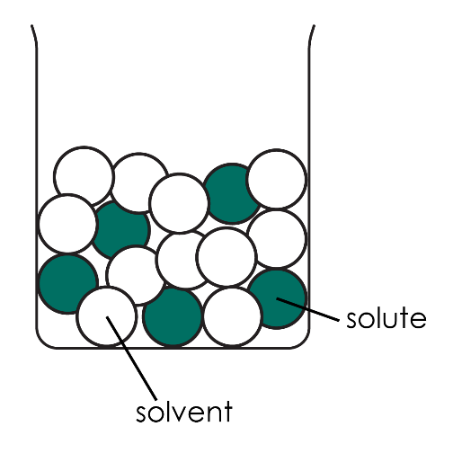
Draw a labelled particle diagram showing a concentrated solution. Briefly explain how the diagram shows it is concentrated. | Look for a diagram with solvent and solute particles labelled with a key, significantly more solute particles than solvent particles. For example –  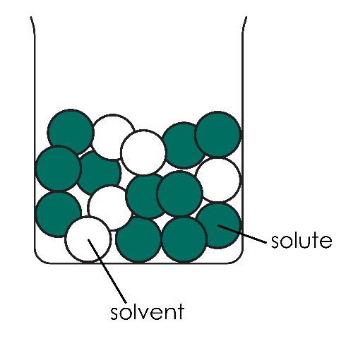

Extension question: Sarah’s solutions

Get learners to answer the question after they have attempted the structure strip. The structure strip activates the required knowledge which learners then apply to the question.

Consider re-framing the context of this question to one your learners are more familiar with, to empower them to unlock their existing science capital. More information – rsc.li/40FAMLP

Example answer to extension question

Dear Sarah,

Squash A is much less concentrated than Squash B. This means that squash B has the same number of particles as squash A but in a much smaller volume.

If you use the same amount of squash and water for both types of squash, then one of the drinks might taste really weak and the other one might taste really strong.

If you use squash B in the same amounts of squash and water as squash A then the drink will be really dark in colour and taste really strongly of blackcurrant.

