The chemistry of iron

Learning objectives
- Review bonding concepts and use them to describe the bonding in haemoglobin (task 1).
- Apply the equilibrium law and Le Chatelier’s principle to the equilibrium reactions occurring between haemoglobin, oxygen and carbon monoxide (task 2).
- Draw conclusions from half-cell equations and their $E^{0}$values about the relative stabilities of binding ligands in complex ions (task 3).
- Analyse the half-cell equations and their $E^{0}$values to examine the effect of pH on redox potential and the final oxidation state of the reductant (task 4).

Introduction

The Education in Chemistry article Carbon monoxide – the silent killer, refers to the bonding of oxygen (O₂) to the haemoglobin complex to form oxyhaemoglobin. Competition between O₂ and carbon monoxide (CO) for the bonding site prevents sufficient O₂ being transported in the body and results in carbon monoxide poisoning, leading to hypoxia (low oxygen in the tissues).

In the first task, you will review the structure and bonding in the oxyhaemoglobin and carboxyhaemoglobin complexes. In the second task you will be applying Le Chatelier’s principle and the equilibrium law to the ligand exchange reactions which form the oxyhaemoglobin and carboxyhaemoglobin complexes.

The redox potential for iron and other transition metal ions changing from a higher to a lower oxidation state is influenced both by the ligand and by pH. In task 3, you will be using $E^{0}$data to assess the effect of the binding ligand on the relative stability of higher and lower oxidation states for nickel (Ni) and iron (Fe).

Across organic and inorganic chemistry there are examples of transition metal ions acting as strong oxidants in their highest positive oxidation state in acidified conditions. In task 4 you will be analysing the effect of pH on the redox potential of a half-cell and the final oxidation state of the reductant. The final part of this task is a challenge: you will construct full ionic equations from half-cell equations and their respective $E^{0}$values for rusting in alkaline conditions.

Task 1

Haemoglobin is an iron(II) complex with a multidentate ligand. The diagram below shows the bonding in haemoglobin.

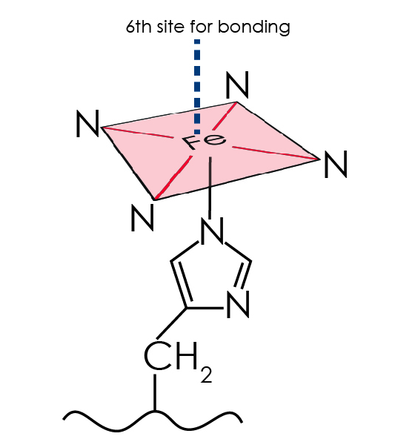
The diagram shows the six bonds around the Fe²⁺ ion:
- four bonds in the plane with nitrogen (N) atoms from a porphyrin ring
- one bond below the plane between the N atom of the globin molecule and the central Fe²⁺
- one further ligand above the plane which could be an O₂, CO or water (H₂O) molecule

- Draw a bonding diagram for the H₂O molecule. Use your diagram to explain why H₂O is classed as a ligand.

- What type of bonds are formed between the N atoms and the Fe²⁺ ion?
- What feature of the attached atom allows it to form this type of bond?

- State and explain the geometry of the haemoglobin complex.

- O₂ binds reversibly to the central Fe²⁺ in haemoglobin forming the oxyhaemoglobin complex. CO binds irreversibly to the central Fe²⁺ in haemoglobin forming carboxyhaemoglobin. Carboxyhaemoglobin is a much more stable complex than oxyhaemoglobin since CO binds more strongly to the central Fe²⁺ making it a stronger ligand.

Complete the diagram below to show how:
- the O₂ ligand bonds to the Fe²⁺ in haemoglobin in the position marked ‘X’
- the CO ligand bonds to the Fe²⁺ in haemoglobin in the position marked ‘X’

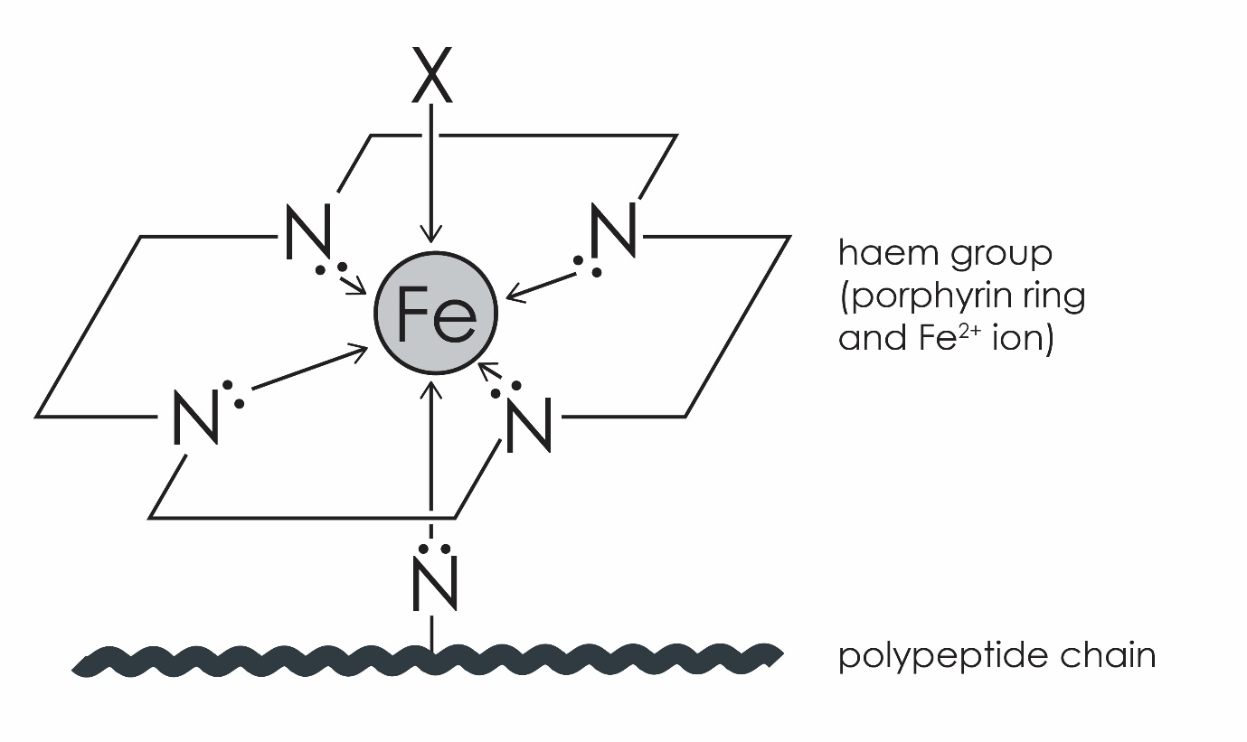

HINT: You should include lone pairs and bond pairs in both molecules. O₂ has a double bond between its atoms and CO has a triple bond between C and O.

- Cyanide (CN–) can also bind strongly to the central Fe²⁺ ion in haemoglobin forming cyanohaemoglobin, which causes hypoxia.

Draw bonding diagrams for (a) CO and (b) CN– to show why these ligands are isoelectronic, ie have the same number of electrons.

Task 2

This task concerns the equilibrium reactions which occur between O₂ and haemoglobin, and between oxyhaemoglobin and carboxyhaemoglobin when CO competes with the O₂ ligand to bind to the central Fe²⁺ ion.

Equilibrium reaction 1: $Hb(H_{2}{O)}_{4} + 4O_{2}\left(g\right) ⇌ Hb({O_{2})}_{4} + 4H_{2}O(g)$
Equilibrium reaction 2: $Hb(O_{2})_{4} + 4CO\left(g\right) ⇌ Hb({CO)}_{4} + 4O_{2}(g)$

- How does the combustion of hydrocarbons increase the level of CO in the environment?

- What type of reaction is taking place in both equilibrium reactions?

- Using Le Chatelier’s principle, predict how O₂ is transported in the blood by considering what happens to the position of equilibrium reaction 1:
- when the concentration of oxygen, [O₂], is high in the lungs
- when the concentration of oxygen, [O₂], is lower in the tissues and the concentration of water, [H₂O], is higher

- Like other equilibrium reactions, equilibrium reactions 1 and 2 have an equilibrium stability constant called $K_{stab}$.

Write an expression for $K_{stab}$ for equilibrium reaction 2 using the equilibrium law. Give the units, assuming all concentrations are measured in mol dm⁻³ and show your working out.

HINT: $K_{stab}$is the same as writing an expression for $K_{c}$. You should not include [O₂] because it is present in a large excess.

- $K_{stab}$ is a measure of the strength of the interaction between the ligands and the binding site in a complex ion. The higher its value, the more stable the complex.
- Predict whether equilibrium reaction 1 or 2 will have the higher $K_{stab}$.
- Use your predicted $K_{stab}$ values to explain why CO is poisonous?

Task 3

Redox or electrode potentials are used to predict how easily an atom or an ion can be reduced to a lower oxidation state. Redox potentials of complex ions depend on the types of ligands involved.
- Half-cell equations are given below for the reduction of Ni(II) to Ni with their respective $E^{0}$ values:

Equilibrium reaction 3: ${[Ni(H_{2}{O)}_{6}]}^{2+} + {2e}^{-} ⇌ Ni\left(s\right) + 6H_{2}O{ E}^{0}=-0.26 V$

Equilibrium reaction 4: ${[Ni({NH}_{3})_{6}]}^{2+} + {2e}^{-} ⇌ Ni\left(s\right) + 6NH_{3} E^{0}=-0.49 V$

Use the $E^{0}$values to answer the following questions:
- Deduce which of the two ligands binds more strongly to the Ni(II) ion.
- Deduce which equilibrium reaction has a higher $K_{c}$ value.
- Deduce in which of the complex ions is the +2 oxidation state of Ni more stable.

HINT: the more positive the redox potential, the more likely an atom/ion is to be reduced.

- Recent research on Fe³⁺/Fe²⁺ has shown that electron-donating ligands stabilise Fe²⁺ while anion ligands stabilise Fe³⁺. An electron-donating ligand donates a lone pair from its donor atom to the vacant orbitals of a metal ion. An anion ligand is a negatively charged ion with a donor atom, eg CN–. Ammonia, NH₃, is a more electron donating ligand than H₂O.

Use this information to match the following $E^{0}$ values to the half-cell equations below giving reasons for your choices.
$E^{0}$values = $+0.77 V, +0.37 V$ and $+0.95 V$

${[Fe(H_{2}{O)}_{6}]}^{3+} + e^{-} ⇌ {[Fe(H_{2}{O)}_{6}]}^{2+}$

$${[Fe({CN)}_{6}]}^{3-} +{ e}^{-} ⇌ {[Fe({CN)}_{6}]}^{4-}$$

${[Fe({NH}_{3})_{6}]}^{3+} + e^{-} ⇌ {[Fe({NH}_{3})_{6}]}^{2+}$

Task 4
The effect of pH on oxidation state varies between oxidation and reduction reactions.

- The reduction of manganese in manganate(VII) can take place in acidic or neutral conditions. The partial half-equations and respective${ E}^{0}$ values are given below. The half-cell equation for the reduction of ${Cl}_{2}$ and its $E^{0}$value is also given.
$Mn{O_{4}}^{-}\left(aq\right) + 8H^{+}\left(aq\right) + me^{-} ⇌ {Mn}^{2+}\left(aq\right) + nH_{2}O\left(l\right){ E}^{0}=+1.52 V$

$$Mn{O_{4}}^{-}\left(aq\right) + xH_{2}O\left(l\right) + ye^{-} ⇌ {MnO}_{2}\left(s\right) + 4{OH}^{-}(aq){ E}^{0}=+0.59 V$$

$${0.5Cl}_{2}\left(aq\right) + e^{-} ⇌ {Cl}^{-}(aq){ E}^{0}=+1.36 V$$

Use this information to:
- State the colour change observed when manganate(VII) is used in acidic solution.
- Balance the half-cell equations for the reduction of manganate(VII) in acidic and neutral conditions by giving values for $m, n, x$ and $y$.
- State two pieces of information which show that manganate(VII) is a stronger oxidant in acidic conditions.
- Explain why HCl(aq) is not a suitable acid to acidify manganate(VII).

- Challenge: in the first step of the rusting process, iron is oxidised to iron(II) hydroxide. In the second step iron(II) hydroxide is further oxidised to iron(III) hydroxide, which is one of the components of orange/brown rust.

- Give the electron configurations of Fe²⁺ and Fe³⁺ and use these to explain why Fe³⁺ is the more stable oxidation state.

The relevant half-cells and their $E^{0}$ values for the two steps involved in the rusting process are given in the table below.

Step | Half-cell equation | $E^{0}$ value (V)
1 | $${Fe}^{2+}\left(aq\right) + 2e^{-} ⇌ Fe(s)$$ | –0.44
1 and 2 | $$O_{2}\left(g\right) + 2H_{2}O\left(l\right) + 4e^{-} ⇌ 4{OH}^{-}(aq)$$ | +0.40
2 | $Fe{\left(OH\right)}_{3}\left(s\right)+ e^{-} ⇌ Fe{\left(OH\right)}_{2}\left(s\right) + {OH}^{-}(aq)$ | –0.56

- Use the half-cell equations to write a redox equation representing the reactions occurring in steps 1 and 2.

- Use the $E^{0}$values to show that both steps are feasible.

HINT: you can either calculate the electromotive force (emf) of the cell or compare the $E^{0}$values of the component half-cells involved in each step to show the step is feasible.

