Covalent bonding in water: Johnstone’s triangle

Learning objectives

1. Describe a covalent compound based on observations.
2. Use symbolic models to represent a covalent compound.
3. Explain how the type of bonding in a covalent compound relates to the properties you can observe.

Introduction

Water is a covalent compound consisting of two hydrogen atoms and one oxygen atom.

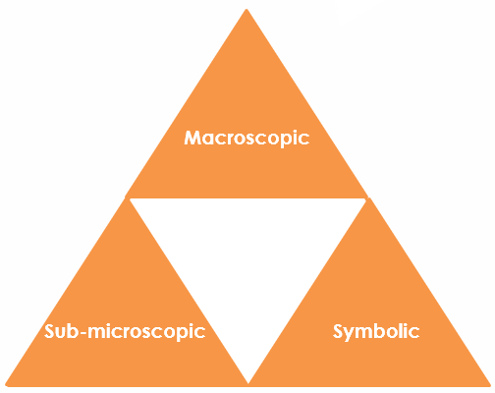Johnstone’s triangle

In chemistry we make sense of the things that we can see by representing what we can’t see using formulas, equations, diagrams and models.

Johnstone’s triangle is a way of thinking about these different concepts as different corners of a triangle:

* Macroscopic – what we can see
* Symbolic – what we use to represent what we’ve seen
* Sub-microscopic – smaller than we can see

Being able to connect and move between these three different levels is important for scientific understanding.

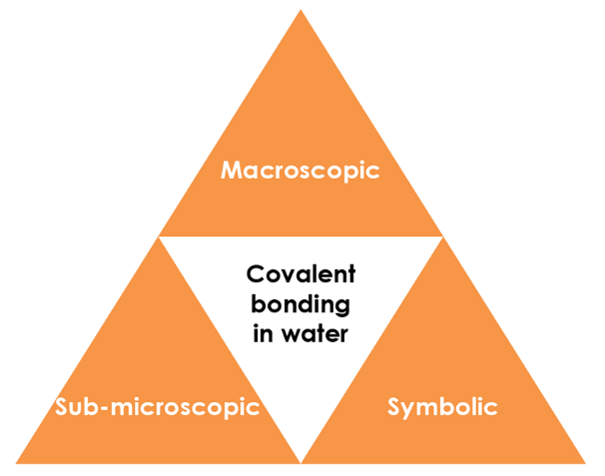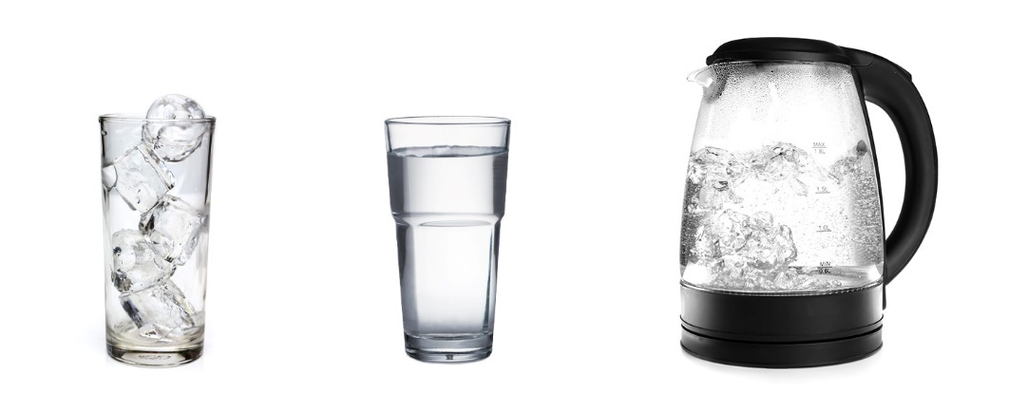

Symbolic - How do we represent it?

What is the chemical formula of water?

Draw a particle diagram for water as a solid, liquid and gas.

solid liquid gas

Draw a dot and cross diagram for water.

Macroscopic - What do we observe?

Observe water in the solid, liquid and gas state.

What are the freezing and boiling temperatures of water?

What state is water in at room temperature?

What do you see when water boils?

Sub-microscopic - What is happening that we can’t see?

Is water a simple covalent molecule or a giant covalent compound?

On the diagram below label a covalent bond and an intermolecular force.  
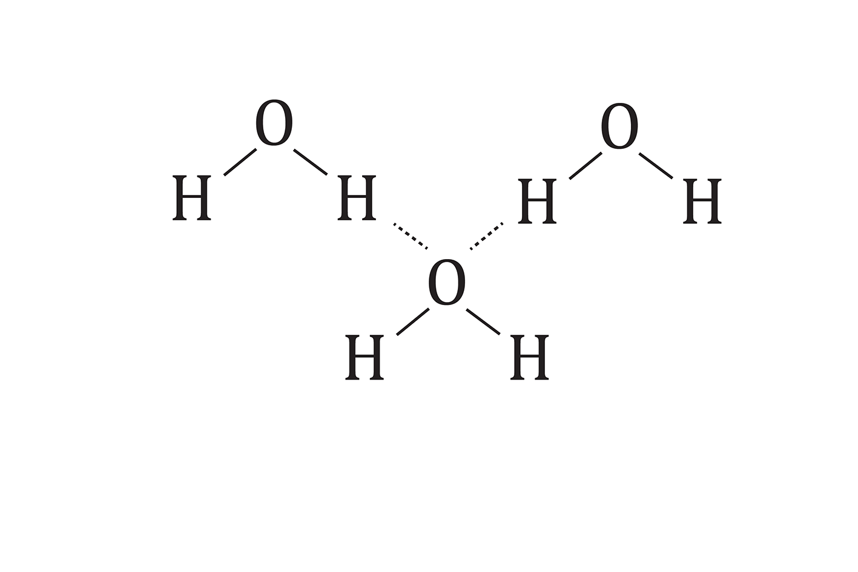  
Which of these are the strongest in water?

**covalent bond intermolecular force**