Covalent structure and bonding in our bodies

1. Covalent bonds are far more common in the human body than other types of bonds. That is because approximately 96% of the mass in our body is made from four non-metallic elements: carbon, hydrogen, oxygen and nitrogen.

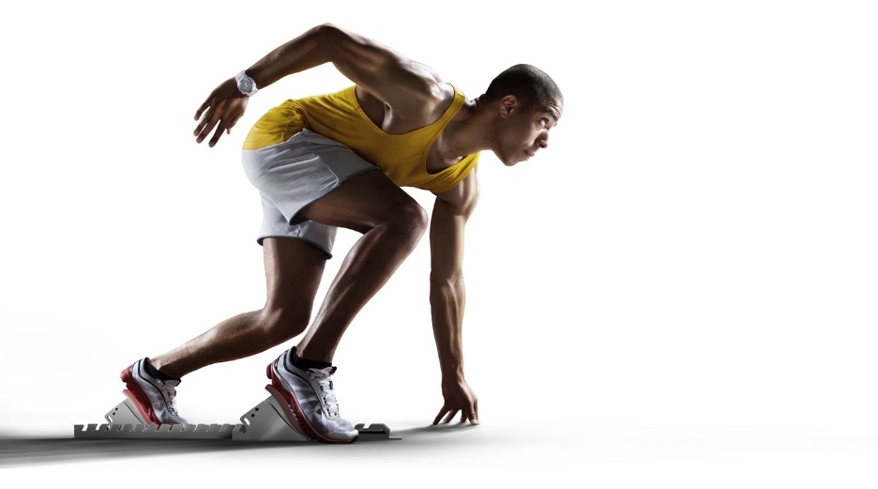

Source: © Shutterstock

* 1. Add lines to link the molecules with the type of covalent bond between their atoms.

|  |  |  |
| --- | --- | --- |
| oxygen molecule |  | single covalent bond |
|  |  |  |
| nitrogen molecule |  | double covalent bond |
|  |  |  |
| hydrogen molecule |  | triple covalent bond |

* 1. Complete the dot and cross diagrams:

|  |  |
| --- | --- |
| **Empty dot and cross diagram for an oxygen molecule showing the outer shells of two oxygen atoms with their shells overlapping in the middle.** | Empty dot and cross diagram for an nitrogen molecule showing the outer shells of two nitrogen atoms with their shells overlapping in the middle. |
| **oxygen molecule** | **nitrogen molecule** |

1. Starch molecules contain carbon, hydrogen and oxygen. Starch is a natural polymer and is part of our diet.

The table shows the approximate sizes of oxygen and starch molecules.

|  |  |
| --- | --- |
| **Molecule** | **Approximate size/nm** |
| oxygen molecule | 0.35 |
| typical starch molecule | 70.0 |

* 1. Calculate how many times larger a typical starch molecule is than an oxygen molecule.

____________________________________________________________________________

____________________________________________________________________________

* 1. State which molecule has the stronger intermolecular forces.

____________________________________________________________________________

* 1. Explain the effect the stronger intermolecular force have on the melting point of starch.

____________________________________________________________________________

____________________________________________________________________________

* 1. Explain why oxygen is a gas at room temperature.

____________________________________________________________________________

____________________________________________________________________________

____________________________________________________________________________

____________________________________________________________________________

The molecular formula of the polymer starch is

* 1. What does ‘*n*’ represent?

____________________________________________________________________________

* 1. Calculate the relative formula mass of a small starch molecule where *n* = 200.

____________________________________________________________________________

____________________________________________________________________________

Starch is broken down into glucose in our digestive systems. This is one form of glucose:

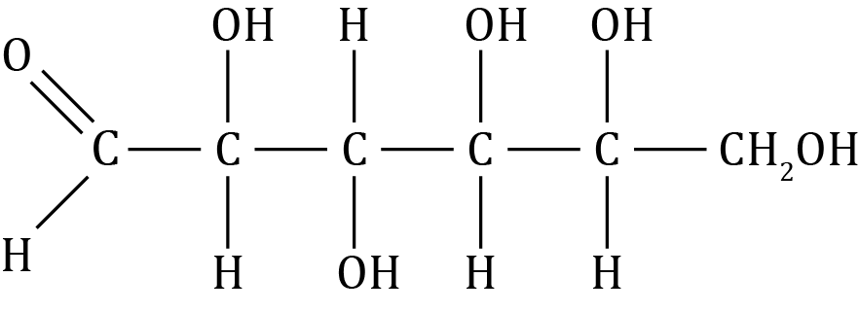

* 1. State the molecular formula of glucose.

____________________________________________________________________________

* 1. Calculate the percentage by mass of carbon in glucose.

*A*r carbon 12, *Ar* oxygen 16, *Ar* hydrogen 1

____________________________________________________________________________

____________________________________________________________________________

____________________________________________________________________________

* 1. Glucose reacts with oxygen in body cells to produce carbon dioxide and water only. State how many moles of carbon dioxide one mole of glucose produces.

____________________________________________________________________________

* 1. A carbon dioxide molecule can be represented as O=C=O. Give three pieces of information shown by this formula.

1. _____________________________________________________________________
2. _____________________________________________________________________
3. _____________________________________________________________________
4. Silicon dioxide is present in small amounts in our bodies. It is essential for skeletal health. The diagram shows part of the structure of silicon dioxide.

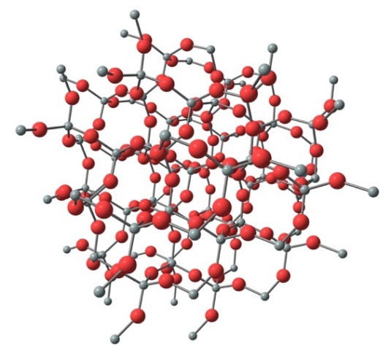

Source: © Shutterstock

* 1. Name this type of structure.

____________________________________________________________________________

* 1. State how many single covalent bonds each silicon atom makes.

____________________________________________________________________________

The melting point of silicon dioxide is 1710 °C.

* 1. State which bonds are broken when silicon dioxide melts.

____________________________________________________________________________

* 1. Explain why silicon dioxide has a high melting point.

____________________________________________________________________________

____________________________________________________________________________

1. Electric charges move around our bodies in our nervous system. Explain why the covalent substances glucose, amino acids and fatty acids are not used to conduct electrical charges.

____________________________________________________________________________

____________________________________________________________________________

____________________________________________________________________________

Which question(s) did you get wrong? Why?

What will you do next time you’re asked a similar question?