Melting and freezing stearic acid

Learning objectives

1. Determine the melting and freezing point of a sample of stearic acid by setting up and carrying out an experiment.
2. Carefully make temperature readings and record them in a table.
3. Plot and interpret a heating and/or cooling curve.
4. Use particle theory to explain what happens during melting and freezing.

Introduction

In this experiment, a solid turns into a liquid and then the liquid turns into a solid. The energy changes are examined.

Equipment

Apparatus

* Safety glasses
* Beaker (250 cm3)
* Boiling tube
* Thermometer (0–100°C)
* Stop clock
* Clamp, stand and boss
* Bunsen burner
* Tripod
* Gauze
* Heat resistant mat

Chemicals

* Stearic acid (octadecanoic acid) ) (less than 5 g)

Health and safety

* Wear eye protection
* Do not handle hot equipment

Method

1. Put about 150 cm3 water into the beaker.
2. Heat it on a tripod and gauze until the water just starts to boil.
3. Set up the apparatus as shown in the diagram and start the timer. Keep the water boiling, but not vigorously.
4. Using a suitable results table, record the temperature of the stearic acid every minute until it reaches about 80°C. Note on your results table the point at which you see the solid start to melt.
5. Use the clamp stand to lift the tube from the hot water. Record the temperature every minute as the stearic acid cools until it reaches about 30°C. Note on your results table the temperature at which you see the stearic acid begin to solidify,

Diagram

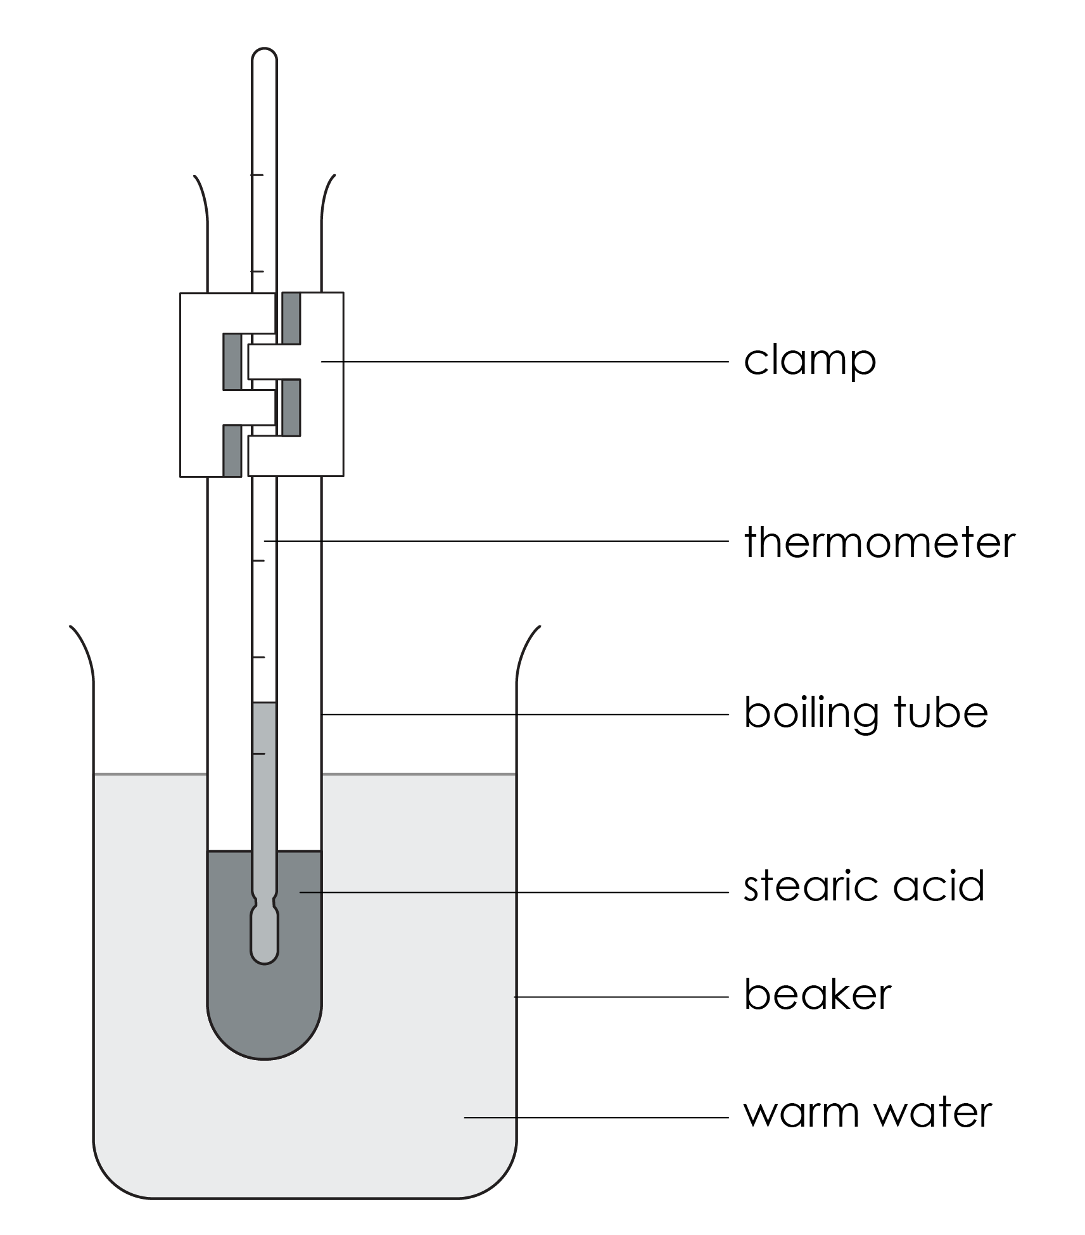

Results table

|  |  |  |
| --- | --- | --- |
| **Time  (minutes)** | **Temperature (°C)** | **Observations** |
|  |  |  |
|  |  |  |
|  |  |  |
|  |  |  |
|  |  |  |
|  |  |  |
|  |  |  |
|  |  |  |
|  |  |  |
|  |  |  |
|  |  |  |
|  |  |  |
|  |  |  |
|  |  |  |
|  |  |  |
|  |  |  |
|  |  |  |
|  |  |  |
|  |  |  |
|  |  |  |
|  |  |  |
|  |  |  |
|  |  |  |
|  |  |  |
|  |  |  |

Questions

1. Plot a graph of the results on the axes provided and draw a line of best fit.

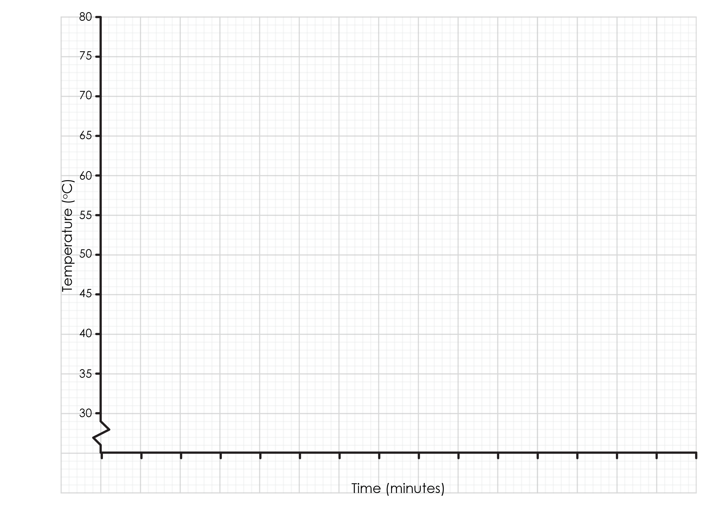

1. Describe the shape of the line graph you have drawn.

__________________________________________________________________________________

__________________________________________________________________________________

__________________________________________________________________________________

__________________________________________________________________________________

1. Label the parts of that graph that show stearic acid:
2. as a solid
3. as a liquid
4. melting
5. freezing
6. Use your graph to determine the:
7. melting temperature
8. freezing temperature
9. Draw a line from each particle diagram to the correct label:

|  |  |  |
| --- | --- | --- |
| Twenty five grey circles arranged in a regular structure of five columns and five rows with all the circles touching their neighbours to either side and above and below. |  |  |
|  |  | **Liquid stearic acid** |
| Six grey circles which are not touching each other and are spread out in an irregular arrangement. |  |  |
|  |  | **Solid stearic acid** |
| Twenty grey circles filling the bottom 2/3rds of the outline of a beaker. They are not in a regular arrangement but most are touching and slightly overlapping each other. |  |  |

1. Complete the sentences using the words below. The same word can be used more than once and some words may not be needed.

**form overcome regular irregular increases**

**decreases stays the same vibrate shape freezing**

**melting slowly quickly gas solid liquid**

In solid stearic acid, the particles are very close together in a ________________ pattern. The particles ________________ around a fixed position. Solids have a fixed ________________. As the temperature increases, the kinetic energy of the particles in the solid ________________ and so the particles vibrate faster.

During ________________, the forces of attraction between the particles are ________________ by the kinetic energy of the particles. The particles are now free to move. They are in the ________________ state.

As the temperature increases, the kinetic energy of the particles in the liquid increases and so the particles move more ________________.