**Alcohols: knowledge check**

1. The table shows four different representations of a molecule of the alcohol ethanol.

Use the words provided to identify each of the representations and circle the alcohol functional group shown in each image. One representation and one alcohol functional group has been identified for you.

**displayed structural formula molecular formula ball and stick model**

|  |  |  |  |
| --- | --- | --- | --- |
| **A**  There is a photograph of a model of a molecule on a grey background. From left to right, there is a large black sphere connected to three smaller white spheres and also attached to another large black sphere. That black sphere is attached to two smaller white spheres and one medium sized red sphere. The red sphere is connected to one small white sphere. There is a circle around the red sphere attached to a while sphere indicating that this is an alcohol functional group. | **B**  **There is a diagram showing two letters C in the middle joined by a single line. The left hand C has three letters H joined to it by single lines. The right hand C has two letters H joined to it by single lines and a letter O joined to it by a single line. The letter O then has a letter H joined to it by a single line.** | **C**  CH3CH2OH | **D**  C2H5OH |
|  |  | **condensed structural formula** |  |

1. The table on page 2 includes the names, molecular formulas, condensed structural formulas and displayed structural formulas for the first four members of the alcohols homologous series.

Use the formulas provided to complete the table.

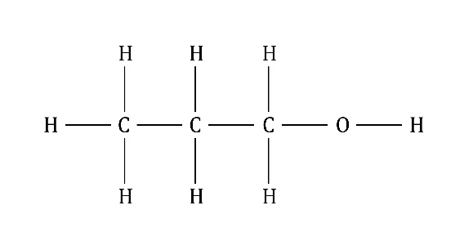 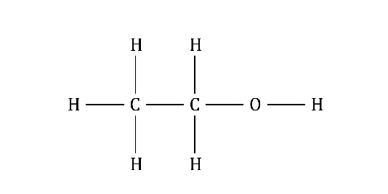 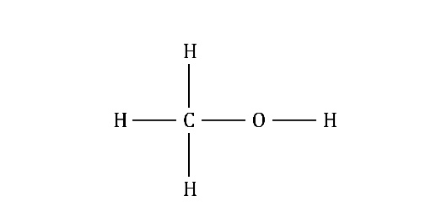

**CH3OH C4H9OH C2H5OH CH3CH2CH2OH**

|  |  |  |  |
| --- | --- | --- | --- |
| **Name** | **Molecular formula** | **Condensed structural formula** | **Displayed structural formula** |
| methanol |  | CH3OH |  |
| ethanol |  | CH3CH2OH |  |
| propan-1-ol | C3H7OH |  |  |
| butan-1-ol |  | CH3CH2CH2CH2OH | There is a diagram showing four letters C in the middle joined by  single lines. The left hand C has three letters H joined to it by single lines. The two middle Cs have two letters H joined to them by single lines and the right hand C has two letters H joined by single lines and a letter O joined to it by a single line. The letter O then has a letter H joined to it by a single line. |

1. Select the correct term from the brackets to complete the sentences.

Alcohols are a homologous series with the functional group [**COOH/OH**].

The general formula of alcohols is [**C*n*H2**n **+ 1OH/C*n*H2*n*OH**]**.**

All alcohols have names ending in [–**al**/–**ol**].

Alcohols with three or more carbon atoms in their molecules have [**letters**/**numbers**] in their names to show the position of the –OH group.

The [**chemical**/**physical**] properties of alcohols, such as boiling points, vary gradually as the molecules increase in size.

1. Select the correct number or words from those provided in the list to complete the sentences and equations. Some may be used twice.

**ethanoic acid hydrogen 2 3**

**combustion chemical oxidised C2H5OH**

All alcohols have similar __________________ properties.

Alcohols reacts with oxygen in __________________ reactions. The equation for the complete combustion of ethanol is:

C2H5OH + ­_________ ­­­­­O2 → _________CO2 + _________H2O

If a small piece of sodium is dropped into an alcohol, it reacts steadily and gives off __________________ gas. A solution of sodium ethoxide is produced.

Alcohols can also be __________________ to form carboxylic acids using an oxidising agent such as potassium manganate(VII).

The equation for the oxidation of ethanol is:

__________________ + 2[O] → CH3COOH + H2O

The carboxylic acid produced is named ____________________________________ .

**Alcohols: test myself**

1. Which compound is an alcohol?

**ethanoic acid decan-1-ol propane ethanal propanone**

1. A molecule of pentan-1-ol has five carbon atoms.

What is its molecular formula?

**C4H9OH C5H10OH C5H11OH C6H13OH**

1. What is the name of the carboxylic acid produced when butan-1-ol is oxidised?

**ethanoic acid butanoic acid hydrochloric acid propanoic acid**

1. What are the two missing products in the equation representing the oxidation of propan-1-ol?

**O2 CH3CH2COOH CH3COOH CH3CH2OH H2O**

CH3CH2CH2OH + 2[O] → __________________ + __________________

1. Use the numbers and formulas provided to complete the balanced symbol equation for the complete combustion of propan-1-ol.

**2 6 8 9 CO2 H2O**

_______________C3H7OH +_______________O2 → _______________ + _______________

1. Ethanol can be produced industrially from ethene gas. What is ethene reacted with to produce ethanol in this process?

**steam hydrogen ethanoic acid oxygen**

1. Ethanol can also be produced from biomass such as sugar beet.
   1. What is the name of the process used?

**hydration hydrogenation combustion fermentation**

* 1. Select the three conditions, from those provided, that are required to produce ethanol from biomass.

**temperature between 0 and 20°C temperature between 25 and 35°C**

**temperature between 50 and 60°C addition of protein**

**addition of sugar solution addition of solid sugar addition of yeast**

The conditions are:

1. _____________________________________________________________________
2. _____________________________________________________________________
3. _____________________________________________________________________
4. Ethanol can be separated from a mixture of ethanol and water.
   1. What is the name of the process used to separate the ethanol?

**evaporation fractional distillation crystallisation filtration**

* 1. What difference in property does the separation of ethanol and water depend on when using the method identified in (a)?

**boiling points solubilities densities reactivity**

**Alcohols: feeling confident?**

1. The image shows the apparatus used by learners to prepare a solution of ethanol.

There is one boiling tube and one test tube connected by a thin tube. The boiling tube on the left is three-quarters full of a yellowish liquid. On top of that liquid is a thin pale brown layer. The tube is stoppered, with a thin tube starting above the liquid layers, going through the stopper. The tube leads to an open test tube on the right. The test tube is about half full of a pale blue liquid. The open end of the tube finishes under the blue liquid.

Use the words provided to label the apparatus and complete the sentences to describe this process.

**enzymes carbon dioxide limewater**

**yeast and glucose solution CO2 oil layer catalyst milky**

The __________________ in yeast act as a __________________ and convert glucose into ethanol and __________________ . The gas produced bubbles through the limewater and turns it __________________ . The equation for the reaction is:

C6H12O6 → 2C2H5OH + __________________

1. The graph shows how the solubility of alcohols in water changes as the number of carbon atoms in the molecules increase.

Use the graph to answer the following questions.

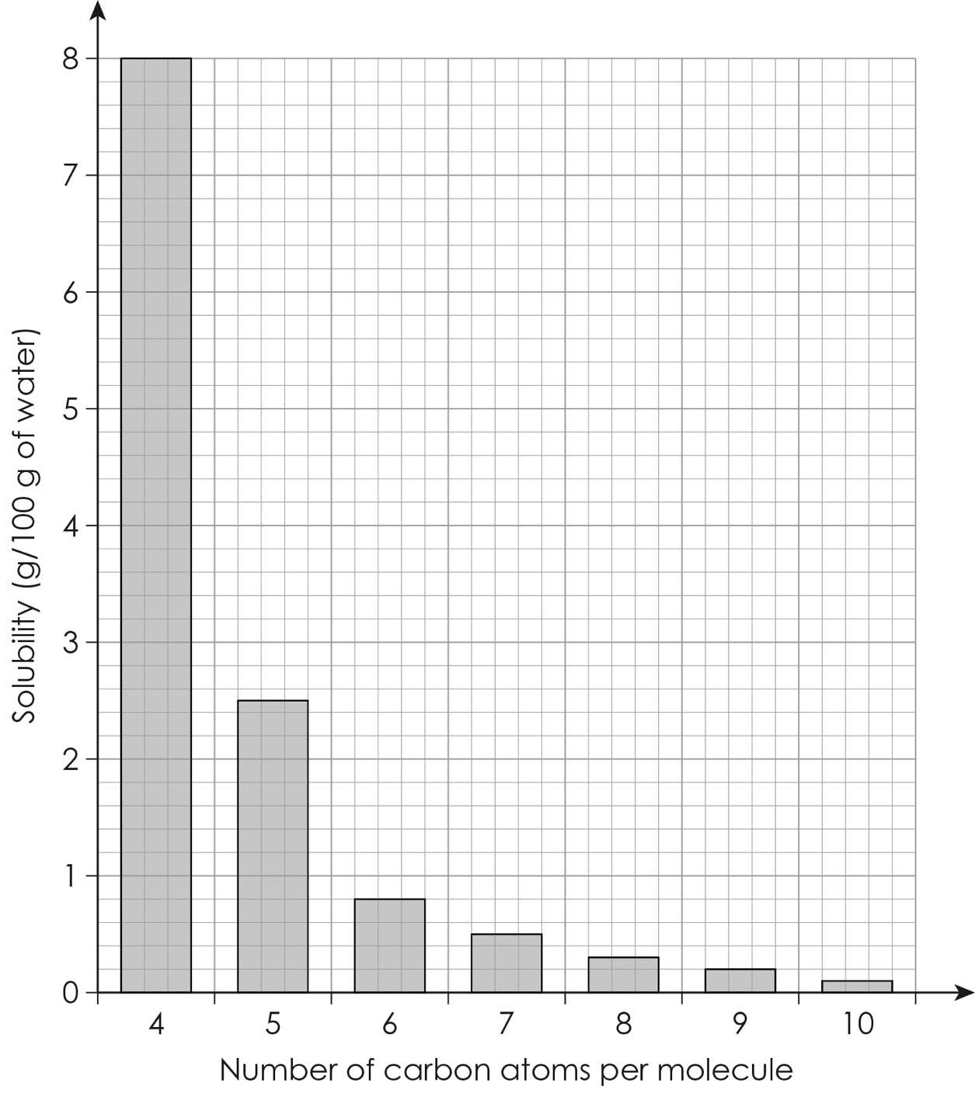

* 1. Which is more soluble in water, butan-1-ol (with four carbon atoms per molecule) or hexan-1-ol (with six carbon atoms per molecule)?
  2. How many grams of pentan-1-ol (with five carbon atoms per molecule) dissolve in 100 g water?
  3. What conclusion can be made about the relationship between the number of carbon atoms per molecule and the solubility of the alcohol?

As the number of carbon atoms per molecule increases, the solubility of the alcohol ____________________________________________________________

* 1. What would you expect to see when decan-1-ol (with ten carbon atoms per molecule) is mixed with water?

I would expect to see _________________________________________ because

**Alcohols: what do I understand?**

Think about your answers and confidence level for each mini-topic. Decide whether you understand it well, are unsure or need more help. Tick the appropriate column.

|  |  |  |  |
| --- | --- | --- | --- |
| **Mini-topic** | **I understand  this well** | **I think I understand this** | **I need more  help** |
| I know that alcohols are a homologous series. |  |  |  |
| I can identify the functional group and molecular and general formulae of alcohols. |  |  |  |
| I can draw the condensed structural and displayed structural formulas of alcohols. |  |  |  |
| I understand how alcohols are named. |  |  |  |
| I can describe the combustion reactions of alcohols. |  |  |  |
| I can describe the reactions of alcohols with sodium metal and with oxidising agents. |  |  |  |
| I can describe how ethanol is produced industrially. |  |  |  |
| I can describe the process of fermentation. |  |  |  |
| **Feeling confident? topics** | **I understand  this well** | **I think I understand this** | **I need more  help** |
| I can answer extending questions on fermentation. |  |  |  |
| I can describe the solubility of alcohols. |  |  |  |