F4 Modelling radioactive decay

Revision: fusion and nuclear equations

1. A student writes this equation for a nuclear reaction. Identify two errors.

1. Another student writes this equation for a nuclear reaction. What are the errors?
2. Suggest a corrected equation for the fusion reaction in (b).
3. Complete the nuclear equations shown below by adding the correct nucleus/particle to the line.
4. Write an equation using nuclear symbols to show the fusion of helium-3 and lithium-6 to produce two nuclei of helium-4 and another product (you’ll need to work out what this is).
5. Explain why all the reactions in parts a) and b) are examples of nuclear fusion.
6. Temperatures in the core of the Sun are approximately 15,000,000°C and the pressure is high enough to compress the plasma to a density of about 160 g cm-3. Explain why these conditions are needed.

Graph drawing

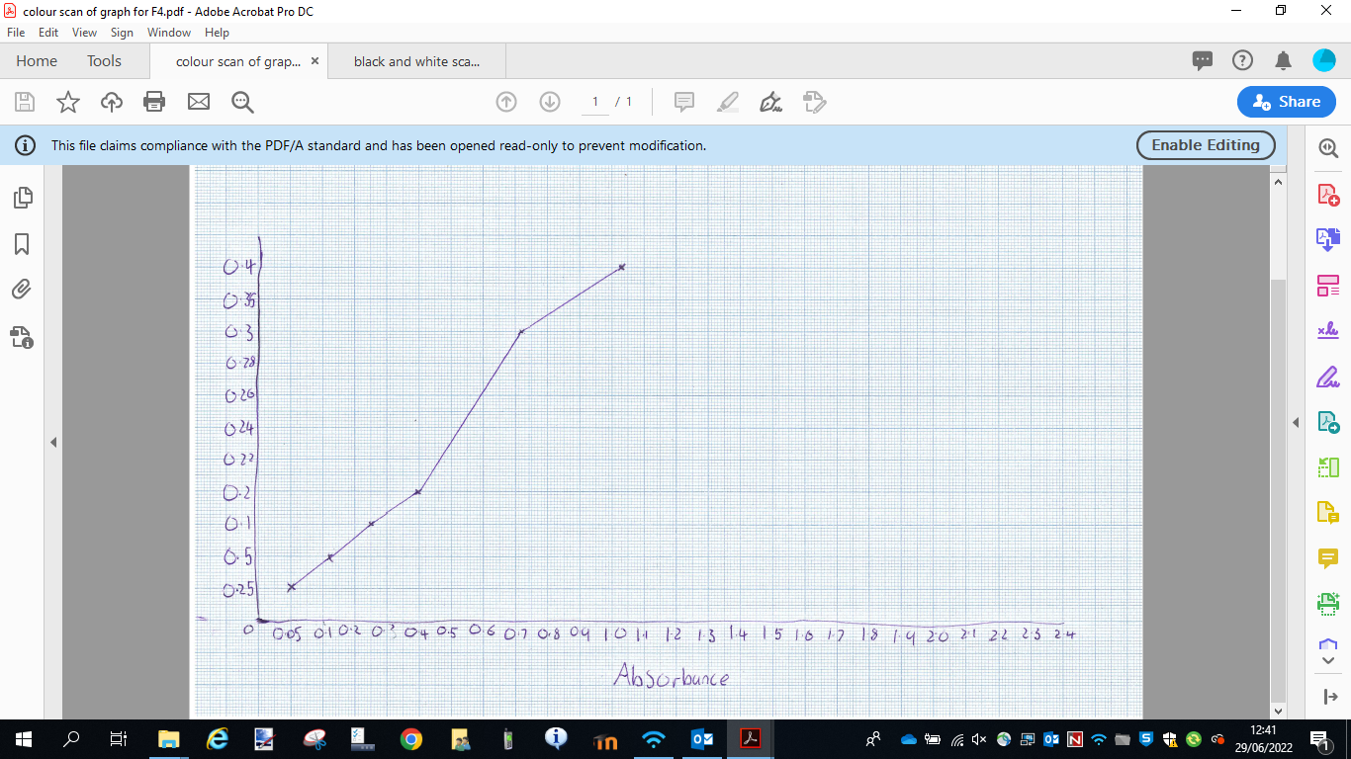Look at this student graph. Can you identify at least four errors with the graph?

|  |  |
| --- | --- |
| **Concentration of copper(II) nitrate solution (mol dm-3)** | **Absorbance** |
| 0.025 | 0.05 |
| 0.050 | 0.12 |
| 0.100 | 0.25 |
| 0.200 | 0.40 |
| 0.300 | 0.72 |
| 0.400 | 1.03 |

Using the data shown and the graph paper below, plot an improved version.

