Microscale titration

These technician notes are part of a collection of microscale chemistry resources at: [rsc.li/4iiIjbl](https://rsc.li/4iiIjbl). Integrated instructions for both gravimetric and volumetric titration are available from [rsc.li/4icIogx](https://rsc.li/4icIogx).

Introduction

Introduce learners aged 11–16 to the principle of titration without the cognitive load of a full-scale set up.

Microscale titrations can be gravimetric (measuring the mass of the reaction vessel before and after) or volumetric (measuring the volume by counting the drops of solution added).

Equipment (per group)

* 1 x beaker, 10 cm3 or small vial
* 1 x white tile
* 1 x clamp stand
* 1 x plastic pipette (preferably a fine-tipped pipette)
* 1 x measuring cylinder (10 cm3)
* 1 x mass balance (to 0.01 g)
* Vinegar solution (shop-bought, diluted by a factor of 4), 1 cm3
* Phenolphthalein solution (0.05%), 1 drop
* Sodium hydroxide solution (0.2 mol dm-3), 10 cm3

Safety equipment

Eye protection: safety glasses to EN166F

Equipment set-up

Dilute shop-bought vinegar by a factor of four (by taking 25 cm3 of vinegar and making up to 100 cm3 with water).

Method

Gravimetric titration

1. Add 1 drop of phenolphthalein to the small beaker and record its mass.
2. Using a measuring cylinder, measure out 1 cm3 of diluted vinegar and add it to the beaker. Record its mass.
3. Fill the plastic pipette with NaOH solution and clamp it gently.
4. Place the beaker below the pipette.
5. Carefully tighten the clamp to add one drop of NaOH solution to the beaker at a time.
6. Swirl the beaker.
7. Add NaOH solution dropwise until a permanent pink colour is formed.
8. Record the mass of the beaker.

Volumetric titration

1. Add 1 drop of phenolphthalein to a small beaker or vial.
2. Add ~1 cm3 of vinegar to the same beaker.
3. Fill a dropping pipette with sodium hydroxide solution (around 0.2 M).
4. Clamp the pipette gently.
5. Tighten the clamp carefully until 1 drop of NaOH is added to the beaker/vial.
6. Swirl the beaker/vial.
7. Repeat steps 5 and 6 (counting the number of drops added) until a pale permanent pink colour is seen.

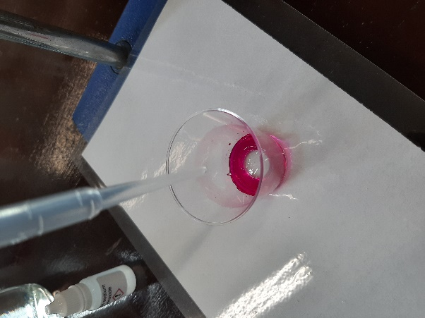

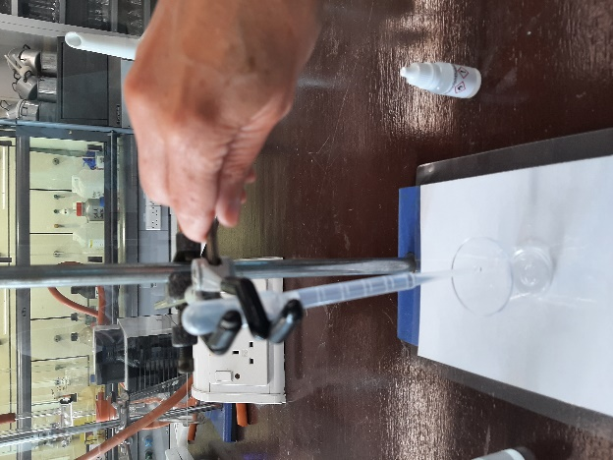A close-up of a pipette containing solution held by a clamp


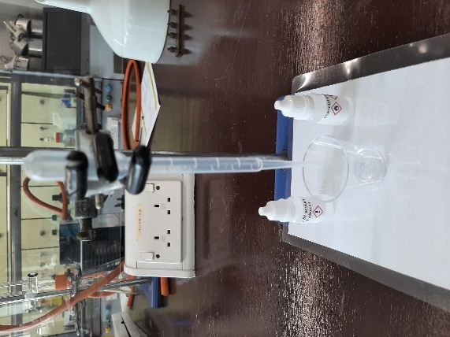

Safety

* [Read our standard health and safety guidance](https://edu.rsc.org/resources/explaining-our-health-and-safety-guidance/1752.article) and carry out a risk assessment before running any live practical.
* Refer to SSERC/CLEAPSS Hazcards and recipe sheets.
* Hazard classification may vary depending on supplier.

|  |  |
| --- | --- |
| **Chemical supplied for the practical** | **Preparation** |
| Vinegar  Not classified as hazardous. | Vinegar  Dilute shop-bought vinegar by a factor of four (by taking 25 cm3 of vinegar and making up to 100 cm3 with water). |
| **Chemical supplied for the practical** | **Preparation** |
| Sodium hydroxide, 0.2 mol dm-3 NaOH(aq)    WARNING Irritant (skin, eyes).  CLEAPSS Hazcard 091A. | Sodium hydroxide  NaOH(s) (40.0 g mol-1)  This substance is dangerous in contact with  WATER (a vigorous exothermic reaction occurs), ZINC, ALUMINIUM (hydrogen evolved).    Five-fold dilution of the 1 M solution.  CLEAPSS recipe sheet RB085. |
| Phenolphthalein 0.05% solution    WARNING  Flammable  CLEAPSS Hazcard 032. | Phenolphthalein, solid  DANGER    May include a risk of one or more hazard statements including, but not limited to:  May be fatal/toxic if inhaled or in contact with skin or eyes.  May cause breathing difficulties if inhaled.  May damage fertility or the unborn child.  Check CLEAPSS Hazcard 032 for most up to date guidance.  Ethanol (and IDA)  WARNING  Flammable    CLEAPSS Hazcard 040A.  Prepare solution following CLEAPSS recipe sheet RB046. |

Disposal

Rinse the aqueous solutions down a foul-water drain with plenty of water.

Acknowledgements

This resource is based on a method developed by CLEAPSS, PP019 Analysis of vinegar (small scale), available at [science.cleapss.org.uk](https://science.cleapss.org.uk/).

Images © Royal Society of Chemistry.