Recycling plastics – is it worth it?

Learning objectives
- Reinforce your knowledge and understanding of recycling plastics and life cycle assessments.
- Practise your evaluation and extended writing skills.
- Practise your maths skills in the context of scientific problems.

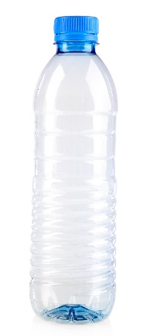
Introduction

Source: © Shutterstock

More and more plastics are recycled these days, which is certainly much better than them ending up in landfill or the oceans. Since 2018 less than 25% of waste has been landfilled in the UK and this amount is decreasing each year. Instead of landfill, an increasing proportion of waste is being incinerated (burned) at high temperatures. Modern incinerators use some of the energy from combustion to generate electricity.

In this activity you will evaluate a life cycle assessment for the manufacture and disposal of a two-litre bottle to discover the arguments for and against landfill, recycling and incinerating plastics.

Worksheets provided
- Recycling plastic bottles – background information

Read this before you attempt the rest of the activity.
- Life cycle assessments for a two-litre drink bottle made from PET

Data sheet to use when answering the questions.
- Questions

Answer these questions using the data sheet provided. The activity is in two parts. Check with your teacher when to attempt each part.

Recycling plastic bottles – background information

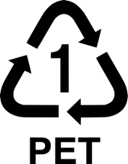
Most two-litre drink bottles are made of poly(ethylene terephthalate), or PET for short. It is particularly suitable for the purpose because it:
- is cheap to produce,
- has a low density,
- is rigid enough to keep the shape of the bottle,
- is nonporous, so does not let dissolved gases escape.

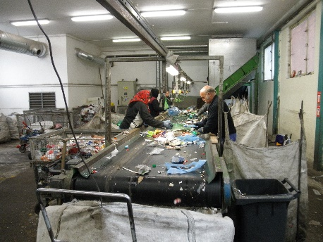
Most PET is manufactured by the polymerisation of chemicals made by distillation and cracking of crude oil. These processes require a lot of energy and release greenhouse gases into the atmosphere. More energy is then needed to mould the PET into the bottles.

Source: © Michal Maňas (CC BY 3.0)

When a consumer finishes using a plastic bottle, they usually throw it away into a general waste bin or a plastics recycling bin. At a materials recovery facility (MRF), the different types of plastic are sorted and any other materials removed if possible.
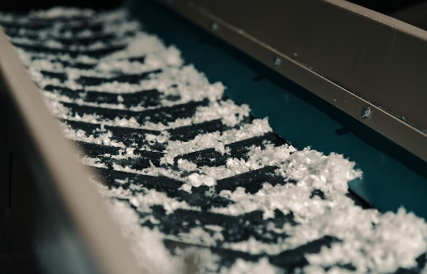

Source: © Green tress (CC BY-SA 4.0)

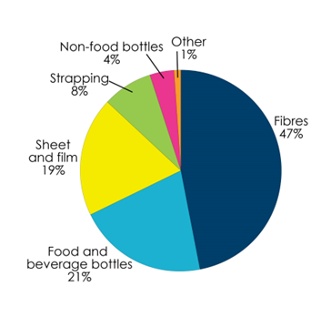
The used PET bottles are then crushed, washed, shredded and melted to turn them into flakes or pellets that can be used to make new products.

Recycled PET use by product category

Source: redrawn © Wood Mackenzie Ltd, https://www.plasticsnews.com/fyi-charts/recycled-pet-use-product-category, (accessed 5 March 2023).

Most recycled PET goes to make fibres for clothing. Other uses include plastic sheets and straps.

Some is used to make new bottles. If you want the bottle to be as strong and transparent as the original bottle, you have to mix the recycled PET with new plastic. Factories typically use a mixture of 35% recycled PET and 65% new PET made from crude oil.

Life cycle assessments for a two-litre drink bottle made from PET

Table 1 summarises the raw materials, energy use and greenhouse gas emissions over the life cycle of a 100 $g$ bottle made of PET. It allows you to compare how the assessment changes when the PET is disposed by landfill, incineration and recycling.

You will need to complete two of the rows relating to energy (see question sheet).

Table 1 Life cycle assessments for a 100 $g$ PET bottle for three different methods of disposal
Stage of the life cycle |  | Disposal by landfill | Disposal by incineration | Disposal by recycling
Raw materials for new bottles |  | 100% fossil fuels | 100% fossil fuels | 65% fossil fuels + 35% recycled plastic
Energy use / $kJ$ per 100 $g$ bottle | Extraction and processing of raw materials | 6500 | 6500 | 4300
 | Manufacture and transport of new bottles | 1500 | 1500 | 1500
 | Transport and disposal of used bottles | 10 | -400 * | 200
 | Total energy used | 8010
 | % Energy saved compared to landfill | 0
Total greenhouse gases emitted / $g {CO}_{2}$ per 100 $g$ bottle |  | 450 | 680 | 360

* Note that the energy use for disposal by incineration is negative because the energy of combustion outweighs the energy used for transport and the incinerator.

Table 2 Other problems and possible improvements for three methods of PET disposal
 | Disposal by landfill | Disposal by incineration | Disposal by recycling
Other problems with the method of disposal | Very little space is now left for landfill | Toxic gases are produced during combustion | Recycling bins are not always available
Other possible improvements to the environmental impact of the method | Develop better biodegradable plastics | Add carbon capture technology to the incinerator | Only make products that can use 100% recycled PET

Questions

Part 1
- Complete the two rows in Table 1 relating to energy use as follows.
- Use the data above the total energy row to calculate the total energy used when the PET bottle is incinerated and when it is recycled.
- Use the data in the total energy row to calculate the percentage energy saved compared to landfill when the bottle is incinerated and when it is recycled.

(4 marks)
- Using only the data in Table 1, evaluate the environmental impact of the three methods of disposal with regard to raw materials, energy use and greenhouse gas emissions.

______________________________________________________________________________

______________________________________________________________________________

______________________________________________________________________________

______________________________________________________________________________

______________________________________________________________________________

______________________________________________________________________________

______________________________________________________________________________

______________________________________________________________________________

______________________________________________________________________________

______________________________________________________________________________

______________________________________________________________________________

______________________________________________________________________________

______________________________________________________________________________

______________________________________________________________________________

______________________________________________________________________________

______________________________________________________________________________

______________________________________________________________________________

______________________________________________________________________________

______________________________________________________________________________

______________________________________________________________________________

______________________________________________________________________________

(6 marks)

Part 2
- Define the meaning of the following terms used in Table 2.
- Renewable________________________________________________________________

______________________________________________________________________________

______________________________________________________________________________
- Biodegradable____________________________________________________________

______________________________________________________________________________

______________________________________________________________________________
- Carbon capture __________________________________________________________

______________________________________________________________________________

______________________________________________________________________________

(3 marks)
- Using the information in Table 2 and your answer to question 2, evaluate the advantages and disadvantages of the three methods of disposal.
______________________________________________________________________________

______________________________________________________________________________

______________________________________________________________________________

______________________________________________________________________________

______________________________________________________________________________

______________________________________________________________________________

______________________________________________________________________________

______________________________________________________________________________

______________________________________________________________________________

______________________________________________________________________________

______________________________________________________________________________

______________________________________________________________________________

______________________________________________________________________________

______________________________________________________________________________

______________________________________________________________________________

______________________________________________________________________________

______________________________________________________________________________

______________________________________________________________________________

(6 marks)
- Do you think this activity will change your approach to recycling the plastics you use? Select the most appropriate answer for you.
- No change – I already try hard to recycle any plastic items I use.
- I will try to recycle more plastic items in the future.
- No change – I will continue to recycle plastic items only when convenient.
- I will recycle fewer plastic items in the future.
- Other __________________________________________________________________

(1 mark for any honest answer)

Source: © Horners’ Charity Fund

Department for Environment, Food & Rural Affairs, Table 13: All waste at final treatment, UK, 2016-18, https://assets.publishing.service.gov.uk/government/uploads/system/uploads/attachment_data/file/1073652/Table_13.csv/preview, (accessed 4 March 2023).

