Representing elements and compounds: knowledge check

1. This diagram shows the chemical symbols of the elements included in the first part of the periodic table.

Use the words to label the diagram with the names of the elements.

**argon calcium carbon chlorine fluorine potassium**

This is the first part of the Periodic Table with elements to be labelled in column 1 row 3,  column 2 row 3,  column 14 row 1,  column 17 row 1, column 17 row 2 and column 18 row 3.

1. This model shows a molecule of the element chlorine. Cross out the incorrect answer for each statement.

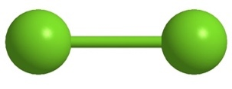

1. An element consists of **one type/two** **types** of atom only.
2. There are 92 naturally occurring **molecules/elements**.
3. A chemical symbol represents one atom of an element. For example, the symbol Ne represents one atom of **neon/sodium**.
4. Some elements naturally exist as two or more atoms bonded together to form **molecules/atoms**.
5. A molecule of chlorine gas has the chemical formula Cl2. The subscript ‘2’ shows that there **is one atom/are two atoms** of chlorine bonded together in one molecule.
6. Use the words provided in the word list to complete the sentences. Each word can be used more than once.

**one two three more molecule covalent**

1. A compound consists of two or __________________ different types of atoms bonded together.
2. Compounds with __________________ bonds form molecules.
3. A molecule of NH3 contains __________________ atom of nitrogen and __________________ atoms of hydrogen.
4. A molecule of C2H5OH contains __________________ atoms of carbon, six atoms of hydrogen and one atom of oxygen.
5. This model shows a __________________ of C2H5OH.

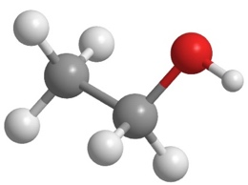

1. For each of the statements below, tick whether it is true or false.
2. Compounds with covalent bonding form ionic structures. **True False**

This model shows part of the ionic structure of sodium chloride:

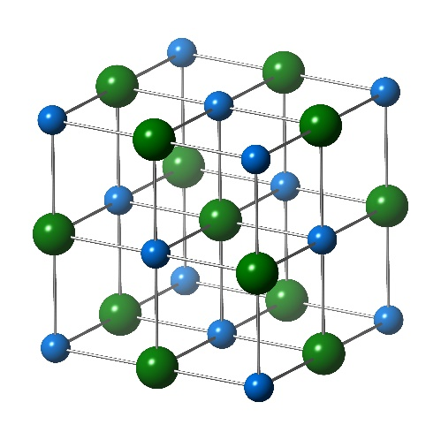

1. The ionic structure consists of many positive ions and many negative ions.

**True False**

1. The structure shows there is one sodium ion to every chloride ion.

**True False**

1. NaCl2 is the molecular formula for sodium chloride. **True False**
2. The compound magnesium chloride also has ionic bonding. Its chemical formula is MgCl2. An ionic structure of magnesium chloride contains two magnesium ions to every three chloride ions. **True False**

Representing elements and compounds: test myself

1. The chemical formula for naturally occurring sulfur is S8. Circle the type of particle that is S8.

**an atom a compound a molecule an ion**

1. Which of these chemical formulas represents an element? Circle the correct answer.

**CaO Ni NO NaOH SO2**

1. Which of these chemical formulas represents an element that exists as single atoms? Circle the correct answer.

**N2 HCl Ar NO I2**

1. Which two of these chemical formulas represent compounds? Circle the correct answers.

**NO N2 NH3 He** **Br2**

1. What is the formula of the molecule shown below?

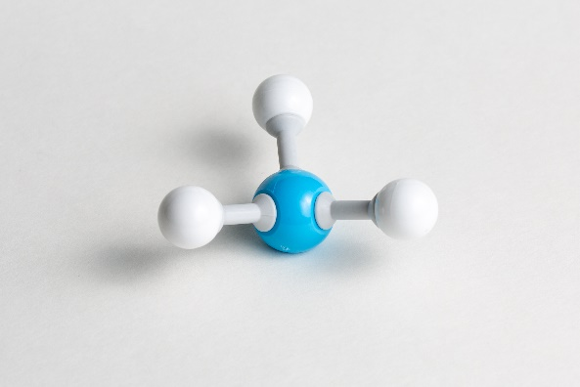

Circle the correct answer.

**NH3 CH4 SO2 HCl O3**

1. How many atoms of hydrogen are contained in one molecule of CH3COOH? [*Hint: Circle all the hydrogen atoms in the formula.*]
2. Magnesium oxide has ionic bonding. Its chemical formula is MgO.
3. How many magnesium ions are represented in the formula? __________________
4. How many oxide ions are represented in the formula? __________________
5. What is the ratio of magnesium to oxide ions? Circle the correct answer.

**one magnesium ion to one oxide ion**

**one magnesium ion to two oxide ions**

**two magnesium ions to one oxide ion**

**two magnesium ions to three oxide ions**

1. Sodium oxide also has ionic bonding. Its chemical formula is Na2O.
2. How many sodium ions are represented in the formula? __________________
3. How many oxide ions are represented in the formula? __________________
4. What is the ratio of sodium to oxide ions? Circle the correct answer.

**one sodium ion to one oxide ion**

**one sodium ion to two oxide ions**

**two sodium ions to one oxide ion**

**two sodium ions to three oxide ions**

1. Which of these images shows a model of an element? Circle the correct answer.

[*Hint: Think about how many types of atom are present in an element.*]

**A B**

[[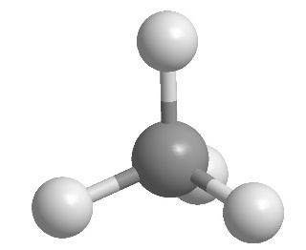](https://www.shutterstock.com/image-vector/methane-ch4-gas-molecule-stick-model-1738448798)](https://www.shutterstock.com/image-vector/methane-ch4-gas-molecule-stick-model-1738448798) 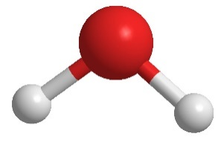

**C D**

[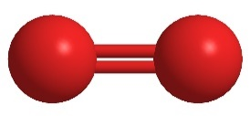](https://www.shutterstock.com/image-illustration/elemental-oxygen-o2-molecular-model-atoms-131939321) 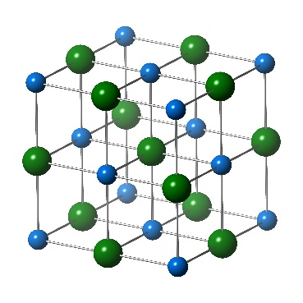

1. Look at the models in **question 2.9** again. Which image shows an ionic compound?

Representing elements and compounds:   
feeling confident?

1. Polymers, like poly(ethene), consist of large molecules. These are chains of atoms with repeating units. The formula for polyethene is written as:

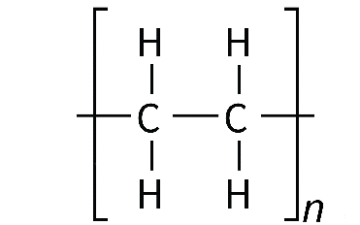

where *n* stands for a large number.

Complete the diagram to show a length of poly(ethene) chain six carbon atoms long.



1. The table shows four different ways of representing a molecule of the compound ammonia, NH3. The blue spheres represent nitrogen atoms and the white spheres represent hydrogen atoms.

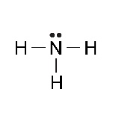Complete the table by adding a ✓ or a 🗶. The second row is done for you.

|  |  |  |  |  |
| --- | --- | --- | --- | --- |
|  | NH3 |  | A ball and stick model of ammonia - a larger central blue ball has three smaller white balls attached with sticks. | A model representing ammonia. It has one large blue sphere with three smaller white half spheres attached to it. |
| Does it show the different types of atoms? |  |  | ✓ |  |
| Does it show how the atoms are arranged? | 🗶 | ✓ | ✓ | ✓ |
| Does it show the molecule in three dimensions? |  |  |  |  |
| Does it show the chemical bonds? |  |  |  |  |

Representing elements and compounds:   
what do I understand?

Think about your answers and confidence level for each mini-topic. Decide whether you understand it well, are unsure or need more help. Tick the appropriate column.

|  |  |  |  |
| --- | --- | --- | --- |
| **Mini-topic** | **I understand  this well** | **I think I understand this** | **I need more  help** |
| I can write names of the elements from their chemical symbols. |  |  |  |
| I can write chemical formulas of elements. |  |  |  |
| I can write chemical formulas of simple molecular compounds. |  |  |  |
| I can write chemical formulas of ionic compounds. |  |  |  |
| I can use models to represent elements and compounds. |  |  |  |
| **Feeling confident? topics** | **I understand  this well** | **I think I understand this** | **I need more  help** |
| I can write the chemical formula of a polymer. |  |  |  |
| I can compare different types of representation. |  |  |  |