Atoms and isotopes

Introduction

These questions are designed to help you to develop your mental models (pictures in your head) of different isotopes. Use the icon in the margin to find out which level of understanding the question is developing.

|  |  |
| --- | --- |
| An icon used to indicate the Macroscopic part of Johnstone's triangle. | **Macroscopic:** what we can see. Think about the properties that we can observe, measure and record. |
| An icon used to indicate the Sub-microscopic part of Johnstone's triangle. | **Sub-microscopic:** smaller than we can see. Think about the particle or atomic level. |
| An icon used to indicate the Symbolic part of Johnstone's triangle. | **Symbolic:** representations. Think about how we represent chemical ideas including symbols and diagrams. |

Questions

1. A helium atom is made up of three types of subatomic particle.

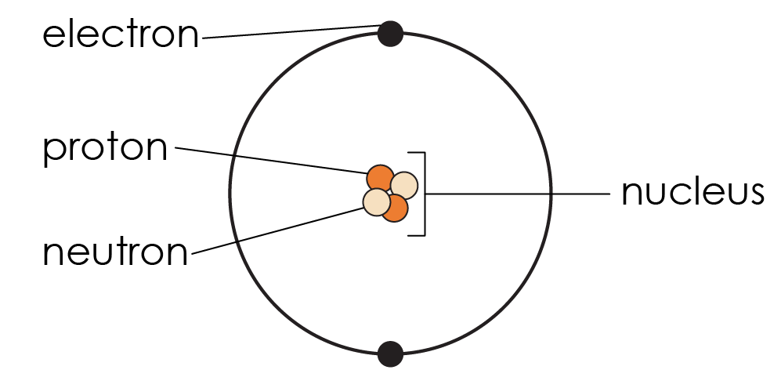

The subatomic particles are: protons, neutrons and electrons.

1. Name the two types of atomic particles that add to the mass of an atom.

__________________________________________________________________________________

1. Name the location of where these two particles are found.

__________________________________________________________________________________

1. The atomic number of helium is 2. Give the number of protons and electrons in the atom of helium:

* Number of protons ______
* Number of electrons _____

The mass number of helium is 4 because there are four subatomic particles in the nucleus of the atom.

1. Calculate the number of neutrons in an atom of helium. Show your working.

__________________________________________________________________________________

1. Complete the expression to how to calculate the number of neutrons in any atom.

Number of neutrons = __________________________ - __________________________



1. The atomic symbol of an element shows the element symbol, the mass number and the atomic number. The atomic symbol for helium is .

The mass number is shown at the top and is larger. The atomic number is shown at the bottom. Complete the table.

|  |  |  |  |  |  |
| --- | --- | --- | --- | --- | --- |
| **Atomic symbol** | **Mass number** | **Atomic number** | **Number of protons** | **Number of electrons** | **Number of neutrons** |
|  | 19 | 9 |  |  |  |
|  |  |  |  |  |  |
|  |  |  |  |  |  |



1. The diagrams show a lithium atom and a lithium ion.

|  |  |
| --- | --- |
| Seven circles, three are dark orange and these are labelled 'proton', four of the circles are light orange and these are labelled 'neutron'. This is surrounded by two larger concentric circles. On the inner large circle there are two black dots, one at the top and one at the bottom. On the largest of thetwo concentric circles is one black dot at the top. | Seven circles, three are dark orange and these are labelled 'proton', four of the circles are light orange and these are labelled 'neutron'. This is surrounded by one larger circle on which there are two black dots, one at the top and one at the bottom. |
| A | B |

1. For each diagram state the number of protons, electrons and neutrons.

**A** protons = ______ electrons = ______ neutrons = _____

**B** protons = ______ electrons = ______ neutrons = _____

1. Each proton has +1 charge. Each electron has -1 charge. Calculate the overall charge of A and B.

**A** ____________________________________________________________

**B** ____________________________________________________________

1. State which diagram shows a lithium ion.
2. Atoms with the same number of protons but different numbers of neutrons are called isotopes.

|  |  |  |
| --- | --- | --- |
| Seven circles, four are dark orange and these are labelled 'proton', three of the circles are light orange and these are labelled 'neutron'. This is surrounded by two larger concentric circles. On the inner large circle there are two black dots, one at the top and one at the bottom. On the largest of the two concentric circles are another two black dots, one at the top and one at the bottom. | Seven circles, three are dark orange and these are labelled 'proton', three of the circles are light orange and these are labelled 'neutron'. This is surrounded by two larger concentric circles. On the inner large circle there are two black dots, one at the top and one at the bottom. On the largest of the two concentric circles is one black dot at the top. | Seven circles, four are dark orange and these are labelled 'proton', two of the circles are light orange and these are labelled 'neutron'. This is surrounded by two larger concentric circles. On the inner large circle there are two black dots, one at the top and one at the bottom. On the largest of thetwo concentric circles are another two black dots, one at the top and one at the bottom. |
| C | D | E |

Give the number of protons, electrons and neutrons in each atom diagram.

**C** protons = ______ electrons = ______ neutrons = _________

**D** protons = _______ electrons = _______ neutrons = _______

**E**  protons = _______ electrons = _______ neutrons = ________

1. Identify the diagram that shows an isotope of lithium. Give reasons for your answer.

__________________________________________________________________________________

__________________________________________________________________________________

__________________________________________________________________________________

1. The most common isotope of carbon is but other isotopes exist.

The table shows the number of protons and neutrons in three different atoms X, Y and Z.

|  |  |  |
| --- | --- | --- |
| **Atom** | **Number of protons** | **Number of neutrons** |
| **X** | 6 | 8 |
| **Y** | 6 | 7 |
| **Z** | 7 | 7 |

Write the atomic symbol for:

|  |  |  |
| --- | --- | --- |
| (a) | atom X |  |
|  |  |  |
| (b) | atom Y |  |

1. Explain why atom Z is not an isotope of carbon.

__________________________________________________________________________________

__________________________________________________________________________________

1. Use the periodic table to identify the element of atom Z.

__________________________________________________________________________________

1. Write the atomic symbol for atom Z.