Atomic structure

This resource is from the **Johnstone’s triangle** series, which can be viewed at: [rsc.li/43oqC3A](https://rsc.li/43oqC3A). In this series you will also find our **Atomic structure: Johnstone’s triangle** worksheet which introduces the triangle in the context of the atomic structure of lithium and can be viewed at: [rsc.li/3FQU8GX](https://rsc.li/3FQU8GX).

Learning objectives

|  |  |  |
| --- | --- | --- |
| **LO** | **Objective** | **Where assessed** |
| **1** | Use atomic number and mass number to work out the number of different sub-atomic particles in an atom. | Q1 (a) and (b) |
| **2** | Label the different parts of an atom as represented using the atomic model. | Q1 (c) |
| **3** | Recall the charges of different sub-atomic particles and use these to explain the overall positive charge of the nucleus and overall lack of charge of an atom. | Q2 |
| **4** | Use appropriate models of the atom to create explanations. | Q3 |

How to use the resource

This resource aims to develop learners’ understanding of the structure of an atom. The questions encourage learners to think about how the structures are represented and what this means at the sub-microscopic level. As a result, learners should develop more secure mental models to support their thinking about this topic.

|  |  |  |  |  |
| --- | --- | --- | --- | --- |
| **When to use?** | Enter with solid fill Introduce | Watering pot with solid fill **Develop** | Arrow circle with solid fill **Revise** | Clipboard Mixed with solid fill Assess |
| Use after initial teaching or discussion of this topic to develop ideas further. You can also use as a revision activity. | | | |
| **Group size?** | Head with gears with solid fill **Independent** | Group brainstorm with solid fill **Small group** | Classroom with solid fill **Whole class** | Work from home house with solid fill **Homework** |
| Suitable for independent work either in class or at home. Or use the questions for group or class discussions. | | | |
| **How long?** | Stopwatch 25% with solid fillArrow Right outlineStopwatch 50% with solid fill | | 15–30 mins | |

Johnstone’s triangle

Johnstone’s triangle is a model of the three different conceptual levels in chemistry: macroscopic, sub-microscopic and symbolic. You can use Johnstone’s triangle to build a secure understanding of chemical ideas for your learners.

Find further reading about Johnstone’s triangle and how to use it in your teaching at [rsc.li/4krDQmW](https://rsc.li/4krDQmW).

Johnstone’s triangle and this resource

The icons in the margin indicate which level of understanding each question is developing to help prompt learners in their thinking.

|  |  |
| --- | --- |
| An icon used to indicate the Macroscopic part of Johnstone's triangle. | **Macroscopic:** what we can see. Think about the properties that we can observe, measure and record. |
| An icon used to indicate the Sub-microscopic part of Johnstone's triangle. | **Sub-microscopic:** smaller than we can see. Think about the particle or atomic level. |
| An icon used to indicate the Symbolic part of Johnstone's triangle. | **Symbolic:** representations. Think about how we represent chemical ideas including symbols and diagrams. |

The levels are interrelated, for example, learners need visual representation of the sub-microscopic to develop mental models of the particle or atomic level. Our approach has been to apply icons to questions based on what the learners should be thinking about.

Questions may be marked with two or all three icons, indicating that learners will be thinking at more than one level. However, individual parts of the question may require learners to think about only one or two specific levels at a time.

Support

This worksheet is ramped so that the earlier questions are more accessible. The activity becomes more challenging in the later questions. You can give extra explanations for the more challenging questions. If completing as an in-class activity it is best to pause and check understanding at intervals, as often one question builds on the previous one.

It is useful for learners to observe macroscopic properties first-hand. You could circulate examples of substances in the classroom, run a class practical of a chemical reaction or show a teacher demonstration of properties.

Give learners physical models to use and manipulate, such as a Molymod kits or counters.

Additional support may be needed for any learners still lacking in confidence in the required symbolic representation, for example by sharing and explaining a diagram or a simulation that can show movement of the particles.

An icon indicating that question one uses the sub-microscopic and symbolic parts of Johnstone's triangle.Answers

1. *Guidance note:* This question consolidates learners’ understanding of the different types of each sub-atomic particle (sub-microscopic understanding) and how the number of each can be worked out from the atomic number and mass number. This question also requires learners to label each type of sub-atomic particle, the nucleus and electron levels on a standard atomic model diagram (symbolic understanding).
2. The atomic number gives the number of positive **protons** and the number of negative **electrons**. The mass number minus the atomic number gives the number of **neutrons**.

|  |  |
| --- | --- |
| **3** | protons |
| **3** | electrons |
| **4** | neutrons |

1. 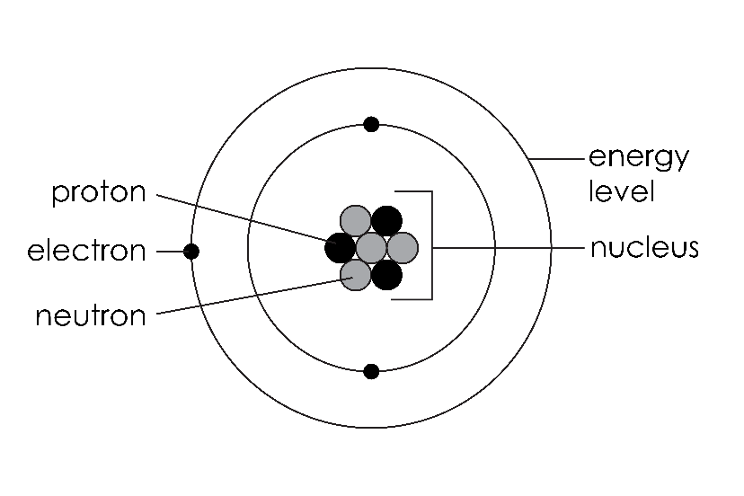

1. *Guidance note:* This question develops learners’ understanding of the connection between the charge of individual particles, the overall charge of the nucleus and the whole atom (sub-microscopic understanding) and the type of force between the nucleus and electrons.

|  |  |
| --- | --- |
| **Charge** | **Sub-atomic particle** |
| positive | proton |
| negative | electron |
| no charge | neutron |

1. The nucleus is made up of positive protons and neutrons which have no charge. So, overall, a nucleus has a positive charge.
2. An atom has the same number of positive protons and negative electrons so overall the charge is zero.
3. Electrostatic.
4.  *Guidance note:* This question develops learners’ understanding of how helium can be represented by both the particle model and atomic model (symbolic understanding) and which model can best explain (sub-microscopic understanding) physical properties of helium (macroscopic understanding) and why helium atoms have no overall charge. This question aims to illustrate the importance of using the most appropriate model to explain a given phenomenon.
5. The atoms of helium are free to move about and can spread out to fill a container.
6. A helium atom has two negative electrons and two positive protons, so its overall charge is zero.
7. The first model shows that helium is made up of atoms. The force of attraction between atoms is weak, so it takes little energy to change from the liquid to the gas state. This means that helium has a low boiling point.
8. A model is designed to help give an explanation. A model can help explain some things but not others so there is no one correct model of helium.