**Solubility: knowledge check**

1. The diagram shows a solid dissolving in a liquid.

Label the diagram to identify the **solute**, **solvent** and **solution** and give correct examples of each.

__________________ __________________ __________________

eg __________________ eg __________________ eg glucose solution

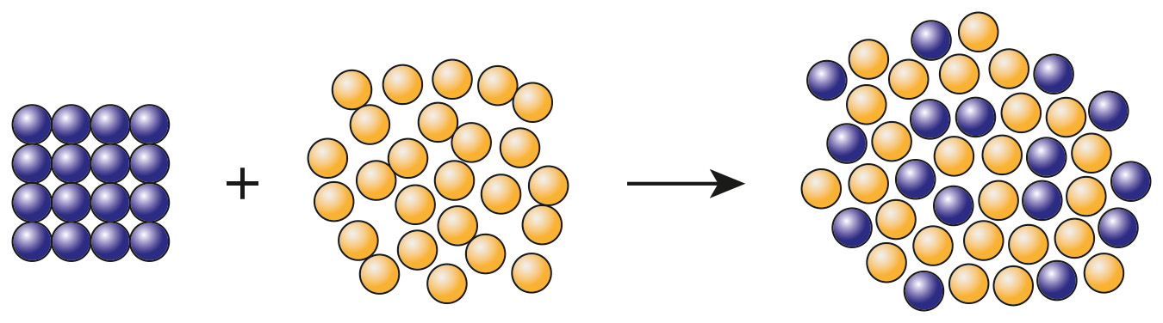

1. Choose the correct term to match each of the definitions included in the table.

**dilute precipitate saturated soluble**

**concentrated liquid insoluble**

|  |  |
| --- | --- |
| A substance that will dissolve in a solvent. |  |
| A substance that will not dissolve in a solvent. |  |
| A solution that contains a high amount of solute dissolved in it. |  |
| A solution that contains a relatively low amount of solute dissolved in it. |  |
| A solution that has the maximum mass of solute dissolved in it. |  |

1. Decide whether each of the following statements is true or false and write your answer in the box provided.
   1. The units for concentration are dm3/g. **True False**
   2. The particles of the solute disappear when a solute   
      dissolves in a solvent. **True False**
   3. 500 cm3 ofa solution with a concentration   
      of 4.50 g dm-3 will contain 2.25 g of solute. **True False**
   4. Most substances are more soluble at higher temperatures. **True False**
   5. All soluble substances have the same solubilities. **True False**
2. When sodium hydroxide solution is added to some metal cation solutions, a metal hydroxide precipitate is formed.

Use some of the words to complete the following sentences to explain why these precipitates are useful.

**blue precipitate colour shape temperature**

**copper iron solution gas insoluble**

The metal hydroxide precipitate formed is an __________________ solid.

The __________________ of the precipitate formed can be used to identify the cations present.

For example, if sodium hydroxide solution is added to copper(II) sulfate __________________, a precipitate of __________________ copper(II) hydroxide forms.

If sodium hydroxide solution is added to iron(II) sulfate solution, a grey/green precipitate of __________________ (II) hydroxide is produced.

**Solubility: test myself**

1. What is the correct unit for concentration if the mass of the solute is given in g and the volume of solvent is given in dm3?
2. What method is used to separate an insoluble substance from a mixture of the substance and water?

*(Hint: think about what the word insoluble means.)*

1. What method is used to separate water from a salt solution?

*(Hint: think about how you could avoid losing the water being separated.)*

1. A solution of sodium hydroxide has a concentration of 10 g dm-3. What mass of sodium hydroxide is present in 100 cm3 of the solution?

*(Hint: think about the relationship between dm3 and cm3.)*

1. What is the concentration, in g dm-3, of a solution of sodium carbonate made by dissolving 2.5 g of sodium carbonate in 500 cm3 of water?

*(Hint: think about the relationship between dm3 and cm3.)*

1. Sodium chloride, NaCl, solution reacts with acidified silver nitrate solution, AgNO3, to form a precipitate of silver chloride, AgCl, and sodium nitrate, NaNO3, solution. Complete the equation by adding the missing formulas and state symbols for all substances. The state symbols may be used once, more than once or not at all.

**(s) (g) (l) (aq)**

NaCl(____________) + ____________ (aq) → AgCl(____________) + ____________ (aq)

1. The concentration of a solution, in g dm-3, can be calculated using the equation:

The mass of solute dissolved in three different solutions is shown in the table.

|  |  |
| --- | --- |
| **Solution** | **Description** |
| **A** | contains 0.2 g solute in 100 cm3 solution |
| **B** | contains 0.9 g solute in 500 cm3 solution |
| **C** | contains 0.5 g solute in 20 cm3 solution |

Use the equation, and the information provided in the table, to work out which of the three solutions, **A**, **B** or **C**, has the highest concentration.

Some of the calculation steps have been laid out to help you.

*(Hint: Remember, 1 dm3 1000 cm3, so to convert the volume from cm3 to dm3 you need to divide the volume in cm3 by 1000.)*

**Solution A**

volume

concentration

concentration g dm-3

**Solution B**

volume

concentration

concentrationg dm-3

**Solution C**

volume

concentration

concentration g dm-3

The solution with the highest concentration is solution __________________ .

**Solubility: feeling confident?**

1. This solubility curve shows how the solubilities of the two salts, potassium nitrate, KNO3, and sodium chloride, NaCl, vary with temperature.

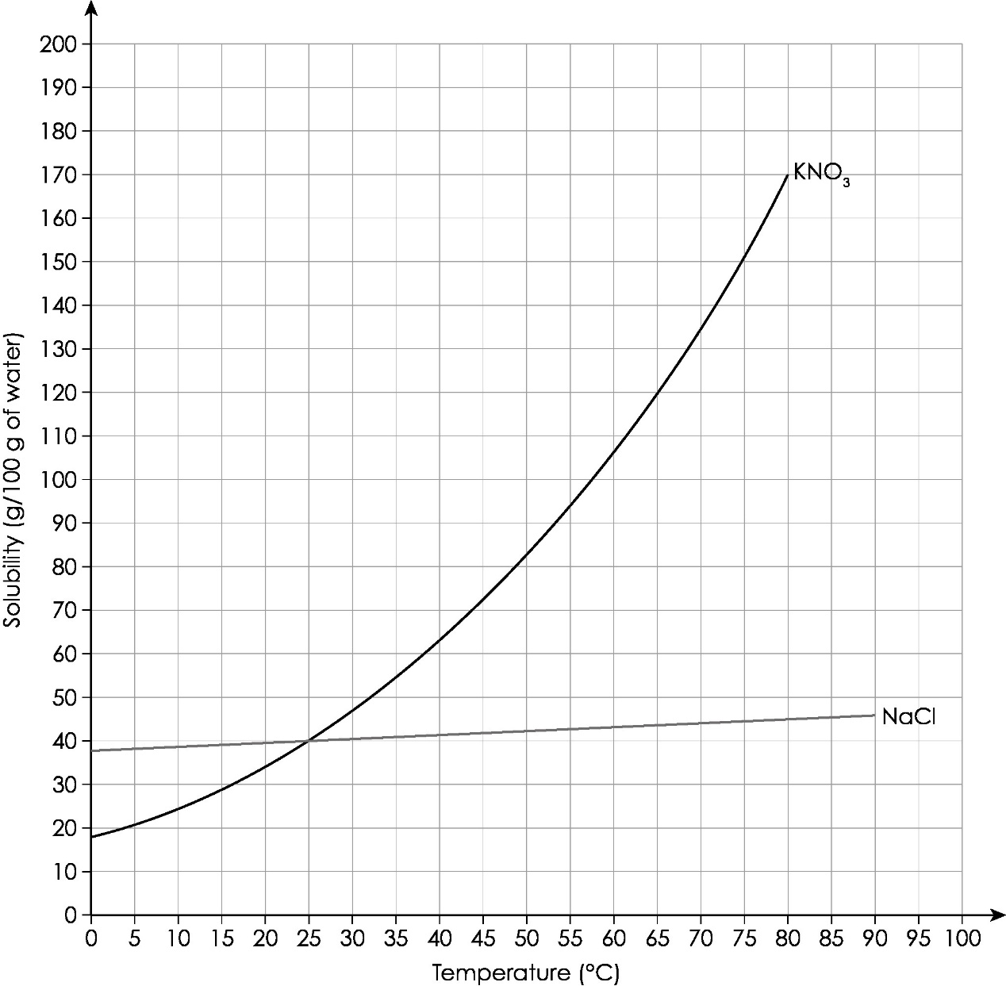

Complete the sentences to produce three conclusions that can be made using the solubility curve about the solubilities of potassium nitrate and sodium chloride.

The two salts have the same solubility at a temperature of ________________ .

At a temperature of 10°C, __________________ has the highest solubility.

The solubilities of both salts __________________ as the temperature increases.

1. Use the solubility curve in **question 3.1** to work out the mass of potassium nitrate that would crystallise out if a saturated solution of potassium nitrate was cooled from 80°C to 10°C.

Mass of potassium nitrate in 100 g water at 80°C = __________________

Mass of potassium nitrate in 100 g water at 10°C = __________________

Mass of potassium nitrate that crystallises out = __________________

**Solubility: what do I understand?**

Think about your answers and confidence level for each mini-topic. Decide whether you understand it well, are unsure or need more help. Tick the appropriate column.

|  |  |  |  |
| --- | --- | --- | --- |
| **Mini-topic** | **I understand  this well** | **I think I understand this** | **I need more  help** |
| I can use the correct words to describe solubility and solutions. |  |  |  |
| I know the difference between dilute and concentrated solutions. |  |  |  |
| I can measure the concentration of solutions in g dm-3. |  |  |  |
| I can calculate the mass of solute in different volumes of solution. |  |  |  |
| I know how to define the term saturated solution. |  |  |  |
| I can describe precipitate formation. |  |  |  |
| I can select the correct method of separation based on solubilities (filtration, distillation, crystallisation). |  |  |  |
| **Feeling confident? topics** | **I understand  this well** | **I think I understand this** | **I need more  help** |
| I can understand solubility curves. |  |  |  |
| I know how to use solubility curves to calculate the mass of a solute that crystallises out when a saturated solution cools. |  |  |  |