Cisplatin and drug design: teacher notes
Education in Chemistry
September 2021
https://rsc.li/36BWN2u
This resource reviews the action of cisplatin as an anticancer drug and explores the properties of transition metal complexes.
Several post-16 exam specifications require learners to know why cisplatin prevents DNA replication and to be able to explain why such drugs can have adverse effects.

Learning Objectives
- To apply an understanding of transition metal chemistry to the structure of cisplatin
- To understand the mechanism of cisplatin as a cancer drug
- To apply this knowledge to other platinum-based cancer drugs

Ability/differentiation
This resource is targeted at learners in the second year of a 16-18 course in chemistry.
The resource consists of three parts. The first two are basic knowledge based on information that the examination boards will test on, the third part is an extension.
Part 1 – exploring the structure of cisplatin using transition metal chemistry.
Part 2 – exploring the mechanism of cisplatin as an anticancer drug.
Part 3 – exploring other drugs in the platin family.

What are learners asked to do?
The resource requires learners to be able to draw the structure of cisplatin and show the mechanism of ligand substitution reaction with DNA by answering examination style questions.
It also contains introductory information about the structure of DNA.

Answers

Part 1: exploring the structure of cisplatin
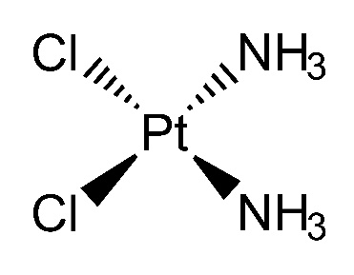
Cisplatin contains a central Pt ion with four ligands. The two chloride ligands can undergo ligand substitution to allow cisplatin to bind to a guanine base on DNA. This property is fundamental to the mechanism of its function as an anticancer drug.

- Cisplatin fact file. Fill in the boxes.
Central metal ion | Pt
Coordination number | 4
Shape | Square planar
Ligands present | Cl⁻ and NH₃
Angle | 90°
Overall charge of complex ion | 0

- Why is cisplatin a neutral complex ion? The platinum is a 2+ ion and this is cancelled out by two Cl⁻ ligand ions in the complex leaving an overall charge of 0.
- What property do both the Cl⁻ ion and the N in the NH₃ have that enables them to bond to the central Pt ion? They both have a lone pair of electrons.
- Explain how the Cl⁻ ion and NH₃ act as a ligand. The Cl⁻ ion and N on the NH₃ can donate a lone pair of electrons to the Pt and make a coordinate or dative covalent bond.

Part 2: exploring the mechanism of cisplatin as an anticancer drug
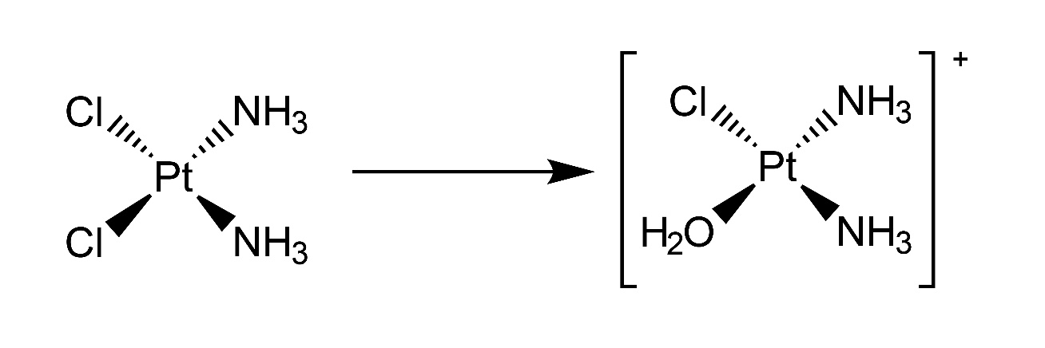
- When cisplatin is absorbed into the human body, it undergoes a ligand substitution reaction. A chloride ligand can be substituted for a water molecule.

Cisplatin A Cisplatin B

- Write a chemical equation to show this reaction. Pt(NH₃)₂Cl₂ + H₂O → [Pt(NH₃)₂Cl(H₂O)]⁺ + Cl⁻
- Why does the exchange of a chloride ligand for water change the charge on the complex ion? The charge on the Pt²⁺ ion is not cancelled out as a negative chloride ion has been replaced by a neutral water molecule so there is now only one negatively charged chloride ion and the overall charge is +1.

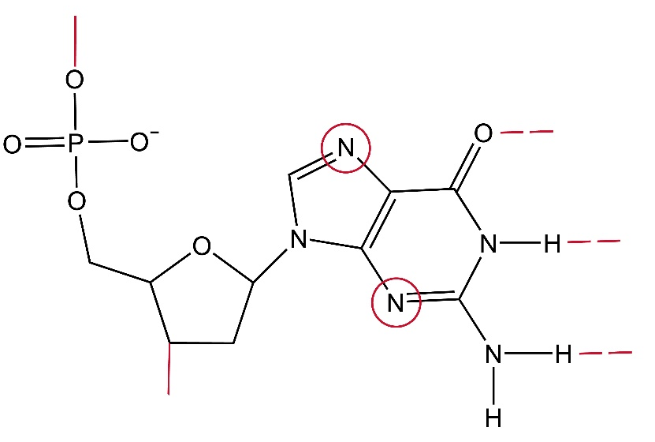
- The diagram below shows a nucleotide with a guanine base. Circle two atoms on the guanine that cisplatin could bind to.
- Explain two possible ways that cisplatin B can bind to the guanine, using either the chloride ligand or the water ligand.
- Chloride ligand exchange – the chloride exchanges for an N in guanine
- Water hydrogen bonding – the H of the water can hydrogen bond with an N in guanine
- There are two possible ways that cisplatin can bind to a DNA molecule, either to two different guanines on the same strand (intrastrand) or two different guanines on different strands (interstrand).
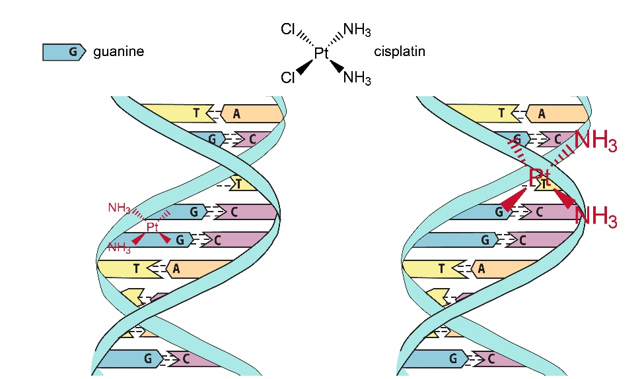
  - Using the simplified DNA below, show two possible ways that cisplatin can bind by ligand substitution to a guanine base.
  - Transplatin is a geometric stereoisomer of cisplatin and does not work as an anticancer drug. Explain why.
As the two Cl⁻ ligands are opposite each other the cisplatin cannot use them both to substitute on to the guanine on DNA. This means that the molecule is not held tightly and is not able to bind successfully either to one strand or both.
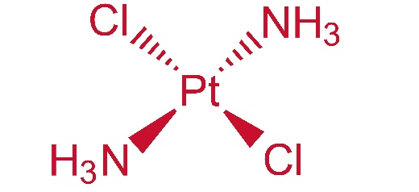
  - Draw transplatin.

Part 3: exploring other drugs in the platin family
To find new drugs, chemists can take an existing drug and use computing iterations to find many different versions but with just a small change each time. These similar compounds could potentially have therapeutic effects using the same mechanism as the original and may have less side effects or, in the case of platins, kill different types of tumours.
- Other platin molecules have also been shown to be successful as anticancer drugs. For each of the compounds below decide:
  - Which ligands, or ligand, will be substituted when binding to the guanine base and circle it.
See table below.
  - If the ligand is monodentate (in which case there will be two ligands) or bidentate (two attachment points, in which case there will be only one ligand) and draw it showing the lone pair/s.
See table below.
Compound | a) Circle the ligand(s) that will be substituted for the N of guanine | b) Draw the substituted ligand showing the lone pair/s
Carboplatin | 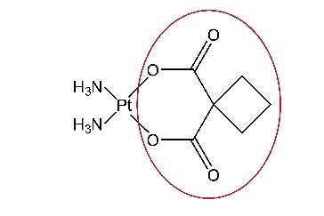 | 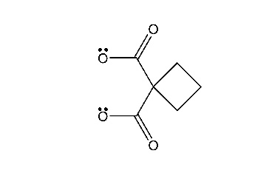  bidentate
Oxaliplatin | 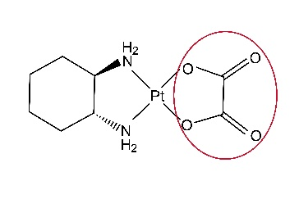 | 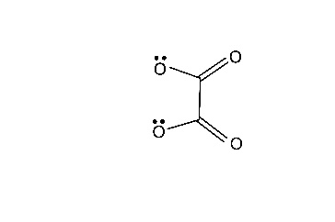  bidentate- ethanedioate
Nedaplatin | 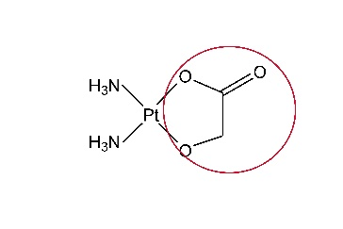 | 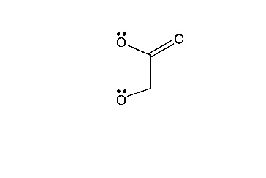  bidentate
Lobaplatin | 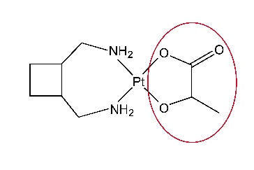 | 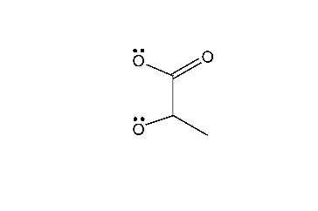  bidentate
Heptaplatin | 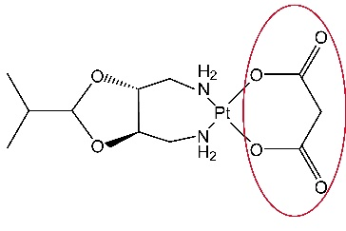 | 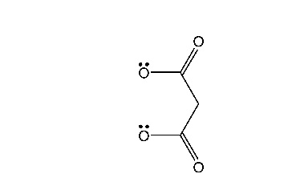  bidentate
Miriplatin | 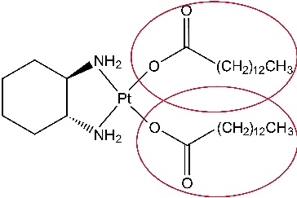 | 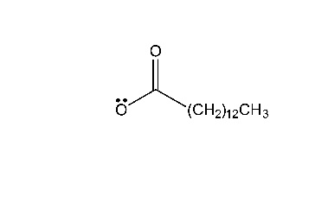  monodentate

- Ligands have an order of stability. The more stable ligand will readily substitute the less stable one.
OH⁻ < H₂O < Cl⁻ < F⁻ < NH₃ < CN⁻ < NH₂CH₂CH₂NH₂ < EDTA
Using NH₃ to represent the N on guanine:

- Identify one ligand that would not enable the cisplatin to bind to the N of guanine on DNA if it was present instead of the Cl⁻.
CN⁻, NH₂CH₂CH₂NH₂ or EDTA

- Identify one ligand, if present instead of Cl⁻ on the cisplatin would still enable it to bind to the N of guanine on DNA.

OH⁻, H₂O or F⁻
- All these drugs are toxic to humans because they are non-specific and will also prevent healthy cells from replicating. What precautions are taken by doctors to minimise this problem?
- Administer very small amounts of the drug.
- Monitor the patients in hospital during use.
- Target the dose so that it is directly injected into the tumour cells. This is called an intratumoural injection.

- Side effects for a person on chemotherapy include feeling extreme tiredness and commonly their hair falls out. Using your knowledge of how platin drugs work, explain why a person might get these side effects.

The drug kills healthy cells making the person feel very tired. Hair cells are rapidly dividing cells compared to most other parts of the body. The drug attacks rapidly dividing cells in the tumour but does not discriminate against other cells that have the same action. It attacks hair cells as well, killing off the cells so the hair falls out.

