Covalent bonding tiles

Learning objectives
- Draw dot and cross diagrams for simple covalent molecules
- Identify single, double and triple covalent bonds

Introduction

A covalent bond is a shared pair of electrons. We use dot and cross diagrams to show which atom the electrons in a covalent bond come from. Each atom usually makes enough covalent bonds to fill its outer shell.

Instructions

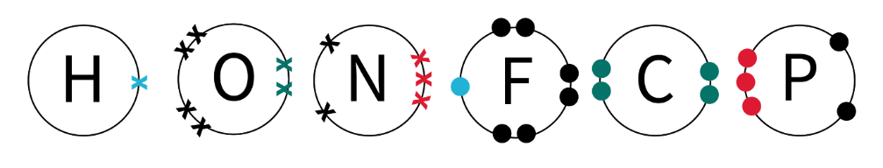
Position the tiles to arrange the atoms into molecules. The electrons are colour coded to help identify the type of bond and where the bond will be. The blue dots and crosses will form a single covalent bond, the green dots and crosses will form a double covalent bond and the red dots and crosses will form a triple covalent bond. The black dots and crosses are not involved in bonding.

Match the colours on the dot and cross tiles to complete the bond.

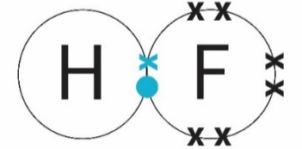
Once you are happy with the arrangement of atoms within your molecule, draw the dot and cross diagram.

Some of the atoms will need different arrangements of electrons depending on the type of bonds that they will form and the shape of the resulting structures. You will need to choose carefully and try different combinations to find the best fit for your molecule. Match, move and explore different combinations.

Task 1: Building bonds
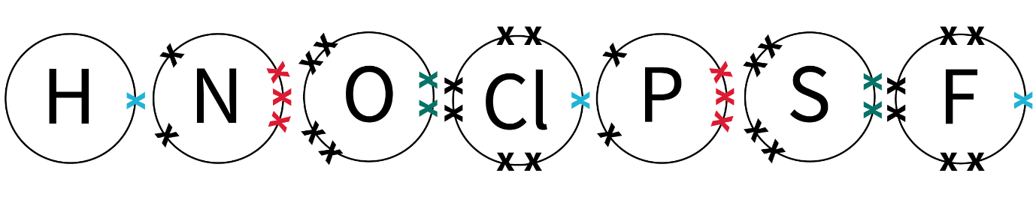
- Find the following tiles:

Make a diatomic molecule using one of the cross tiles pictured above and choosing one of the dot tiles to complete the bond.

How many different molecules can you make? Write down their formulas.
- Find the following tiles:

Choose dot tiles to complete the bonds.
- How are these molecules different to the ones you completed previously?
- Why do you think there are two oxygen tiles? What is the difference?
- Write down the formulas of any molecules you have made.
- Can you draw the dot and cross diagram?

- Find the following tiles:

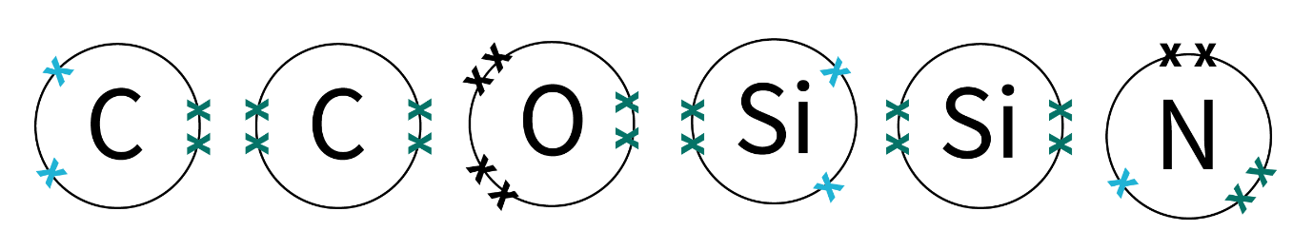

Choose dot tiles to complete the bonds.
- What is the smallest molecule you can make using these tiles?
- How many molecules can you make using only three tiles?
- How many molecules can you make using no more than four tiles?

Challenge

What is the largest simple covalent molecule you can make using these tiles?
- Can you draw the dot and cross diagram for your large molecule?
- How would you write the formula for it?
- Find out if your molecule exists and if it has a common scientific name.

Task 2: Simple covalent molecules

Using the dot and cross tiles make the following simple covalent molecules. Draw the dot and cross diagram in the table:
Name of molecule | Formula | Draw the dot and cross diagram
Water | H₂O
Hydrochloric acid | HCl
Carbon dioxide | CO₂
Methane | CH₄
Nitrogen | N₂
Ammonia | NH₃

Challenge:

Can you make a different simple covalent molecule using the tiles? Draw the dot and cross diagram and write down the formula. Find out if your simple covalent molecule has a common scientific name. Add this to the blank row in the table.

Task 3: Hydrocarbons

Alkanes
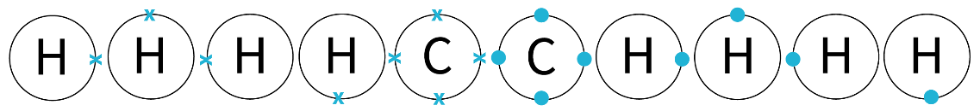
- Use the following tiles to assemble the alkanes in the table at the bottom of this page. You will need a few of each. Combine your tiles with other groups for the largest molecules.
- Count the number of carbon atoms and the number of hydrogen atoms in each molecule. Write down the formula in the table.
- Choose three of the alkanes and draw their dot and cross diagrams.

Alkenes
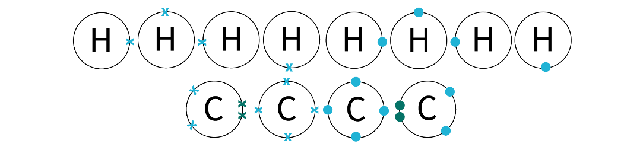
- Use the following tiles to assemble the alkenes. Why can’t you assemble an alkene with just one carbon atom?

- Count the number of carbon atoms and the number of hydrogen atoms in each molecule. Write down the formula in the table.
- Choose three of the alkanes and draw their dot and cross diagrams.
Alkane series | Formula | Alkene series | Formula
Methane | CH₄
 | C₂H₆ | Ethene
Propane |  |  | C₃H₆
Butane
Pentane
 | C₆H₁₄ | Hexene
 |  | Heptene
Octane |  |  | C₈H₁₆
Nonane
 | C₁₀H₂₂ | Decene
- Did you notice any patterns in the structures and formulas for the alkanes and alkenes?

Task 4: Polymerisation
- Assemble an ethene molecule using your tiles. Ethene is the simplest hydrocarbon in the alkene series. Ethene is also the monomer which forms poly(e)thene via the polymerisation process.
- Assemble a single repeating unit of the polymer chain for poly(e)thene using your tiles. The bonds at the ends of the chain should be incomplete.
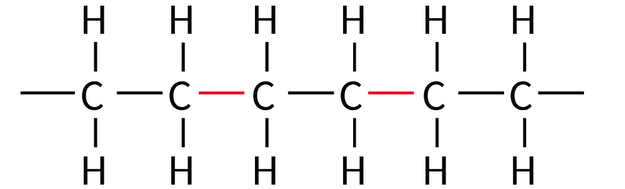
- Now come together in a group of three or four. Combine your single units to form a longer polymer chain with the other people in your group.
- In your group use a camera and your tiles to capture a stop motion video, time-lapse or a series of photos to make a gif showing the polymerisation of ethene.

Challenge

Can you animate the polymerisation of other molecules in the same way? Show the formation of polychloroethene (PVC polyvinylchloride), polytetrafluoroethene (PTFE or Teflon) or polypropene.

