Spot the bonding

The diagrams below show a few different chemical substances and a range of models. For each diagram either write:
- the name(s) of the type(s) of bonding present
- ‘none’ (if there is no chemical bonding)
- ‘don’t know’ (if you are unsure)
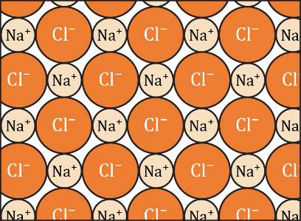 |  | 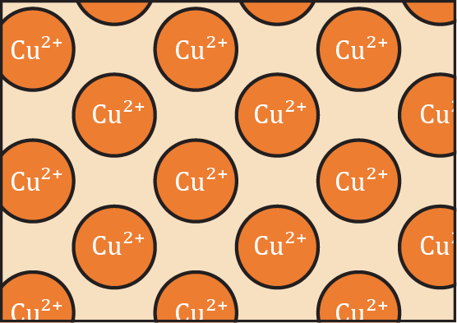
1. Sodium chloride lattice | 2. Diamond lattice | 3. Copper metal lattice
_________________________  _________________________  _________________________ | _________________________  _________________________  _________________________ | _________________________  _________________________  _________________________
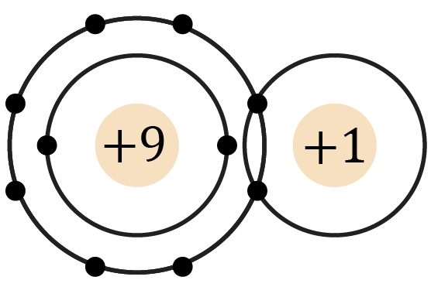 | 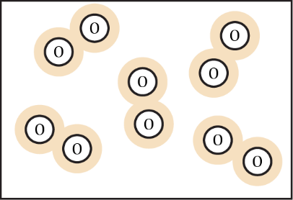 | 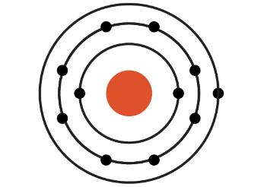
4. Hydrogen fluoride molecule | 5. Oxygen gas | 6. Sodium atom
_________________________  _________________________  _________________________ | _________________________  _________________________  _________________________ | _________________________  _________________________  _________________________
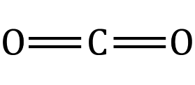 | 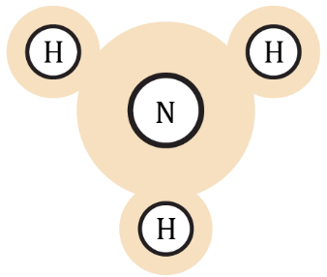 | 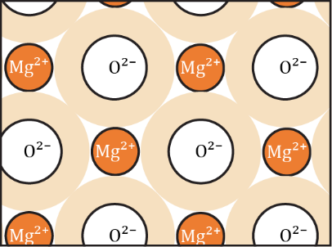
7. Carbon dioxide molecule | 8. Ammonia molecule | 9. Magnesium oxide lattice
_________________________  _________________________  _________________________ | _________________________  _________________________  _________________________ | _________________________  _________________________  _________________________

