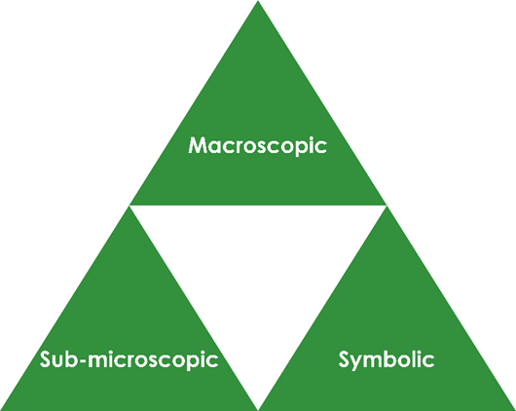Dissolving salt: Johnstone’s triangle

Learning objectives

1. State that solutions are formed when a solute is dissolved in a solvent.
2. Explain this in terms of the particles present.

Introduction

When a solid dissolves in water, the particles within the solid break apart and spread out until they are distributed throughout the water.

Johnstone’s triangle

In chemistry we make sense of the things that we can see by representing what we can’t see using formulas, equations, diagrams and models.

Johnstone’s triangle is a way of thinking about these different concepts as different corners of a triangle:

* Macroscopic – what we can see. Think about the properties we can observe, measure and record.
* Sub-microscopic – smaller than we can see. Think about the particle or atomic level.
* Symbolic – representations. Think about how we represent chemical ideas, including symbols and diagrams.

Being able to connect and move between these three different levels is important for scientific understanding.

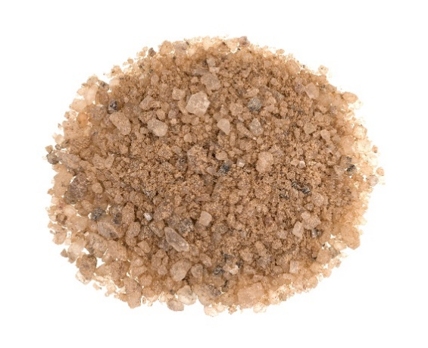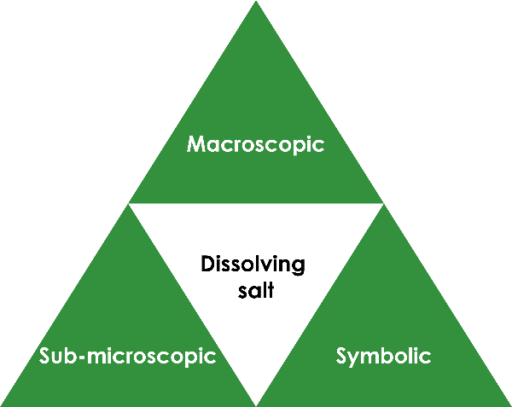

© Shutterstock / BW Folsom

Symbolic – representations

Identify the solute, solvent and solution in the diagram below:

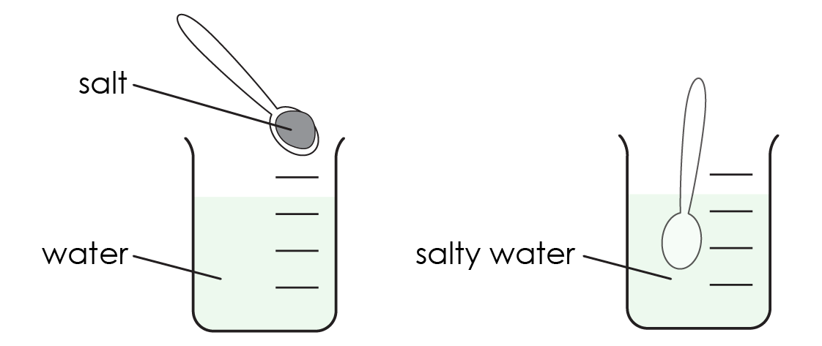

Solute: _______________________________________________

Solvent: ______________________________________________

Solution: ______________________________________________

Sub-microscopic – smaller than we can see

Choose the correct term to complete the sentences:

Salt is in the **solid / gas** state. The particles are **close together / far apart**.

Water is a **solid / liquid**. The particles are in **a fixed position / able to move around**.

When salt is dissolved in water, the salt particles **move together / spread out** to form a salt solution.

In the salt solution the salt particles are **evenly spread / all in one place**.

______________ ______________ ______________

Macroscopic – what we can see

Add one teaspoon of the salt and sand mixture to water and stir gently. Note your observations.