Ionic structure and bonding in rubies: teacher guidance

These In context worksheets ask learners to use their knowledge of ionic structure and bonding in an applied context, building their confidence and capability to face exam questions. Calculation questions are included to give opportunities to practise mathematical skills within this topic. The worksheets are available at Foundation and Higher level and as fully editable versions, giving you the flexibility to select the questions most relevant to a particular lesson.

Also available to assess this topic:
- Review my learning worksheets: available with three levels of scaffolded support to help build confidence in every learner. Use before, during or after teaching the relevant topic to understand progress and identify misconceptions, rsc.li/44igB7V.
- Knowledge check worksheets: select from Foundation and Higher level to assess learners’ knowledge and understanding of this topic at the end of a period of teaching or as revision, rsc.li/3RpKwpB.

Answers

Foundation

  - B giant ionic
  - C 3⁺
  - electrostatic forces
  - D 2000°C

  - ${Al}_{2}O_{3}$
  - 30 oxide ions

Element | Electronic configuration of atom | Electronic configuration of ion
aluminium | 2, 8, 3 | 2, 8
oxygen | 2, 6 | 2, 8
  - i. neon

ii. neon

  - i. M_{r} ${Al}_{2}O_{3}$ $=$ (2 × 27) $+$ (3 ×16)
$=$ 54 $+$ 48

$=$ 102

ii. $\%$ of Al in ${Al}_{2}O_{3}$ $=$ $\frac{54}{102}$ × 100

$=$ 52.9 $\%$
  - Mass of aluminium in ruby crystal $=$ $\frac{52.9}{100}$ × 0.20

$=$ 0.11 g
  - Mass of chromium(III) oxide $=$ $\frac{0.05}{100}$ × 0.20

$=$ 0.0001 g or 1 × 10^{‒4} g

Higher

  - giant ionic
  - i. 3⁺

ii. 2–
  - An empirical formula for a giant ionic structure gives the ratio of the ions in the structure.
  - ${Al}_{2}O_{3}$

Element | Electronic configuration of an atom | Electronic configuration of an ion
aluminium | 2, 8, 3 | 2, 8
oxygen | 2, 6 | 2, 8
  - i. neon

ii. neon

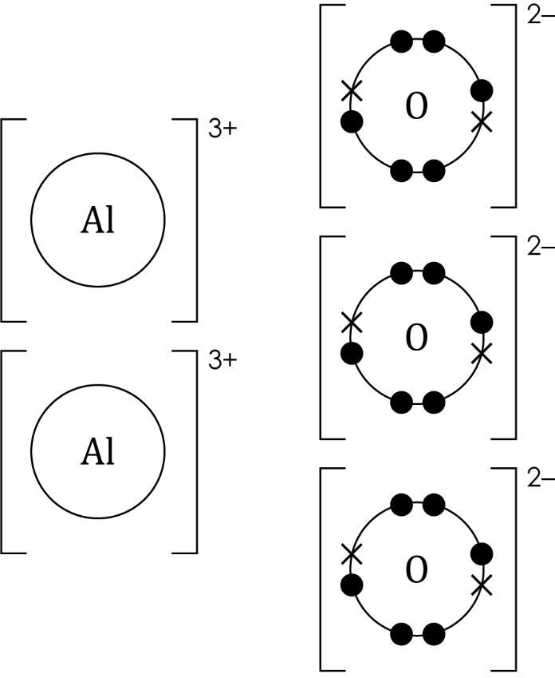

(a) M_{r} ${Al}_{2}O_{3}$ $=$ $(2 × 27) + (3 ×16)$
$=$ 54 $+$ 48
$=$ 102

(b) $\%$ by mass of Al in ${Al}_{2}O_{3}$ $=$ $\frac{54}{102}$ × 100

$=$ 52.94$\%$

(c) 1 mol Al₂O₃$=$ 102 g

0.20 g $=$ $\frac{0.20}{102}$ mol

$=$ 0.002 mol

(d) 1 mol aluminium ions contains 6.02 × 10²³ ions

0.05 mol aluminium ions contains 0.05 × (6.02 × 10²³) ions

$=$ 3.01 x 10²² ions

(a) mass of chromium oxide $=$ $\frac{0.05}{100}$ × 0.20

$=$ 0.0001 g or 1 × 10^{–4} g
  - M_{r} ${Cr}_{2}O_{3}$ $=$ (2 × 52) + (3 × 16)

$=$104 $+$ 48

$=$152

$\%$ by mass Cr in ${Cr}_{2}O_{3}=$ $\frac{104}{152}$ × 100

$=$68.42$\%$

mass of chromium $=$ $\frac{68.42}{100}$ × (1 × 10^{‒4})

$=$ 6.84 × 10^{‒5} g

