Ionic structure

This resource is from the **Johnstone’s triangle** series which can be viewed at: [rsc.li/3M0gZzQ](https://rsc.li/3M0gZzQ) . In this series you will also find our **Ionic bonding in table salt: Johnstone’s triangle** worksheet which introduces the triangle in the context of ionic bonding in table salt: [rsc.li/3WGzpdx](https://rsc.li/3WGzpdx)

Learning objectives

|  |  |  |
| --- | --- | --- |
| **LO** | **Objective** | **Where assessed** |
| **1** | Recognise a diagram that shows the structure of sodium chloride. | Q1 and 2 |
| **2** | Draw electronic structure diagrams of common ions. | Q3a and b |
| **3** | Use the idea of electron energy levels to compare the size of ions. | Q3c |
| **4** | Interpret ionic lattice diagrams of an unfamiliar ionic compound. | Q4 |

How to use the resource

This resource aims to develop learners’ understanding of ionic structures. Being able to think about ions in different ways will help learners to develop their understanding of ionic structures. As a result, learners should develop more secure mental models to support their thinking about this topic.

|  |  |  |  |  |
| --- | --- | --- | --- | --- |
| **When to use?** | Enter with solid fill Introduce | Watering pot with solid fill **Develop** | Arrow circle with solid fill **Revise** | Clipboard Mixed with solid fill Assess |
| Use after initial teaching or discussion of this topic to develop ideas further. You can also use as a revision activity. | | | |
| **Group size?** | Head with gears with solid fill **Independent** | Group brainstorm with solid fill **Small group** | Classroom with solid fill **Whole class** | Work from home house with solid fill **Homework** |
| Suitable for independent work either in class or at home. Or use the questions for group or class discussions. | | | |
| **How long?** | Stopwatch 25% with solid fillArrow Right outlineStopwatch 50% with solid fill | | 15–30 mins | |

Johnstone’s triangle

Johnstone’s triangle is a model of the three different conceptual levels in chemistry: macroscopic, symbolic and sub-microscopic. You can use Johnstone’s triangle to build a secure understanding of chemical ideas for your learners.

Find further reading about Johnstone’s triangle and how to use it in your teaching at [rsc.li/40bZ01F](https://rsc.li/40bZ01F).

Johnstone’s triangle and this resource

The icons in the margin indicate which level of understanding each question is developing to help prompt learners in their thinking.

|  |  |
| --- | --- |
| An icon used to indicate the macroscopic part of Johnstone's triangle. | **Macroscopic:** what we can see. Think about the properties that we can observe, measure and record. |
| An icon used to indicate the sub-microscopic part of Johnstone's triangle. | **Sub-microscopic:** smaller than we can see. Think about the particle or atomic level. |
| An icon used to indicate the symbolic part of Johnstone's triangle. | **Symbolic:** representations. Think about how we represent chemical ideas including symbols and diagrams. |

The levels are interrelated, for example, learners need visual representation of the sub-microscopic in order to develop mental models of the particle or atomic level. Our approach has been to apply icons to questions based on what the learners should be thinking about.

Questions may be marked with two or all three icons, indicating that learners will be thinking at more than one level. However, individual parts of the question may require learners to think about only one or two specific levels at a time.

Support

This worksheet is ramped so that the earlier questions are more accessible. The activity becomes more challenging in the later questions. You can give extra explanations for the more challenging questions. If completing as an in-class activity it is best to pause and check understanding at intervals, as often one question builds on the previous one.

It is useful for learners to observe macroscopic properties first-hand. You could circulate examples of substances in the classroom, run a class practical of a chemical reaction or show a teacher demonstration of properties.

Give learners physical models to use and manipulate, such as a Molymod™ kits or counters.

Additional support may be needed for any learners still lacking in confidence in the required symbolic representation, for example by sharing and explaining a diagram or a simulation that can show movement of the particles.

Answers

1. Guidance: This question assumes learners are already familiar with basic particle diagrams of elements and compounds in different states.
2. **B**
3. Any valid explanation given. Learners may have identified that:

* Diagram B and C contain particles in two colours whereas diagram A contains only one type of particle. Therefore, A cannot be sodium chloride as it does not represent a compound.
* Diagram A and B both represent solids, whereas diagram C shows a gas. Therefore, C cannot be sodium chloride because it is a solid at room temperature.



1. Guidance: This question supports learners to compare an illustration of the 3D structure of an ionic lattice with the 2D particle diagram that they may be more familiar with.
2. The diagram shows an ionic lattice made up of sodium and chloride ions.
3. This diagram is better because it shows the 3D structure of sodium chloride.



1. Guidance: This question allows learners to consolidate how to draw electron configuration diagrams before linking these to the representation of ions as different sized spheres.

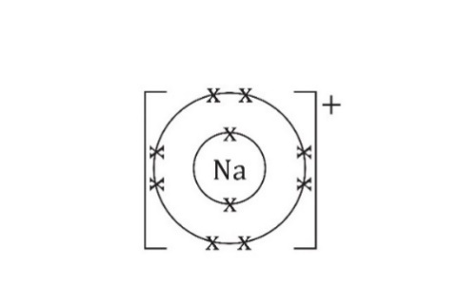

1. 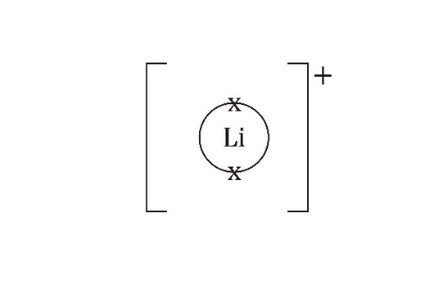

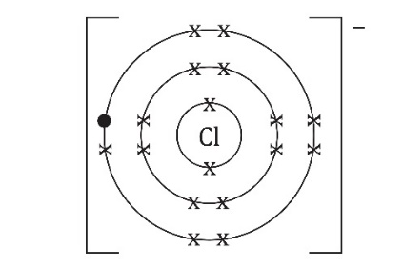

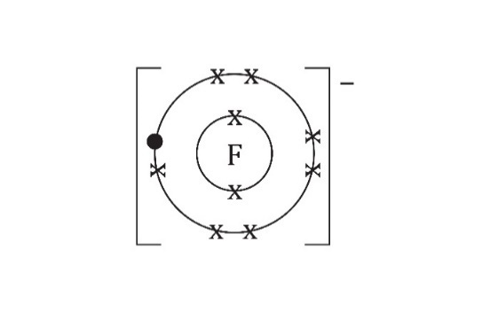

1. A sodium ion is **smaller** than a chloride ion.
2. A chloride ion is **larger** than a fluoride ion.
3. A lithium ion is **smaller** than a fluoride ion.
4. 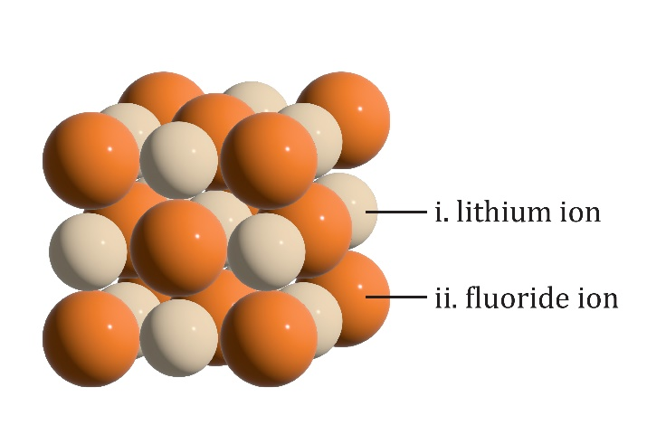



1. Guidance: This question shows learners how one representation of an ionic lattice can be used to help explain a difference in structure between two ionic compounds. It also supports learners in comparing two different representations of an ionic lattice that they may see.
2. The lithium ions in lithium fluoride are much smaller than the fluoride ions. The caesium ions are closer in size to the chloride ions. Fewer chloride ions can fit around each caesium ion so the pattern of ions in the lattice has to be different.
3. The ball-and-stick model shows more clearly how the ions are arranged. It is easier to see how many chloride ions surround a caesium ion. The model shows the ionic bond as separate sticks when an ionic bond is an attractive force not an object.  
     
   The space-filling model shows the ionic lattice more clearly as a lattice of spherical ions but it is harder to see or work out the arrangement of ions as it does not show the inside of the structure.