**Alcohols: knowledge check**

1. The table shows four different representations of a molecule of the alcohol ethanol.

Add the correct name to identify each of the representations and circle the alcohol functional group shown in each.

|  |  |  |  |
| --- | --- | --- | --- |
| **A**  There is a photograph of a model of a molecule on a grey background. From left to right, there is a large black sphere connected to three smaller white spheres and also attached to another large black sphere. That black sphere is attached to two smaller white spheres and one medium sized red sphere. The red sphere is connected to one small white sphere. | **B**  **There is a diagram showing two letters C in the middle joined by a single line. The left hand C has three letters H joined to it by single lines. The right hand C has two letters H joined to it by single lines and a letter O joined to it by a single line. The letter O then has a letter H joined to it by a single line.** | **C**  CH3CH2OH | **D**  C2H5OH |
|  |  |  |  |

1. The table below includes the names, molecular formulas, condensed structural formulas and displayed structural formulas for the first four members of the alcohols homologous series. Complete the table by filling in the missing formulas.

|  |  |  |  |
| --- | --- | --- | --- |
| **Name** | **Molecular formula** | **Condensed structural formula** | **Displayed structural formula** |
| methanol |  |  |  |
| ethanol |  |  |  |
| propan-1-ol |  |  |  |
| butan-1- ol |  |  |  |

1. Add the correct terms to complete the gaps in the following sentences.

Alcohols are a homologous series with the functional group __________________ .

The general formula of alcohols is __________________ .

All alcohols have names ending in __________________ .

Alcohols with three or more carbon atoms in their molecules have __________________ in their names to show the position of the –OH group.

The __________________ properties, such as boiling points, vary gradually as the molecules increase in size.

1. Add the correct numbers or terms to complete the sentences.

All alcohols have similar __________________ properties.

Alcohols reacts with oxygen in __________________reactions. The equation for the complete combustion of ethanol is:

CH3CH2OH + _________O2 → _________CO2 + _________H2O

If a small piece of sodium is dropped into an alcohol, it reacts steadily and gives off __________________ gas. A solution of sodium ethoxide is produced.

Alcohols can also be __________________ to form carboxylic acids using an oxidising agent such as potassium manganate(VII).

The equation for the oxidation of ethanol is:

__________________ + 2[O] → CH3COOH + H2O

The carboxylic acid produced is ____________________________________________ .

**Alcohols: test myself**

1. Which **two** compounds are alcohols?

**ethanoic acid decan-1-ol propane ethanal**

**propanone propan-2-ol propanal**

1. What is the molecular formula for a molecule of pentan-1-ol?
2. Name the carboxylic acid produced when butan-1-ol is oxidised.
3. Complete the equation representing the oxidation of propan-1-ol.

CH3CH2CH2OH + 2[O] → __________________ + __________________

1. Write the balanced symbol equation representing the complete combustion of propan-1-ol.

________________C3H7OH + ________________ → ________________ + ________________

1. Ethanol can be produced industrially from ethene gas. What is ethene reacted with to produce ethanol?
2. Ethanol can also be produced from biomass such as sugar beet.
   1. What is the name of the process used?
   2. State the three conditions required to produce ethanol from biomass.
3. _____________________________________________________________________
4. _____________________________________________________________________
5. _____________________________________________________________________
6. Ethanol can be separated from a mixture of ethanol and water.
   1. What is the name of the process used to separate the ethanol?
   2. What property does the separation of ethanol and water depend on when using the method identified in (a)?

**Alcohols: feeling confident?**

1. The image shows the apparatus used by learners to prepare a solution of ethanol.

There is one boiling tube and one test tube connected by a thin tube. The boiling tube on the left is three-quarters full of a yellowish liquid. On top of that liquid is a thin pale brown layer. The tube is stoppered, with a thin tube starting above the liquid layers, going through the stopper. The tube leads to an open test tube on the right. The test tube is about half full of a pale blue liquid. The open end of the tube finishes under the blue liquid.

Label the diagram and complete the sentences to describe this process.

The __________________ in yeast act as a __________________ and convert glucose into ethanol and __________________ . The gas produced bubbles through the limewater and turns it __________________ . The equation for the reaction is:

C6H12O6 → 2C2H5OH + _________

1. The graph shows how the solubility of alcohols in water changes as the number of carbon atoms in the molecules increase.

Use the graph to answer the following questions.

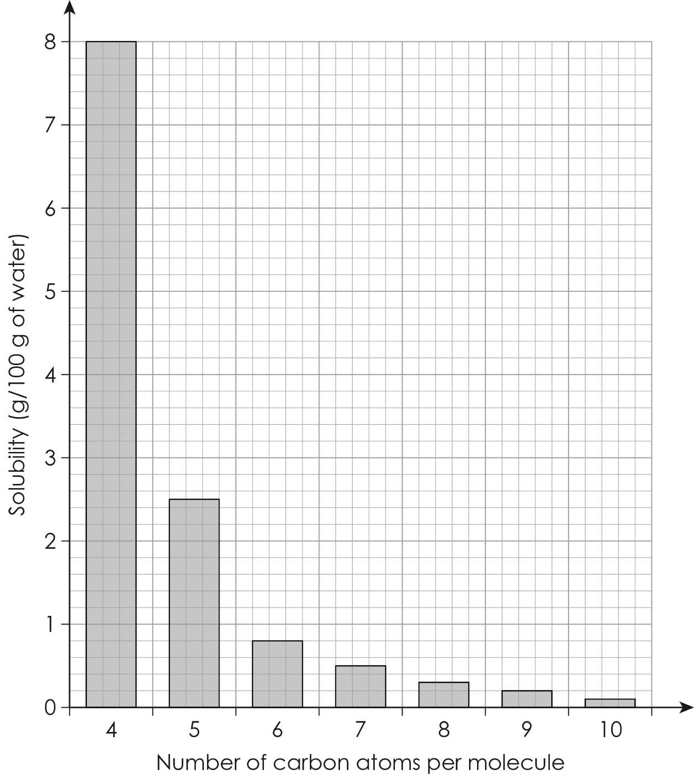

* 1. Which is more soluble in water, butan-1-ol or hexan-1-ol?
  2. How many grams of pentan-1-ol dissolve in 100 g water?
  3. What conclusion can be made about the relationship between the number of carbon atoms per molecule and the solubility of the alcohol?
  4. What would you expect to see when decan-1-ol is mixed with water? Explain your answer.

**Alcohols: what do I understand?**

Think about your answers and confidence level for each mini-topic. Decide whether you understand it well, are unsure or need more help. Tick the appropriate column.

|  |  |  |  |
| --- | --- | --- | --- |
| **Mini-topic** | **I understand  this well** | **I think I understand this** | **I need more  help** |
| I know that alcohols are a homologous series. |  |  |  |
| I can identify the functional group and the molecular and general formulae of alcohols group of alcohols. |  |  |  |
| I can draw the condensed structural and displayed structural formulas of alcohols. |  |  |  |
| I understand how alcohols are named. |  |  |  |
| I can describe the combustion reactions of alcohols. |  |  |  |
| I can describe the reactions of alcohols with sodium metal and with oxidising agents. |  |  |  |
| I can describe how ethanol is produced industrially. |  |  |  |
| I can describe the process of fermentation. |  |  |  |
| **Feeling confident? topics** | **I understand  this well** | **I think I understand this** | **I need more  help** |
| I can answer extending questions on fermentation. |  |  |  |
| I can describe the solubility of alcohols. |  |  |  |