Changing the state of water scarcity

Introduction

Scientists work to understand the world around us and what they find out often ends up in the news. The work of scientists impacts our lives all the time, so it is useful to be able to understand science writing. Read the science news story below and answer the questions.

**Changing the state of water scarcity**

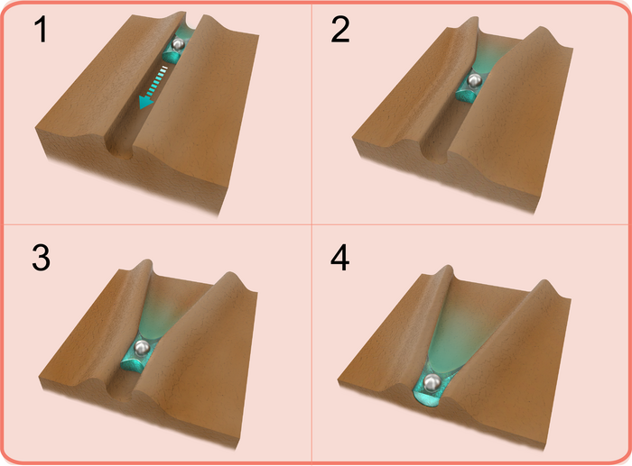

A diagram showing water droplets condensing on a crystal and moving through channels that widen as the crystal sublimes. Diagram courtesy of NYUAD.

A new way to harvest water from the air has been observed on crystals. Scientists observed water **condensing** and moving across the surface of a slowly **subliming** organic **crystal**. The water moves along small channels that appear on the surface of the crystal. These channels get larger over time as more of the **solid** sublimes to a **gas**. The water was also seen to move small solid **particles** along the channels.

This could be a novel way of combating water scarcity in desert areas. A similar process has been observed in some desert plants and animals to trap water.

Questions

1. Describe how the movement and arrangement of particles change when water condenses from a gas to a liquid.
2. Explain how this process could be used to collect water in a desert environment.
3. Write down the meaning of the following scientific words from the story – have you seen or heard these words before? Look them up in the glossary on page 4.
4. Condensing
5. Sublimes
6. Scarcity

Use the scale below to rate how much using the glossary is helping you understand the science in the story.

1 2 3 4 5 6 7 8 9 10

Not helping → Really helping

1. Get two different colour pencils. Circle any scientific words in colour one.
2. Using colour two, circle about five to ten words that communicate the key message in the story.

Use the scale below to rate how much circling words is helping you to understand the news story.

1 2 3 4 5 6 7 8 9 10

Not helping → Really helping

Use the scale in the box above to rate how confident you would feel explaining the story to the person next to you. Think of something else you can do when reading the text to help you understand the story and share it with the person next to you.

1. Write down one new thing you have learned from reading this science research news story.
2. Write your own summary of the story for the other learners in your class. Use the prompts below.

* What have the scientists discovered? Try to write this is just one sentence. (Findings)
* What was the problem they were trying to solve? (Context)
* Why does their discovery matter? (Relevance/application)
* Think about who it matters to, and what impact it could have for them. (Impact)

Scientists publish their findings in research articles. These are then written about by writers and journalists for different audiences. Research articles and other types of science writing can be very technical but they will mostly always cover the four prompts in question 6.

1. Read the story called ‘Helping drought-hit areas’. This is based on the same research, but it is written for a different audience than the text at the top of this worksheet. With a pen or pencil, highlight bits of the article that link to each of the bullet points in question 6.

*Hint: You could number the bullet points 1–4 and use a different colour for each bullet point.*

1. How is this science writing different from the science writing at the top of this worksheet? Write down your answers.
2. Imagine you are a professional science writer. Explain how you would write about this research for:
3. a post on social media
4. a magazine article aimed at adults who work in the chemistry industry
5. a report for school that gets published on the school website for other learners to read, including learners who are younger than you.

*Hint: In each case, think about your audience (in other words, who will read it) and what they might want and need from the writing. This will help you answer the question.*

Glossary

Words in bold are chemistry key terms that you will find in our key terms support resources.

|  |  |
| --- | --- |
| **Unfamiliar word** | **What it means** |
| Channel | a passage for water or other liquids to flow along |
| **Condensing** | when a gas is cooled, energy is transferred from the gas to the gas’ surroundings and the gas turns into a liquid |
| **Crystal** | a piece of a solid that has formed in a regular shape |
| **Gas** | a state of matter with no defined shape or volume and where the particles move randomly and have a large distance between them |
| Harvest | to take or collect a useful substance, for example water or a chemical element, from somewhere so that it can be used |
| Organic | a chemical substance containing carbon |
| **Particle** | a small portion of matter; examples include atoms, molecules or ions |
| Scarcity | a situation in which something is not easy to find or get |
| **Solid** | a state of matter with a defined shape and volume and where the particles are touching and vibrating |
| **Sublimes** | when a solid is heated, gains energy and turns into a gas, without turning into a liquid first |

Definitions of channel, harvest, organic and scarcity from Cambridge Dictionary, [www.dictionary.cambridge.org/](http://www.dictionary.cambridge.org/), © Cambridge University Press. Accessed January 2025. Used with permission.