**F5 Light and electrons in energy levels**

Scale

|  |  |  |  |
| --- | --- | --- | --- |
| **Subatomic** | **Atom** | **Molecule** | **Giant structure** |
|  |  |  |  |

A diagram of the three areas of Johnstone's triangle, the three points are labelled submicroscopic, symbolic and macroscopic


Properties of light

1. List the types of electromagnetic radiation in order of increasing energy, including all the colours of visible light. Indicate how wavelength and frequency also vary across the spectrum.

Wave model of light

1. State the equation that links the frequency and wavelength of electromagnetic radiation to the speed of light. Give the correct units of each quantity in the equation.

Particle model of light

1. State the equation that links the frequency and energy of electromagnetic radiation. Give the correct units of each quantity in the equation.
2. Blue light has a wavelength of 452 nm.
3. Find the frequency of the blue light.
4. Find the energy of a photon of blue light.
5. A photon has energy of 2.925 x 10-19J.
6. Calculate the frequency of this photon.
7. Calculate the wavelength of the light.
8. Suggest a colour for the radiation by referring to the spectrum below: 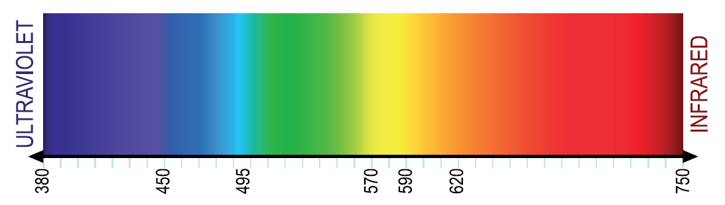

Increasing wavelength (λ) in nm →

The Bohr model of the atom

1. Describe how electrons are arranged in the Bohr model of the atom.
2. How many electrons in a hydrogen atom? How many energy levels?
3. Describe what happens to an electron when the atom gains energy/absorbs a photon; draw a diagram to illustrate this.
4. Describe what happens to an electron when the atom loses energy/emits a photon; draw a diagram to illustrate this.
5. How does the energy of the photon in (c) and (d) compare to the energy change of the electron if the two energy levels involved are the same?

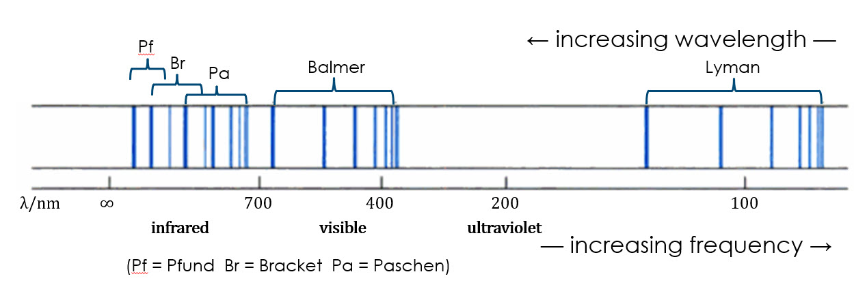

1. Refer to the diagram above to describe the appearance of the atomic emission spectrum of hydrogen:

Hint: think about how the diagram is a ‘limitation’ of the colours in the emission spectrum.



1. Compare the emission spectrum of another element (e.g. helium) to that of hydrogen.
2. Explain why there are specific lines at fixed frequency in the hydrogen emission spectrum.
3. Describe the appearance of an atomic absorption spectrum.
4. How do the positions of the lines in the absorption spectrum compare to the position of the lines in the emission spectrum of the same element? Why?
5. Explain why the positions of the lines in the hydrogen spectrum are different to the position of the lines in a helium emission spectrum?
6. Why are there several ‘series’/’blocks’ of lines in the emission spectrum of an element?
7. On each set of energy levels below, show transitions that would correspond to the:
8. Lyman series in the ultraviolet region
9. Balmer series in the visible light region
10. Paschen series in the infrared region

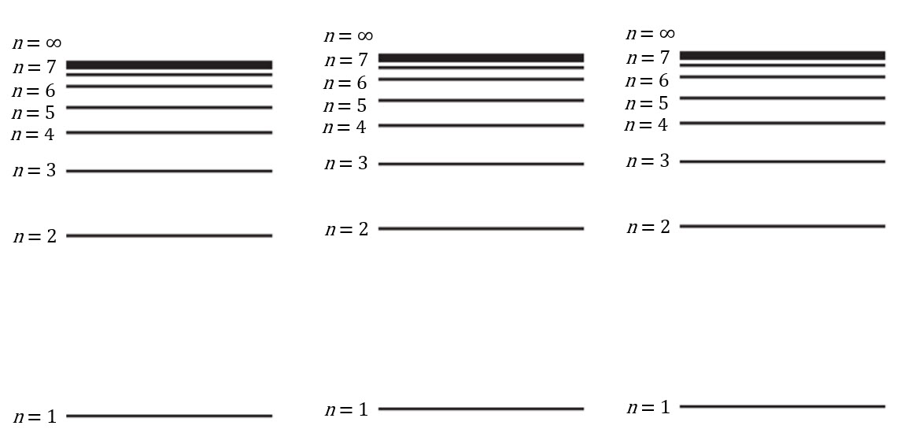

1. Comment on the energy levels/size of transitions in relation to the region of the spectrum in which the lines are observed.
2. Explain why the lines in a series get closer together as the frequency increases.
3. The atomic emission spectrum of calcium contains a line with a wavelength of 618 nm.
4. Give the wavelength of the line in metres.
5. Calculate the frequency of this line.
6. Calculate the gap between the two electron energy levels involved in the transition that causes this line in the spectrum.
7. With reference to the electromagnetic spectrum in question 5, suggest the colour of the line at 618 nm in the calcium spectrum.
8. Another line in the calcium spectrum has a frequency of 6.77 x 1014 Hz. Calculate the wavelength of the line in nm and suggest the colour.

Application of emission spectra

1. 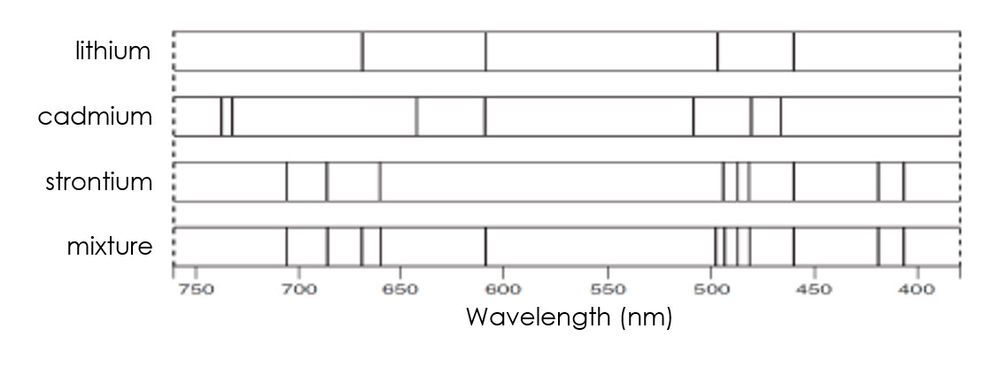Look at the emission spectra below:

Answer to part (c)

1. Explain why the lines in the cadmium spectrum are at different frequencies to those in the lithium spectrum.
2. What can you conclude about the composition of the ‘mixture’? Explain your answer.
3. In the bottom rectangle, sketch the spectrum you would expect from a mixture of cadmium and strontium only.

Extension question

1. The energies, *E*, of the energy levels in a hydrogen atom can be calculated using the formula:

eV

is the integer value of the energy level, i.e. 1, 2, 3, 4 etc…

This equation gives the energy in a unit called ‘electron volts’.

1 eV = 1.602 x 10-19 J

1. Use the equation to complete the table below:

|  |  |  |
| --- | --- | --- |
| **Energy level *n*** | **Energy in electron volts / eV** | **Energy in joules / J** |
| 1 |  |  |
| 2 |  |  |
| 3 |  |  |
| 4 |  |  |
| 7 |  |  |
| 9 |  |  |
| 12 |  |  |
| 20 |  |  |
| ∞ |  |  |

1. Sketch a *y*-axis below to show the relative values.
2. Suggest what happens to a hydrogen atom if it gains more than 13.6 eV of energy.