**The structure of benzene**

This resource accompanies the article **Teaching aromatic chemistry post-16** in *Education in Chemistry* which includes more support for teaching this topic and can be viewed at: [rsc.li/3EhJGb4](https://rsc.li/3EhJGb4)

**Learning objectives**

1. Understand and use the concept of double bond equivalence (Q1–5 and stretch and challenge question).
2. Consider and discuss the evidence for the delocalised π-bond in benzene (Q6–8).
3. Discuss and understand the thermodynamic stability of benzene (Q9–11).

**How to use this resource**

Instruct learners to tackle **Questions 1–6** in class or at home. The questions focus on the concept of double bond equivalence and link it to the structure of benzene as proposed by Kekulé. Question 6 is open-ended with built in differentiation depending on how many alternative structures are suggested. Get confident learners to tackle the stretch and challenge question at the end of the worksheet.

Once complete, use the PowerPoint to talk about how the model has evolved and introduce the idea of the 6-centre 6-electron delocalised π-bond.

Use **Question 7** once you get to the stage of discussing the evidence of bond length.

* Print and cut out the information cards on the last page.
* Put learners into groups.
* Give each group a copy of the cards.

Introduce the largely overlooked figure of Kathleen Lonsdale, who did the x-ray crystallography showing the carbon–carbon bond lengths are all the same in benzene.

Instruct learners to attempt **Question 8** in their groups. Ask them to construct an energy level diagram to show the evidence from enthalpies of hydrogenation. The answers to each part (a), (b) etc are shown on slides 6–9 of the PowerPoint. Check understanding before moving on to the next part.

Get learners to discuss **Questions 9–11** in their smaller groups then clarify the answers as a whole class.

Ask learners todiscuss **Questions 12–14,** a reflection task, in their groups or as a whole class.

Answers

**Double bond equivalence**

5. 0
6. 1
7. 1
8. 2
9. 0
10. 1
11. 1
12. Completed table

|  |  |  |
| --- | --- | --- |
| **Molecular formula** | **Number of DBE** | **Possible structures** |
| CH | 1.5 | No feasible structure |
|  | 2 | A structural diagram representing ethyne - from left to right, an H is joined by a single line to a C, joined by three lines to another C and then a single line to an H.This is ethyne |
|  | **2.5** | No feasible structure |
|  | **3** | A range of possible structural diagrams for C4H4 are shown, including a square with lines along two opposite internal sides, a tetrahedron with CH at each corner, a diagram from left to right, H2C is joined by two lines to a C, joined by two lines to another C, two lines to another C and then two lines to CH2 |
|  | **3.5** | **No feasible structure** |
|  | **4** | **There are many possible, here are just a few:**  A range of possible structural diagrams for C6H6 are shown - including an opened out tetrahedron, a hexagon with lines along two opposite internal sides and then parallel lines projecting from the opposite corner, and three diagrams showing from left to right, H2C is joined by two lines to a C or one line to a CH in different combinations and then two lines to CH2. |
|  |  | Further examples of possible structures for C6H6 |

1. This question uses the numbered information cards 1, 5, 7,12,16 and 17. Tell that to groups that are struggling.
2. Alternating long and short carbon–carbon bond lengths around the ring would be consistent with Kekulé’s structure cylohexa-1,3,5–triene.
3. No, all the carbon–carbon bond lengths around the ring are the same.
4. Other things being equal, shorter bonds are stronger than longer bonds.
5. Not only are the carbon–carbon bond lengths around the ring the same, they are also intermediate between the single and double bond lengths.
6. This question uses the numbered information cards 4, 9, 10, 11,15, (16 and 17). Tell that to groups that are struggling.

Answers (a)–(d) are revealed one at a time in the PowerPoint that goes with this resource. The diagram on the final slide of the series is reproduced here for convenience.

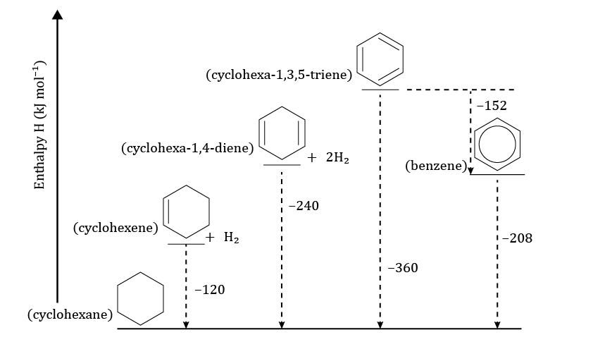

+ 3H2

+ 3H2

1. Benzene is more energetically stable than the theoretical cyclohexa-1,3,5-triene. The theoretical transition from discrete alternating double bonds to the delocalised π-ring would be exothermic (by roughly 150 kJ mol-1).
2. Benzene is less reactive than alkenes because of the stability of the delocalised π-bond.
3. Benzene is more energetically stable than the theoretical cyclohexa-1,3,5-triene because the electron density is spread out more thinly around the ring, so the electrons experience less electron–electron repulsion.

Stretch and challenge question

1. (i)

(ii)

(iii)

(iv)

|  |  |  |  |
| --- | --- | --- | --- |
| **DBE** | **Ring** | **Double bond** | **Triple bond** |
| 3 | 3 | 0 | 0 |
|  | 2 | 1 | 0 |
|  | 1 | 2 | 0 |
|  | 1 | 0 | 1 |
|  | 0 | 3 | 0 |
|  | 0 | 1 | 1 |
| 4 | 4 | 0 | 0 |
| 3 | 1 | 0 |
| 2 | 2 | 0 |
| 2 | 0 | 1 |
|  | 1 | 3 | 0 |
|  | 1 | 1 | 1 |
|  | 0 | 4 | 0 |
|  | 0 | 2 | 1 |
|  | 0 | 0 | 2 |

1. (i) 4

(ii) 9

(iii) 61

(iv) 4

(v) 4

(vi) 3

(d)

|  |  |  |  |  |  |  |  |  |  |
| --- | --- | --- | --- | --- | --- | --- | --- | --- | --- |
|  | **Number of atoms in each region**  **(must add up to 8)** | | | | | **Structural information deduced** | | | |
| **Spectrum** | **Triple bond (alkyne)** | **Double bond (alkene)** | **Single bond** | **Allene central** | **Allene flanking** | | **Number of triple bonds** | **Number of double bonds** | **Number of rings** |
| **A** | 0 | 8 | 0 | 0 | 0 | | 0 | 4 | 1 |
| **B** | 0 | 0 | 8 | 0 | 0 | | 0 | 0 | 5 |
| **C** | 4 | 0 | 4 | 0 | 0 | | 2 | 0 | 1 |
| **D** | 0 | 2 | 0 | 2 | 4 | | 0 | 5 | 0 |
| **E** | 0 | 8 | 0 | 0 | 0 | | 0 | 4 | 1 |
| **F** | 2 | 6 | 0 | 0 | 0 | | 1 | 3 | 0 |
| **G** | 0 | 6 | 2 | 0 | 0 | | 0 | 3 | 2 |
| **H** | 0 | 6 | 2 | 0 | 0 | | 0 | 3 | 2 |
| **I** | 0 | 2 | 6 | 0 | 0 | | 0 | 1 | 4 |

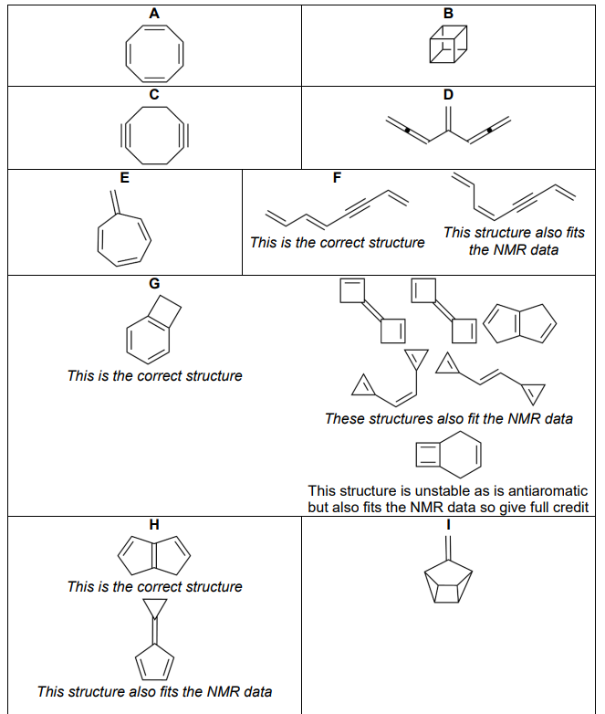

|  |  |  |
| --- | --- | --- |
| The single  carbon–carbon bond length  (C–C) is 0.15 nm  **1** | The double  carbon–carbon bond length, (C=C) is 0.13 nm  **12** | The carbon–carbon bond length in benzene is 0.14 nm  **5** |
| X-ray crystallography shows the  carbon–carbon bonds in benzene are all the same length  **7** | Benzene does not undergo electrophilic **addition**  **3** | Benzene undergoes electrophilic **substitution**  **8** |
| In electrophilic addition reactions the π-bond is not present in the product  **6** | In electrophilic substitution reactions the π-bond or system is retained in the product  **2** | The enthalpy of hydrogenation of cyclohexene is -120 kJ mol-1  **11** |
| The enthalpy of hydrogenation of 1,4–cyclohexa-diene is -240 kJ mol-1  **4** | The enthalpy of hydrogenation of benzene is -208 kJ mol-1  **10** | The predicted enthalpy of hydrogenation of cyclohexa-1,3,5-triene is … kJ mol-1  **15** |
| The electron density in the delocalised π-ring in benzene is more spread out than in than the theoretical cyclohexa-1,3,5-triene  **14** | The bonding in the ring is described as an extended π-system rather than three separate double bonds  **13** | Benzene is more stable than the theoretical cyclohexa-1,3,5-triene by about … kJ mol-1  **9** |
| The p atomic orbitals not involved in the single bonds overlap with each other side by side all the way round the ring  **16** | The π-system in benzene is a 6-electron 6-centre bond    **17** |  |