Metallic bonding: Johnstone’s triangle

This resource is from the **Johnstone’s triangle** series which can be viewed at: [rsc.li/3WViQfg](https://rsc.li/3WViQfg). Use this resource alongside our **Developing understanding** worksheets which can be downloaded from: [rsc.li/4fzqR0N](https://rsc.li/4fzqR0N)

Learning objectives

1. Describe a metal and its uses based on observations.
2. Use symbolic models to represent metallic bonding.
3. Explain how the type of bonding in a metallic compound relates to the properties you can observe.

How to use Johnstone’s triangle

Use Johnstone’s triangle to develop learners’ thinking about scientific concepts at three different conceptual levels:

* 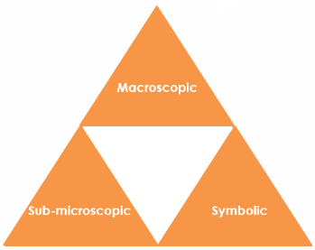Macroscopic – what we can see
* Symbolic – what we use to represent what we’ve seen
* Sub-microscopic – smaller than we can see

For learners to gain a deeper awareness of a topic, they need to understand it at all three levels.

Read more about how to use Johnstone’s triangle in your teaching with these *Education in Chemistry* articles:

* Develop deeper understanding with models: [rsc.li/3SJt8wz](https://rsc.li/3SJt8wz)
* Improve students’ understanding with Johnstone’s triangle: [rsc.li/3AsvPwb](https://rsc.li/3AsvPwb)

Scaffolding

It is important to share the structure of the triangle with learners prior to use. Tell them why you want them to use the triangle and how it will help them to develop their understanding.

Ask learners to complete the Johnstone’s triangle worksheet independently, in small groups or as a whole class activity.

Use an ‘I try, we try, you try’ approach when you are introducing Johnstone’s triangle for the first time, as detailed in the article *Develop deeper understanding with models*, link above.

Next steps

Get learners to use the completed Johnstone’s triangle as a support document to refer back to when they move on to complete the associated **Developing understanding** worksheet ([rsc.li/4fzqR0N](https://rsc.li/4fzqR0N)).

These worksheets contain icons in the margin referring to the level of thinking needed to answer the question.



Macroscopic - What do we observe?

Match the common uses of copper below with the properties that make it suitable.

Electrical wires Ductile

Saucepan Malleable

Water pipes Lustrous (shiny)

Jewellery Good conductor of heat and electricity

Symbolic - How do we represent it?

Complete a metallic bonding diagram for copper by adding electrons to this diagram.

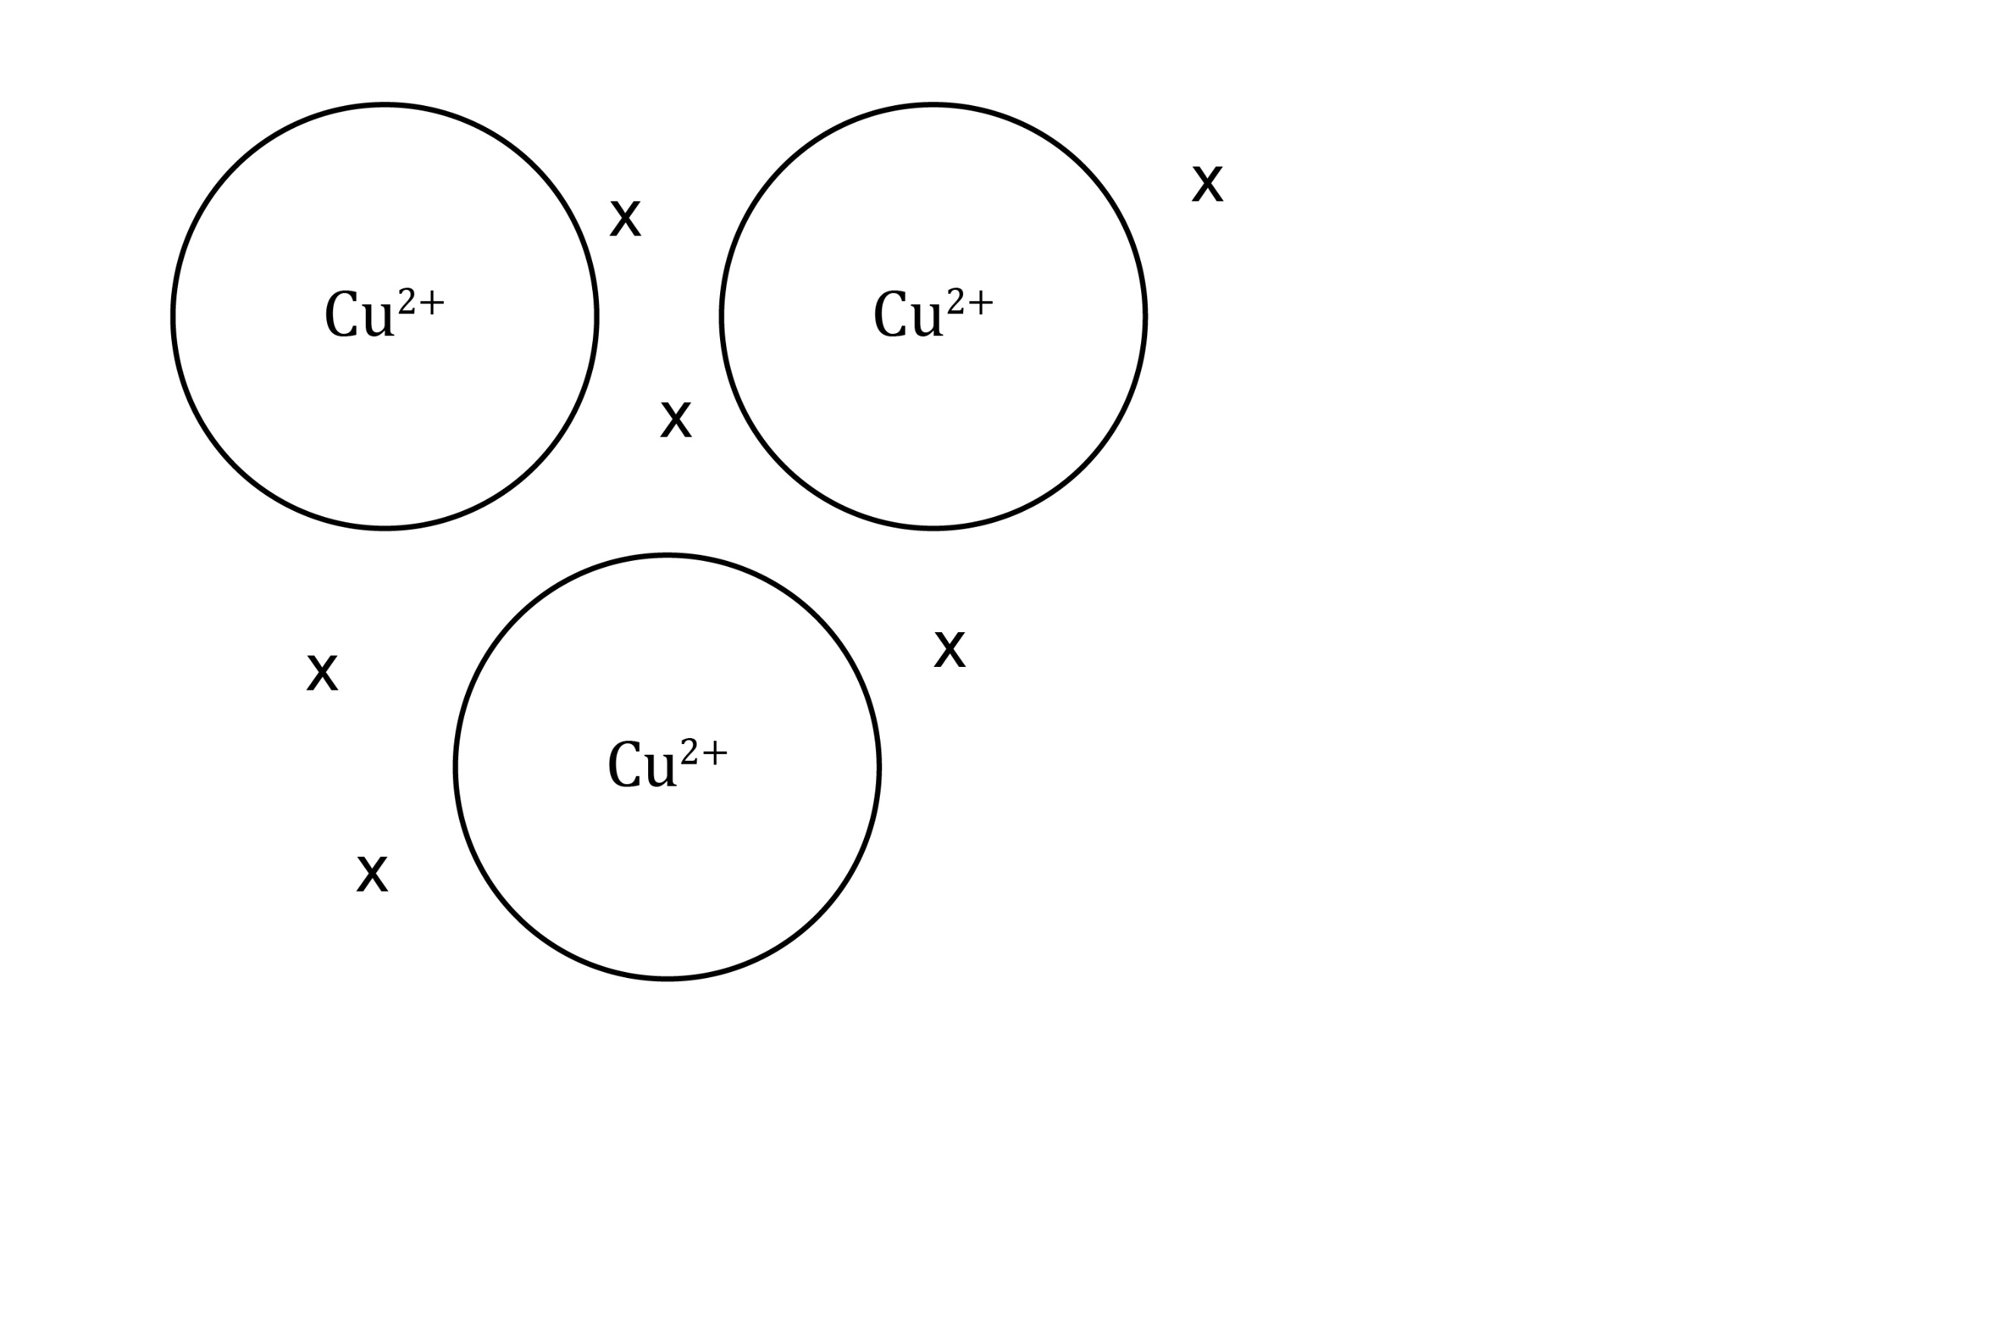

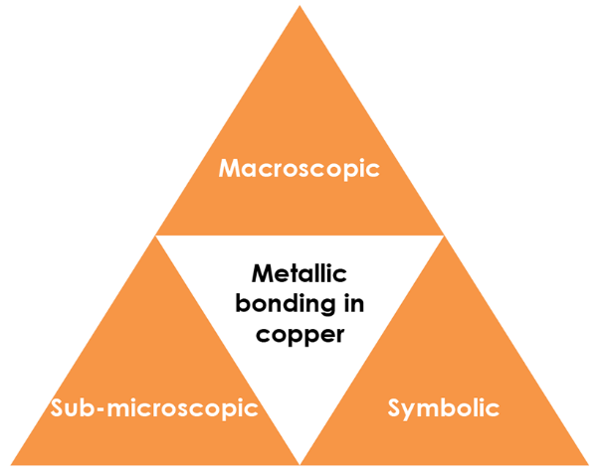

Sub-microscopic - What is happening that we can’t see?

With reference to the structure and bonding in metals explain why:

* Copper is malleable

**Metal ions are arranged in layers which can slide over each other. The delocalised electrons maintain the bonding within the metal even while the shape is changing.**

* Copper is a good conductor of heat and electricity

**The delocalised electrons are free to move. The charged particles carry electrical current and transfer heat energy quickly throughout the metal.**