Smartphone spectroscopy: Beer–Lambert law
Education in Chemistry
January 2021
rsc.li/2XFiZE8
Explore colour and concentration using a smartphone, some fruit squash, a filter and a torch. Investigate the Beer–Lambert law through calculations based on your results.

Measuring lux at different concentrations
Watch the video here: rsc.li/3bCk0W2.
This video demonstrates a simple experiment for measuring concentration that touches on many core chemistry concepts such as particle theory, colour, spectroscopy, colorimetry, dilutions and concentrations. This simple activity can be set for learners to try at home with a responsible adult or used as a hands-on classroom experiment or demonstration. This resource explains how it can also be adapted for teaching the Beer–Lambert law.

Equipment list
- A small torch
- A smartphone
- Some identical drinking glasses
- Fruit squash (blackcurrant works best)
- Water
- Something for measuring eg, a graduated cylinder/cooking jug
- A spoon
- A green filter (eg, sweet wrapper or drinks bottle)

Health and safety
If your green light filter is from a green drinks bottle, please make sure to be extra careful when cutting it out with scissors.
Always ask for the permission of the smartphone owner before downloading any apps.

Activity instructions
- Download a light meter app to the smartphone. There are many free versions available across all platforms. They are sometimes called a ‘lux meter’ because they provide us with ‘lux numbers’.
- Prepare your green light filter. You can get this from a sweet wrapper or by cutting it out of a used drinks bottle.
- Using the measuring jug, measure an equal amount of water into each glass. It doesn’t matter how much you use as long as it’s the same amount in each glass. 100 ml should be sufficient.
- Add a measured amount (1 ml, 5 ml, 10 ml) of blackcurrant squash to each glass to create your standards (see table below).
- Ensure each drink is thoroughly mixed using the spoon.
- Set up the experiment with the torch and green filter on one side of one of the glasses and the smartphone on the other side. Ensure the camera is directly across from the torch. Consistency between each sample is very important to achieve the best possible straight-line graph.
- Repeat the experiment for each drink, recording the lux number each time.
- Observe that the lux number is inverse to the concentration, so the higher the concentration the lower the lux number.

The Beer–Lambert law
Light absorption occurs when the contents of the squash drink take up the energy of a photon of light, which reduces the transmission of the light as it passes through the sample.
The lux number that is recorded for each sample in our experiment is directly proportional to the transmittance. The length of the sample holder (l) must remain constant for all samples.
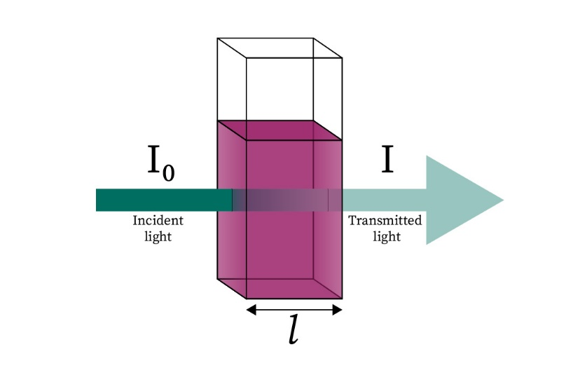
Image © Royal Society of Chemistry

The following equation will give you the percentage of transmitted light (%T) for each sample (A, B and C):
$$\%T= \frac{Transmitted Light (I)}{Incident Light (I_{0})} X 100$$
Transmitted light = lux number of squash + water (sample A, B, C)
Incident light = lux number of water (blank sample)
Absorbance is the opposite of transmittance and states how much of the light the sample absorbed:
Absorbance = 2 – log₁₀ (%T)

Example:
To convert a transmittance of 56% to absorbance:
Absorbance = 2 – log₁₀ (%T)
Absorbance = 2 – log₁₀ (56)
Absorbance = 0.252 absorbance units

 | Control | Sample A | Sample B | Sample C | Unknown
Squash (ml) | 0 | 1 | 5 | 10 | X
Water (ml) | 100 | 100 | 100 | 100 | 100
Lux number
% Transmittance
Absorbance

Recording results
Record your observations and calculations in a table:

Using your samples A, B and C as standards, a straight line graph can be formed with absorbance on the
y-axis and concentration on the x-axis. 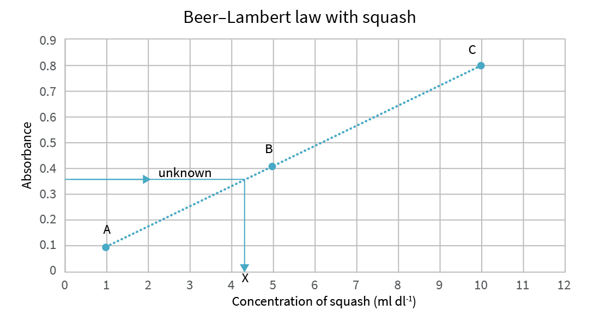
You can now use your graph to find the concentration of an unknown sample of diluted squash by plotting its absorbance on the y-axis and drawing a straight line over to your line of best fit and then down to the x-axis.
The units in the label on the x-axis include dl, or decilitres. 1 dl is the same as 100 ml.

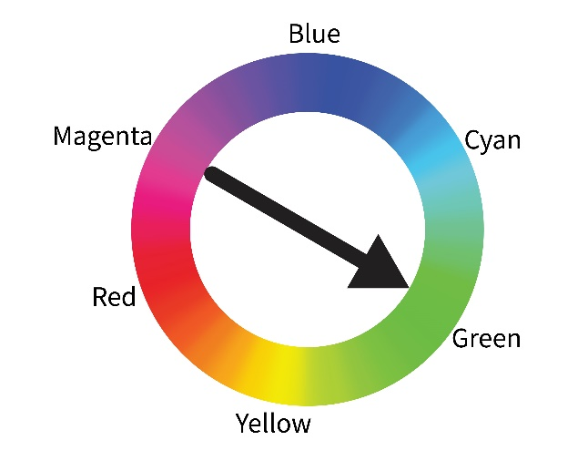
Explanation
The reason we see colour is because everything around us absorbs different wavelengths of light. The colour wheel can help us keep track of what colours are being absorbed. In this experiment, our blackcurrant drink is purple/magenta so it will absorb green light – green is opposite magenta on the colour wheel.
Using identical drinking glasses and an equal amount of water in each drink is important because it reduces the number of variables in the experiment. In this instance, the glasses and volume of water become our constants. The only variable should be the amount of blackcurrant squash that is added to each drink sample. It is always important to discuss which are the constants and variables with learners, particularly when setting up experiments.
Image © Royal Society of Chemistry
Adapted from © Shutterstock
In more diluted drinks there is only a small amount of blackcurrant squash available to absorb the light. Most of our green light from the torch will pass straight through the drink and into the camera of the smart phone, giving us a large lux number. However, in more concentrated drinks there is more blackcurrant squash available to absorb the light. In this case, only a small amount of light will pass through the drink and into our smartphone camera, which will give us a smaller lux number.
External light will affect the results. Make sure to do the experiment away from other light sources like a window, or perhaps set it up in a closed space such as a box, etc.

Also check out
You can take this activity further using the PhET Beer’s law simulation: rsc.li/3i9zjqa.

