F5 Light and electrons in energy levels

This is the fifth lesson in an introductory course for post-16 chemistry learners covering key ideas in order of scale. Find out more about the course and approach here: [**rsc.li/4kGyaoN**](https://rsc.li/4kGyaoN)

Before each lesson, ask learners to complete the preparation worksheet to revise knowledge from their 14–16 courses or previous lessons and introduce the topic for the lesson.

Then, get them to complete the student sheet during the lesson. It includes all key content and challenges misconceptions. Each student sheet has a scale and a Johnstone’s triangle diagram at the top. Use these to help learners think about the relative scale of different aspects of chemistry and connect their understanding of sub-microscopic, macroscopic and symbolic representations.

This icon indicates that students will need access to learning materials e.g. textbook or online resources to support their learning. See [**rsc.li/4m69t6t**](http://rsc.li/4m69t6t) for links.

Begin each lesson by checking learners have completed the preparation work. Share the answers and ask learners to mark their own worksheets as part of their independent work.

Topics in this lesson

|  |  |  |
| --- | --- | --- |
| Beginning with solid fill | **Last lesson** | F4 Modelling radioactive decay |
|  | **Preparation worksheet** | Revision: models of the atom  New content: electrons moving within atoms |
|  | **Lesson worksheet** | Properties of light: wave model of light, particle model of light; the Bohr model of the atom; application of emission spectra |
| End with solid fill | **Next lesson** | F6 Recording data and uncertainty |

Answers

Revision: models of the atom

|  |  |  |  |
| --- | --- | --- | --- |
| **Model** | **Name of model** | **What it shows** | **Limitations** |
| A | indivisible spheres | each element’s atoms are different; atoms are solid spheres | no subatomic particles are shown |
| B | plum pudding | negative charges (electrons) embedded in positive cloud | no nucleus, no subatomic particles |
| C | nuclear model | very small dense positive nucleus; atom is mostly empty space | no neutrons; no energy levels for electrons |
| D | Bohr model | very small dense positive nucleus containing protons and neutrons; atom mostly empty space; electrons in levels | does not show the smaller particles like quarks which the subatomic particles are made from |

New content: electrons moving within atoms

1. **wave speed = wavelength x frequency**

= wave speed in metres per second (m s-1)

= frequency in hertz (Hz) = s-1

= wavelength in metres (m)

**energy = Planck’s constant x frequency**

= Energy in joules (J)

= Planck’s constant in joule seconds (J s)

= frequency (s-1)



(a) 3.00 x 108 m s-1

(b)

(c)

energy = Planck’s constant x frequency

Worksheet

**Scale**

|  |  |  |  |
| --- | --- | --- | --- |
| **Subatomic** | **Atom** | **Molecule** | **Giant structure** |
| Electrons |  |  |  |

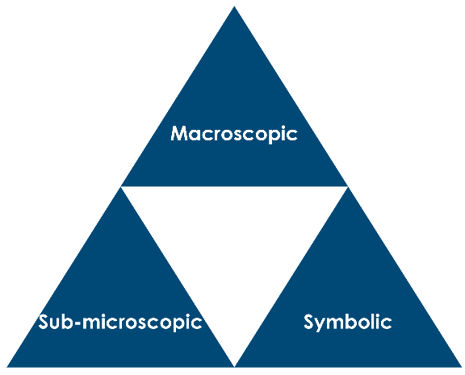

Visible light

Electrons

1. Radio waves, microwaves, infrared (IR), red, orange, yellow, green, blue, indigo, violet, ultraviolet (UV), x-rays, gamma rays.

→ Increasing energy

→ Increasing frequency

→ Decreasing wavelength

wavelength (m)

1. frequency (Hz or S-1)

speed of light (m s-1)

Planck’s constant 6.63 x 10-34 J Hz-1

1. frequency (Hz or s-1)

Energy (J)

= 680 nm

1. At 680 nm on the scale: orange–red.

The Bohr model of the atom

1. In energy levels.
2. One electron, an infinite number of energy levels are available.
3. The electron jumps up to a higher energy level.

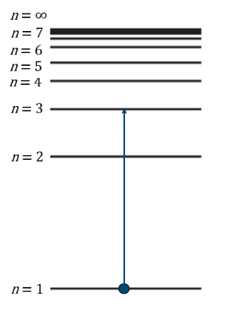

1. The electron drops back down to a lower energy level.
2. The energy of the proton is the same as the energy difference between the two levels.

* coloured lines
* on a black background
* getting closer together at higher frequency
* in sets of lines in the IR, visible and UV regions

1. It will have lines in different places because it has unique energy levels.
2. These lines correspond to the fixed energy gaps between energy levels and .
3. 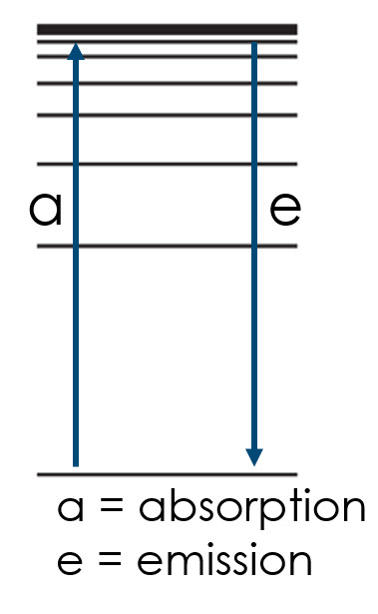Black lines on a coloured background at the same frequencies as the emission spectrum.
4. They are in the same positions because the size of the transitions are the same.
5. Because each element has unique energy levels, and gaps between them.
6. Because these correspond to electrons dropping down to e.g. the first level (Lyman, UV), second level (Balmer, vis) or third level (Paschen, IR).

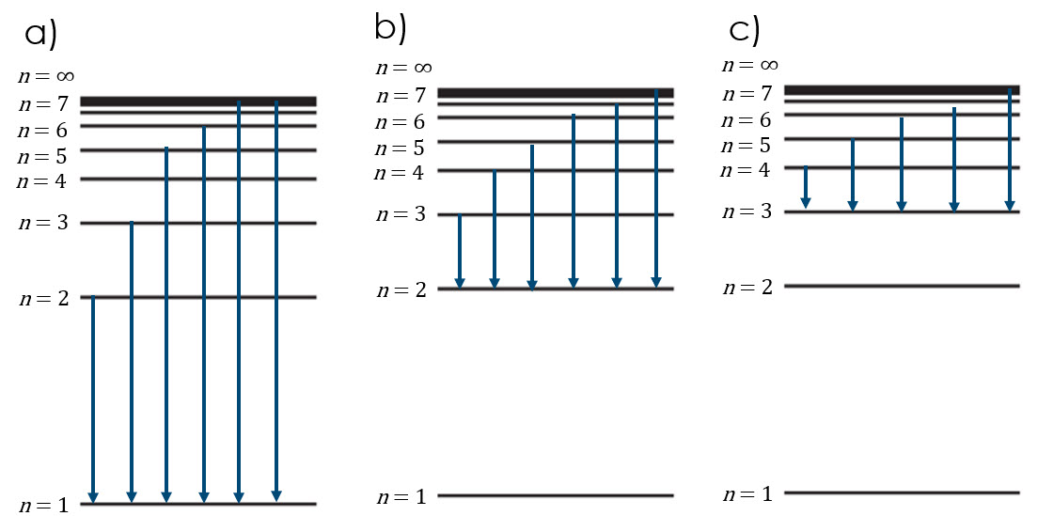

1. a = largest energy gap → highest frequency → UV

b = middle energy gap → middle frequency → visible

c = smallest energy gap → lowest frequency → IR

1. The difference between the energy levels gets less as they eventually converge.

= 6.63 10-34 4.851014

= 3.22 10-19 J (3 s.f.)

1. yellow–orange

= 4.43m

443 nm (violet)

1. Each element has unique energy levels so the gaps between them are unique. Due to the relationship , the lines are at different frequencies.
2. Contains strontium and lithium but no cadmium.

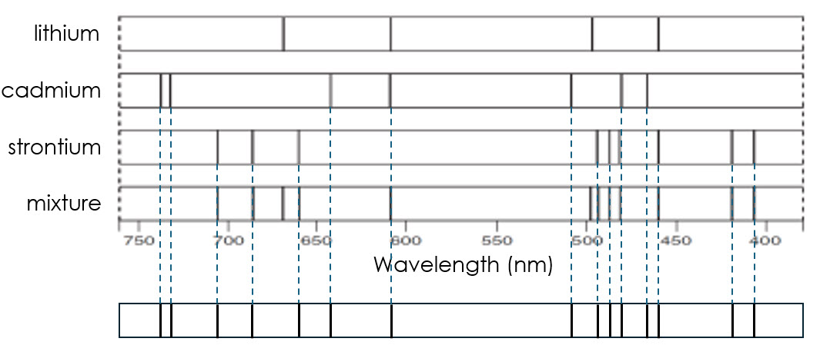

1. (a)

|  |  |  |
| --- | --- | --- |
| **Energy level *n*** | **Energy in electron volts / eV** | **Energy in joules / J** |
| 1 |  | -2.18 x 10-18 |
| 2 |  | -5.45 x 10-19 |
| 3 |  | -2.42 x 10-19 |
| 4 |  | -1.36 x 10-19 |
| 7 |  | -4.49 x 10-20 |
| 9 |  | -2.72 x 10-20 |
| 12 |  | -1.51 x 10-20 |
| 20 |  | -5.45 x 10-21 |
| ∞ |  | 0 |

By the way… For *n*=1 to *n*=2:

= 2.466 1015 Hz

= 1.22 10-7 m

122 nm

= UV light

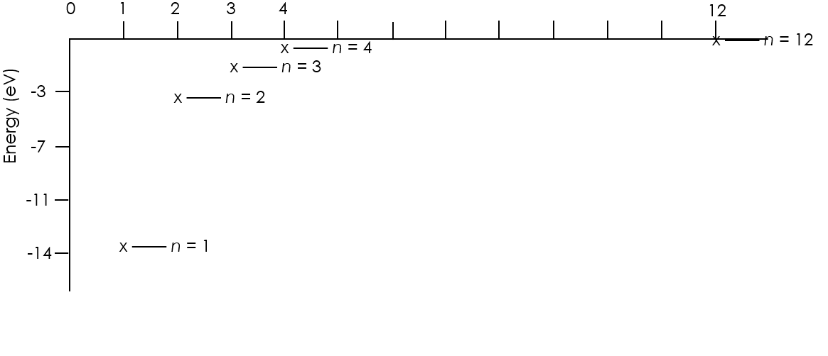

(c) The electron will leave the atom.