Microscale universal indicator
These technician notes are part of a collection of microscale chemistry resources at: rsc.li/4iiIjbl. Integrated instructions for this experiment are also available from rsc.li/4i8Muq6.

Introduction

Use this activity to introduce learners aged 11–16 to the concept of pH, as well as addressing common misconceptions regarding the use of indicators.

Equipment (per group)
- A4 print out of integrated instructions (laminated or within a plastic wallet)

All chemicals below to be supplied in 10 ml dropper bottles:
- Hydrochloric acid (0.1 mol dm⁻³), 12 drops
- Sodium hydroxide (0.1 mol dm⁻³), 12 drops
- pH 4 buffer solution, 12 drops
- pH 7 buffer solution, 12 drops
- pH 9 buffer solution, 12 drops
- Bromothymol blue solution (<1%), 20 drops
- Phenolphthalein (0.05%), 15 drops
- Methyl orange solution (<1%), 15 drops
- Universal indicator solution, 20 drops

Full preparation information and hazard classification is given below.

Safety equipment
- Eye protection: safety glasses to EN166 F

Method

Part 1 – testing indicators

Complete the experiment on the integrated instructions worksheet (slide 3).

Working down the columns:​
- Add 2 drops of strong acid to each square in the first column.​
- Add 2 drops of weak acid to each square in the second column.​
- Add 2 drops of neutral buffer to each square in the third column.​
- Add 2 drops of weak alkali to each square in the fourth column.​
- Add 2 drops of strong alkali to each square in the last column.​

Working across the rows:​
- Add 2 drops of bromothymol blue to each square in the top row.​
- Add 2 drops of methyl orange to each square in the second row.​
- Add 2 drops of phenolphthalein to each square in the third row.​
- Add 2 drops of universal indicator to each square in the bottom row.

The expected results are shown in the image below.

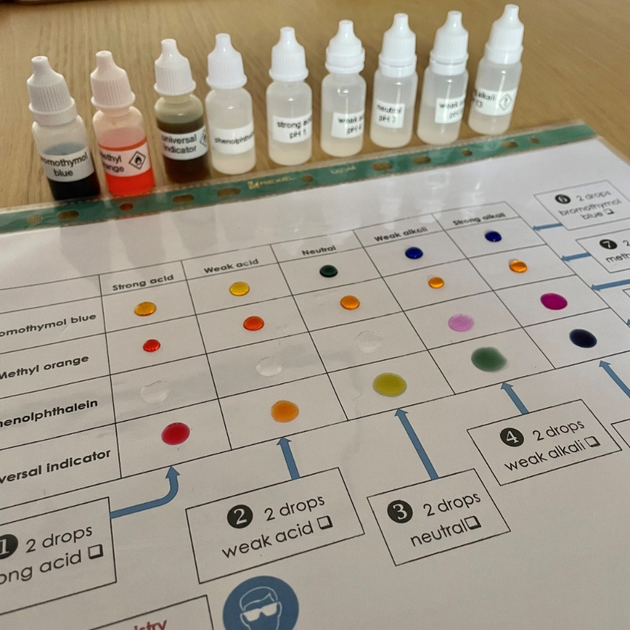

Part 2 – making universal indicator

Complete the experiment on the integrated instructions worksheet (slide 4).
- Make the mixed indicator by adding 10 drops of bromothymol blue, 5 drops of methyl orange and 5 drops of phenolphthalein to a small beaker or vial.

Working down the columns:
- Add 2 drops of strong acid to each square in the column.
- Add 2 drops of weak acid to each square in the column.
- Add 2 drops of neutral buffer to each square in the column.
- Add 2 drops of weak alkali to each square in the column.
- Add 2 drops of strong alkali to each square in the column.

Working across the rows:
- Add 2 drops of your mixed indicator to each square in the top row.
- Add 2 drops of universal indicator to each square in the bottom row.

Safety
- Read our standard health and safety guidance (rsc.li/3zyJLkx) and carry out a risk assessment before running any live practical.
- Hazard classification may vary depending on supplier.
Chemical supplied for the practical | Preparation
Hydrochloric acid, 0.1 mol dm⁻³  HCl(aq)  Not currently classified as hazardous. | Hydrochloric acid, concentrated (≥6.8 M)  HCl(l)  MW = 35.46 g mol⁻¹  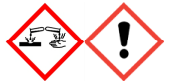  DANGER  Corrosive to skin and eyes.  Irritant if inhaled.  Refer to CLEAPSS Hazcard 47A.  Prepare solution following CLEAPSS recipe sheet RB043.
Sodium hydroxide, 0.1 mol dm⁻³  NaOH(aq)  Not currently classified as hazardous. | Sodium hydroxide, solid  NaOH(s)  MW = 40.00 g mol⁻¹  DANGER  Corrosive to skin and eyes.  Refer to CLEAPSS Hazcard 91A.  Prepare solution following CLEAPSS recipe sheet RB085.
Buffer solutions pH 4, 7 and 9  Not currently classified as hazardous. | Buffer solutions  Buffer tablets of pH 4, 7 and 9 can be used or alternatively prepare the buffer solutions following CLEAPSS recipe card RB018.  If following the recipe card:  Sodium tetraborate-10-water (borax)    DANGER  May damage fertility and the unborn child.  Refer to CLEAPSS Hazcards 13B, 09A and 14A.

Phenolphthalein 0.05% solution  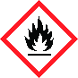  WARNING  Flammable  CLEAPSS Hazcard 032. | Phenolphthalein, solid  DANGER  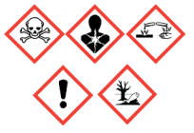  May include a risk of one or more hazard statements including, but not limited to:  May be fatal/toxic if inhaled or in contact with skin or eyes.  May cause breathing difficulties if inhaled.  May damage fertility or the unborn child.  Check CLEAPSS Hazcard 032 for most up to date guidance.  Ethanol (and IDA)  WARNING  Flammable  CLEAPSS Hazcard 040A.  Prepare solution following CLEAPSS recipe sheet RB046.
Methyl orange (<1%) solution  WARNING  Flammable  CLEAPSS Hazcard 032 | Methyl orange, solid  DANGER  May include a risk of one or more hazard statements including, but not limited to:  May be fatal/toxic if inhaled or in contact with skin or eyes  May cause breathing difficulties if inhaled  May damage fertility or the unborn child  Check CLEAPSS Hazcard 032 for most up to date guidance.  Ethanol (and IDA)  WARNING  Flammable  CLEAPSS Hazcard 040A.  Prepare solution following CLEAPSS recipe sheet RB046.
Bromothymol blue (<1%) solution  WARNING  Flammable  CLEAPSS Hazcard 032. | Bromothymol blue, solid  Not currently classified as hazardous.  Ethanol (and IDA)  WARNING  Flammable  CLEAPSS Hazcard 040A.  Prepare solution following CLEAPSS recipe card RB046.
Universal indicator solution  WARNING  Flammable  CLEAPSS Hazcard 032. | Universal indicator solution  Either use a commercial universal indicator or prepare a solution following CLEAPSS recipe card RB047.  Follow the recipe in conjunction with the advice on CLEAPSS Hazcards 032 and 040A.

Disposal
- Wipe down the laminated sheet/plastic wallet with a paper towel and dispose of the towel in laboratory waste.
- Rinse and dry the laminated sheet/plastic wallet.

