Metallic deuterium formed at high pressures

This resource forms part of the **structure and bonding** topic package where you will find more resources to embed literacy skills development into your teaching. You can edit all the linked files in this resource to best suit the needs of your learners.

Learning objectives

1. Use active reading strategies to help you understand a science news story.
2. Use the glossary to support your understanding of unfamiliar words.
3. Know what key information to look for when reading a science news story.
4. Understand how people write about science differently depending on their audiences.
5. For extension – confidently talk about the science news story, with consideration for your audience.

Questions 1–3 in the student sheet support learning objectives 1 and 2. Question 6 supports learning objective 3. Questions 7–9 support learning objective 4 and the ‘Present the news’ extension task supports learning objective 5.

Introduction

Reading about science is pivotal for understanding the world around us and the events and discoveries that effect our lives. In this reading comprehension, learners will actively engage with a simple text about a research article.

*Education in Chemistry* has collated and distilled a wealth of science research news stories (see [rsc.li/4m10GDJ](https://rsc.li/4m10GDJ)). This reading comprehension resource is based on one of these stories relevant to the **structure and bonding** topic. This resource includes:

|  |  |  |
| --- | --- | --- |
|  | **Extension task** | |
| **Reading comprehension worksheet**  A simplified summary of a research article with comprehension questions and a glossary. | **Present the news slides**  Instructions for extension task, plus hints and reflection questions. | **Present the news script**  A script template for learners to write into in groups and a table for reflecting on class presentations. |

Reading comprehension activity

The story text has line numbers so you can easily direct learners to particular parts of the text. These can be disabled; more information [bit.ly/4cHKkeW](https://bit.ly/4cHKkeW)

Model active reading

Read the story aloud with your learners and prompt them throughout to actively engage with the text. You can ask:

* ‘What do you think will happen next?’
* ‘How would you rephrase what’s just been said?’
* ‘What is this news story about?’

More info: [rsc.li/4jqaF3A](https://rsc.li/4jqaF3A)

Consider using playback or recording software, so that learners can listen to the text on a device as they read along.

Question 6 asks learners to write a summary of the news story for their classmates, using the prompts given. You can work through this question as a class first, before tasking learners to draw out the required information from the text independently. You can get learners to peer mark the summaries.

Glossary of relevant terms

The glossary is pre-populated with vocabulary from the story that learners may need support with. The Education Endowment Foundation recommends prioritising teaching tier 2 and tier 3 terms, which learners are less likely to hear or read outside of their science lessons. More information: [bit.ly/4imgii2](https://bit.ly/4imgii2)

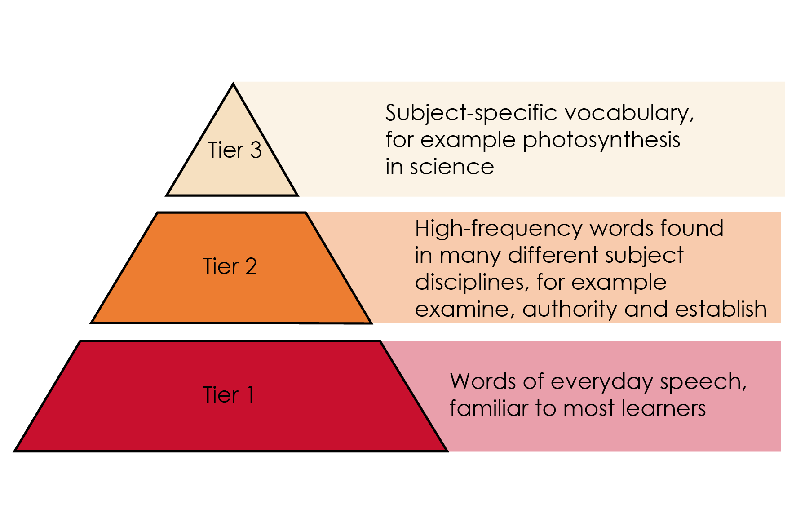

Reproduced with permission from Guildford Press, copyright 2013

The words listed in bold in the glossary are key terms and link with our key terms support resources ([rsc.li/444TbFh](https://rsc.li/444TbFh)). For more challenge, remove or edit entries and task learners with researching and then populating the glossary.

Accompanying resources

To answer questions 7 and 8, learners will need access to a longer and more complex version of the reading comprehension text. This is available to download and print or can be viewed online. Learners will need a printed version to annotate in question 7. See: High pressure forces heavy hydrogen to act like a metal ([rsc.li/3pZFGkU](https://rsc.li/3pZFGkU))

Extension task: present the news

Instruct learners to present the science news story they have read as an item in a news programme.

Split learners into groups of three or four and assign each of them one of three roles – news anchor, reporter, or scientist. If there are more than three per group, assign multiple scientists. It’s important that everyone says something during the presentation.

* Project the ‘Present the news’ slides on the board. Explain the task (slide 2) and provide learners with printouts of what each role needs to do (slides 3–5).
* Talk through the slide called ‘What does a good news presentation look like?’ (slide 6) before inviting the groups to present (allow five minutes per group).
* Give learners the script template and direct them to prepare, as a group, what they want to say in the presentation. This will firstly involve reading the introduction on the script template, which you can do as a class if necessary. As a rough guide, allow about 45 minutes for learners to prepare.
* Direct learners to fill in the feedback sheet on the script template while their classmates are presenting. After all groups have presented, invite reflections and make notes of any learnings for the next speaking and listening activity.

Oracy Cambridge’s Oracy skills framework provides more information about speaking and listening skills. For more information, see: [bit.ly/4jBaTEG](https://bit.ly/4jBaTEG)

Metacognition

This resource supports learners to develop their metacognitive skills in three key areas.

|  |  |
| --- | --- |
| **Aspect** | **Ideas for prompts** |
| Plan | * Question 6 provides learners with a series of prompts to scaffold their summary of the science news story. * The ‘present the news’ script introduction contains questions for learners to ask themselves when planning the presentation, for example about keeping to time. |
| Monitor | * Ask learners questions when reading the text aloud (see section called ‘model active reading’) to prompt them to monitor their understanding throughout the task. * The comprehension questions prompt learners to assess how much the active reading strategies help them to understand the text and what other strategies they can employ to aid their understanding. |
| Evaluate | * Invite feedback on answers to the metacognitive questions (those in the red boxes) and collate a reading strategies ‘cheat sheet’ as a class. Revisit this cheat sheet the next time you do a reading comprehension activity. * Use the populated feedback table to reflect as a class on the strengths of the presentations and identify things to work on next time you do a class speaking and listening activity. |

Example answers and guidance

1. Positive metal ions are closely packed in a regular pattern. The ions are surrounded by a sea of delocalised electrons.

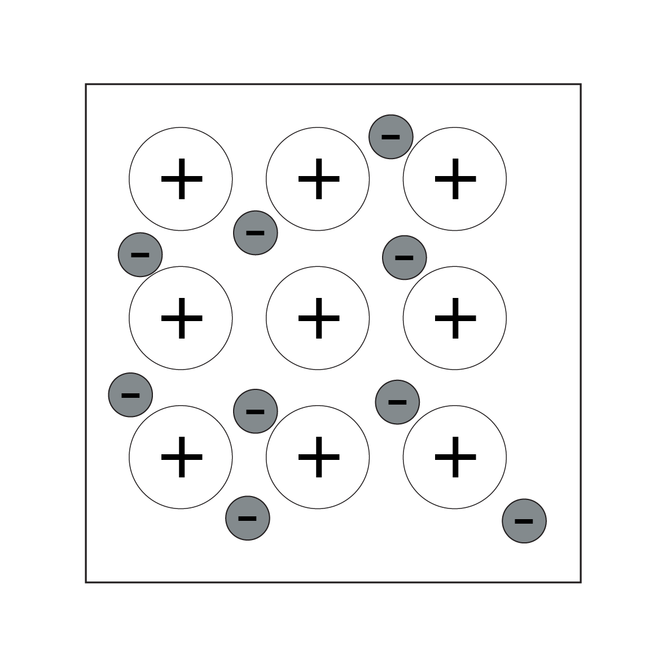

1. A delocalised electron is an electron in a molecule or structure that is not associated with any particular atom, ion, or covalent bond and which is free to move. This means the delocalised electrons are free to move through the structure and carry electrical charge.
2. Element – a pure substance made of only one type of atom.
3. Absorption – the process of taking something into another substance.
4. Isotope – atoms with the same number of protons but different numbers of neutrons.

Learners rate how much the glossary is helping them. Do a rough show of hands to gauge confidence and note learners’ responses.

1. Scientific words: element, metallic, atom, electron, delocalised, isotope.

The point of this exercise is to prompt learners to consider which potentially unfamiliar words are specific to science or chemistry, compared to e.g. connecting words. The list above is an example and there may be variation in answers.

1. Look for a good understanding of the key message in the story. Example answer – pressure, isotope, metallisation, electrons, delocalised, superconductors, rocket fuels.

Learners rate how much circling words is helping them. Do a rough show of hands to gauge confidence and note learners’ responses.

Learners rate their confidence explaining the story. Do a rough show of hands to gauge confidence and note learners’ responses. Ask learners to share their strategies for the benefit of the class.

How learners rate the techniques in questions 3 and 4, and their confidence to explain the story, can inform your approach to future reading comprehension activities.

1. Ask learners to share what they have learned from reading the news article.
2. Indicative answers for summary of story.

* *What have the scientists discovered? (Findings)*

That hydrogen/deuterium can be given the properties of a metal if it is compressed at a high enough pressure.

* *What was it that scientists were trying to investigate? (Context)*

Whether elements can be given the properties of metals.

* *Why does their discovery matter? (Relevance/application)*

It could be used in the development of superconductors and rocket fuels.

It allows us to use common elements in new ways by giving them new properties.

* *Think about who it matters to and what impact it could have for them. (Impact)*

Scientists developing superconductors and rocket fuels, and people (including other scientists) who might benefit from these new technologies.

1. Learners should highlight the full article in different colours using the prompts. See the highlighted text below as an example.

* What have the scientists discovered? (The findings)
* What was it that scientists were trying to investigate? (The context)
* Why does their discovery matter? (Relevance/application)
* Think about who it matters to and what impact it could have for them.

**High pressure forces heavy hydrogen to act like a metal**

Original article by Tim Wogan. Adapted by Emma Davies.

**Scientists have created a metallic hydrogen isotope that offers a superconductor promise**

A French team that first made headlines when it claimed to have made metallic hydrogen has now found promising evidence that the isotope deuterium can also be forced into a metallic state but at even higher pressure.

Metallic hydrogen and deuterium hold great promise for new superconductors. They could also be used for powerful rocket fuel, which would be ‘game changing’, according to Nasa.

**Piling on the pressure**

In theory, all elements become metallic at sufficiently high pressures to squeeze the atoms close enough together that electrons become delocalised, like those in a metal. First predicted in the 1930s, metallic hydrogen is thought to exist at high temperature and pressure inside the giant planets Jupiter and Saturn, giving them their magnetic fields. Producing metallic hydrogen in the laboratory could therefore also help astrophysicists to understand how the two planets formed.

The article above has been truncated in these teacher notes, to save space. Visit High pressure forces heavy hydrogen to act like a metal ([rsc.li/3pZFGkU](https://rsc.li/3pZFGkU)) to access the full article.

* The article is longer.
* It contains more details about the discovery and what related research has been done.
* It contains quotes from scientists.
* It gives examples of why the research was being done and where it could be useful.
* It has subheadings.

1. Look out for an awareness of different writing formats and an appreciation that different audiences have different needs or interests, for example:
2. shorter version, links to other interesting articles, key message up front, relevant pictures or video clips
3. longer version, lots of detail, including information on who did the research and maybe their contact information
4. simplifying complicated language, pictures to aid understanding.

Example script for Present the news

|  |  |  |
| --- | --- | --- |
| **Role** | **What to communicate** | **Example script** |
| News anchor | Introduce the discovery in one sentence. | Scientists have figured out how to make a form of hydrogen act like a metal, even though hydrogen is a non-metal. |
| News anchor | Explain why this discovery might be important. | This could be an important step in developing new superconductors or rocket fuels. |
| News anchor | Introduce your reporter who will provide more information. | Our reporter (Name of learner) has been investigating. |
| Reporter | Briefly explain the context – the difference between metals and non-metals and what the scientists have done. | All elements are either metals or non-metals. But by applying enough pressure, scientists have been able to make deuterium (an isotope of hydrogen) act like a metal. |
| Reporter | In one sentence, introduce the scientist/s and why you are interviewing them. | Here we have (learner name) to tell us about how this discovery was made. |
| Reporter | Ask the scientist to explain what they did. | [Name of scientist], tell us what deuterium actually is, and what you did and what you discovered. |
| Scientist | Answer the first question | Deuterium is similar to hydrogen in that it has 1 proton and 1 electron. But it has 2 neutrons, so it’s a bit heavier.  We put deuterium under so much pressure that the electron delocalised (which means it could move free) and in this way it is acting like a metal.  Delocalised electrons are what make metals good conductors of electricity. |
| Reporter | Ask why being able to make deuterium act like a metal is important or useful. | Why is pressurising deuterium like this useful? What is the point? |
| Scientist | Respond to the question. | Metallic hydrogen could be really useful as a new superconductor. It could also be used as a powerful rocket fuel. |
| Reporter | Prompt scientist to explain more of the background. | But why do this experiment with so-called heavy hydrogen, rather than just hydrogen? |
| Scientist | Respond to the question. | Well in 2020 a French team claimed to have crushed hydrogen in a diamond anvil at a pressure of 425 gigapascals (GPa). So we wanted to know if we could do the same with a different type of hydrogen and we did manage it at 460 GPa. |
| Reporter | Ask the scientist where the research needs to go next. | So, what’s next? What else do we need to know about giving non-metals metallic properties in this way? |
| Scientist | Tell the reporter what else needs to be done or found out in order to move closer to this discovery having a real impact on people. | It would be interesting to see if we can increase the pressures even more and find out if we can increase electrical conductivity in metallic hydrogen. |
| Reporter | Thank the scientist. | Thank you very much for your time. |
| Scientist | Acknowledge the thanks. | No problem. |
| News anchor | Say something in response to what the scientist and the reporter have said, which reflects what your audience might be thinking. Thank the reporter. This will end the presentation. | Thank you to our reporter (learner name) for that report. A really exciting discovery and one that could help us in future space exploration. |

Acknowledgements

Vocabulary tier diagram: Beck, Isabel L., Margaret G. McKeown, and Linda Kucan. *Bringing Words to Life: Robust Vocabulary Instruction*. New York: Guilford Press, 2013.