Spot the bonding

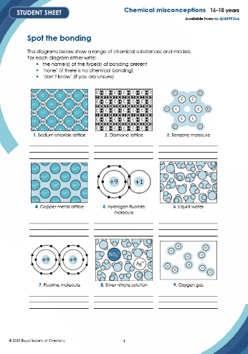This resource is from **Chemical misconceptions – prevention, diagnosis and cure**,which can be viewed at: [rsc.li/456d4fF](https://rsc.li/456d4fF). This series of resources includes classroom activities you can use to identify learner misconceptions; challenge some of these alternative ideas; and help learners construct the chemical concepts they need to grasp.

Resource components

**Student sheet:** a set of diagrams where learners must identify the type/s of bonding represented in each one.

How to use this resource

Use this resource to quickly audit learners’ awareness of different bond types. (Use the **Interactions** resource to explore post-16 learners’ more detailed understanding of the same topic: [rsc.li/3qEUZTr](https://rsc.li/3qEUZTr).)

Point out to learners that some of the diagrams refer to individual atoms or molecules, while others show some of the particles in named substances and they should therefore pay close attention to the labels under the figures.

|  |  |  |  |  |
| --- | --- | --- | --- | --- |
| **When to use?** | Enter with solid fill Introduce | Watering pot with solid fill **Develop** | Arrow circle with solid fill Revise | Clipboard Mixed with solid fill **Assess** |
| Use with 16–18 learners, who have completed studying bonding at post-16 level. | | | |
| **Group size?** | Head with gears with solid fill **Independent** | Group brainstorm with solid fill Small group | Classroom with solid fill Whole class | Work from home house with solid fill Homework |
| Suitable for independent work in class to diagnose learners’ misconceptions. | | | |
| **Topics assessed?** | Chemical bonding (including: ionic, covalent, metallic, polar, hydrogen, dipole-dipole, van der Waals, solvation, dative, double, delocalised). | | | |
| **How long?** | Stopwatch 25% with solid fill | | 10–15 minutes | |

Rationale

Research suggests that learners focus on covalent and ionic bonding, and can either miss, or down-play the importance of, other types of bonding. You can read a discussion of learners’ ideas about atomic structure and other chemical structures here: [rsc.li/3NOaVvL](https://rsc.li/3NOaVvL).

A variety of types of diagram are used in this resource, as it is important for learners to be able to interpret and use various ways of representing chemical species (read more about learners’ beliefs in alternative ideas at: [rsc.li/44mXmJf](https://rsc.li/44mXmJf)).

Scaffolding

An alternative version of this resource has been adapted for learners aged 14–16 years and is available here: [rsc.li/3ILA7mt](https://rsc.li/3ILA7mt)

The 14-16 version includes lesson slides, two levels of worksheet (one with fewer diagrams selected for their familiarity to 14–16 learners) and an acknowledgement of the limited range of bond types met at the 14–16 level.

Answers

|  |  |  |
| --- | --- | --- |
| **Question** | **Figure** | **Answer** |
| **1** | Sodium chloride lattice | ionic |
| **2** | Diamond lattice | covalent |
| **3** | Benzene molecule | covalent, delocalised |
| **4** | Copper lattice | metallic |
| **5** | Hydrogen fluoride molecule | covalent, polar |
| **6** | Liquid water | covalent, polar, hydrogen, van der Waals forces, dipole-dipole forces |
| **7** | Fluorine molecule | covalent |
| **8** | Silver nitrate solution | covalent (water), polar, hydrogen, van der Waals forces, dipole-dipole forces, solvent-solute interactions |
| **9** | Oxygen gas | (double) covalent, van der Waals, sigma + pi |
| **10** | Sulfur molecule | covalent |
| **11** | Sodium atom | no chemical bonding (although intra-atomic forces of similar nature) |
| **12** | Aluminium chloride dimer | covalent, polar, including dative (coordinate) covalent |
| **13** | Carbon dioxide molecule | (double) covalent, polar (double/sigma + pi) |
| **14** | Ethanoic acid dimer | covalent, polar, hydrogen |
| **15** | Iodine lattice | covalent, van der Waals forces |
| **16** | Ammonia molecule | covalent, polar |
| **17** | Magnesium oxide lattice | ionic |
| **18** | Liquid hydrogen chloride | covalent, polar, van der Waals forces |

Notes

1. Where a bond has significant polarity, it could be described as polar rather than covalent (or polar covalent).
2. The term *van der Waals forces* has been used for induced dipole-dipole forces.
3. Learners may forget to mention van der Waals forces in cases where they recognise hydrogen-bonds are present (i.e. items 6, 8, and 18).
4. The presence of some covalent character in the magnesium oxide lattice may be spotted by some learners.