Dissolving salt: Johnstone’s triangle

This resource is from the **Johnstone’s triangle** series which can be viewed at: [rsc.li/43jMfSn](https://rsc.li/43jMfSn) It will help learners to understand the different ways you need to think in chemistry, building their mental models and understanding.

Learning objectives

1. State that solutions are formed when a solute is dissolved in a solvent.
2. Explain this in terms of the particles present.

How to use Johnstone’s triangle

Use Johnstone’s triangle to develop learners’ thinking about scientific concepts at three different conceptual levels:

* 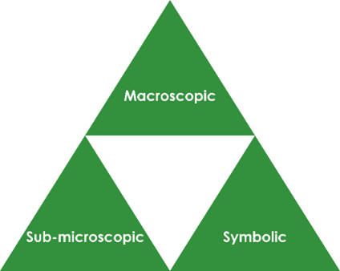Macroscopic – what we can see. Think about the properties you can observe, measure and record.
* Sub-microscopic – smaller than we can see. Think about the particle or atomic level.
* Symbolic – representations. Think about how we represent chemical ideas including symbols and diagrams.

For learners to gain a deeper awareness of a topic, they need to understand it at all three levels.

When introducing a topic, do not try to introduce the three levels of thinking at once. This will overload working memory. Instead complete the triangle over a series of lessons, beginning with the macroscopic level before introducing the sub-microscopic and then the symbolic levels, once understanding of the previous stages is secure.

The three levels are interrelated, for example, learners need visual representation of the sub-microscopic level to develop mental models of the particle or atomic level.

Find further reading about Johnstone’s triangle and how to use it in your teaching at [rsc.li/422BP92](https://rsc.li/422BP92)

Scaffolding

It is important to share the structure of the triangle with learners prior to use. Tell them why you want them to use the triangle and how it will help them to develop their understanding. Use an ‘I try, we try, you try’ approach when you are introducing Johnstone’s triangle for the first time.

More resources

To further develop learner’s thinking in all areas of Johnstone’s triangle, try our **Developing understanding of solutions** worksheets [rsc.li/4klHYVL](https://rsc.li/4klHYVL). These include icons in the margin referring to the conceptual level of thinking needed to answer the question.

Learner activity

Use this learner activity to encourage learners to observe and describe the macroscopic formation of a solution of salt in water.

Equipment per learner pair

* Spatula
* Mixture of sand and salt
* 100 ml beaker
* Water

Method

1. Add water to the beaker.
2. Add a spatula of the sand and salt mixture.
3. Stir gently.
4. Observe.

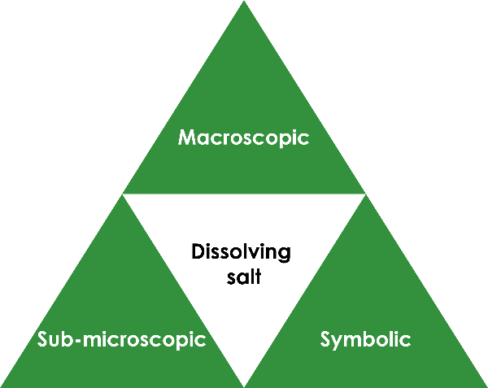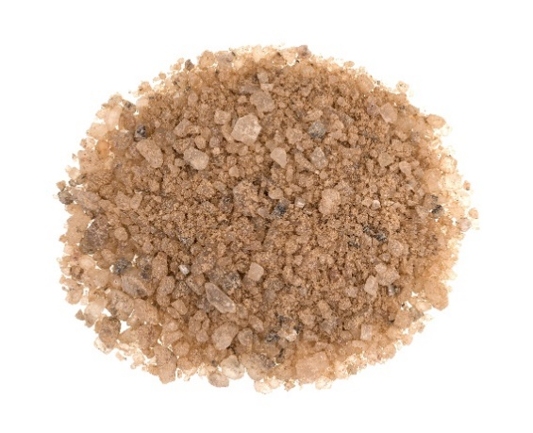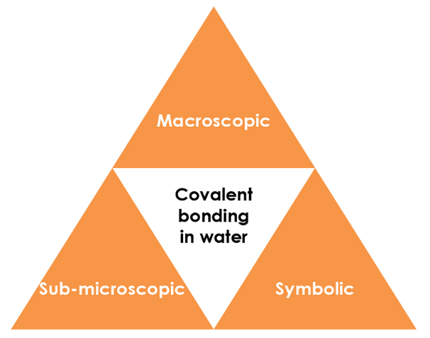

Macroscopic – what we can see

Add one teaspoon of sand and salt to water and stir gently. Note your observations.

**Some of the mixture (the salt/sodium chloride) dissolved but the rest (the sand) did not dissolve.**

© Shutterstock / BW Folsom

Symbolic – representations

Identify the solute, solvent and solution in the diagram below:  
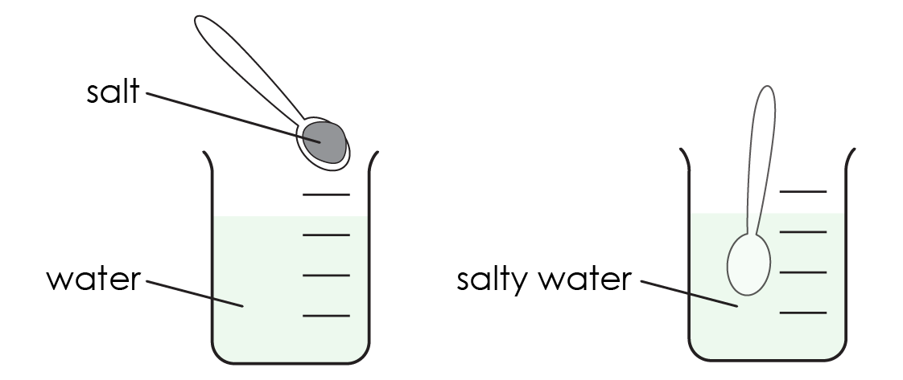

Solute: **salt**

Solvent: **water**

Solution: **salty water**

Sub-microscopic – smaller than we can see

Choose the correct term to complete the sentences:

Salt is in the **solid / ~~gas~~** state. The particles are **close together / ~~far apart~~**.

Water is a **~~solid~~ / liquid**. The particles are in **~~a fixed position~~ / able to move around**.

When salt is dissolved in water, the salt particles **~~move together~~ / spread out** to form a salt solution.

In the salt solution the salt particles are **evenly spread / ~~all in one place~~**.