Metallic bonding and the structure of iron

This resource is from the Assessment for learning series which can be viewed at: rsc.li/44jTX18. This series contains lesson plans and associated resources to actively involve students in their learning.

Resource components
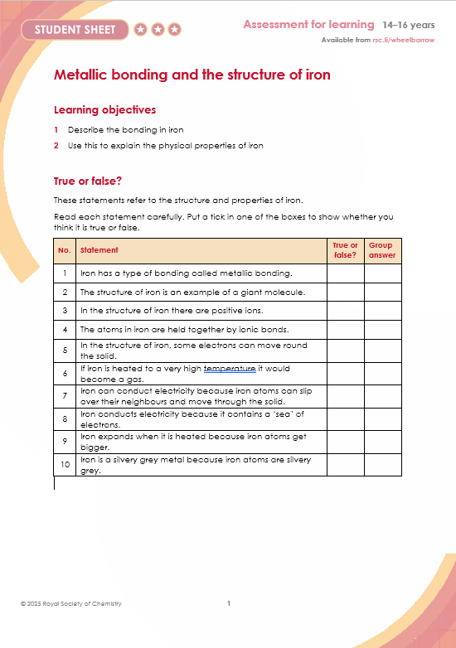 | 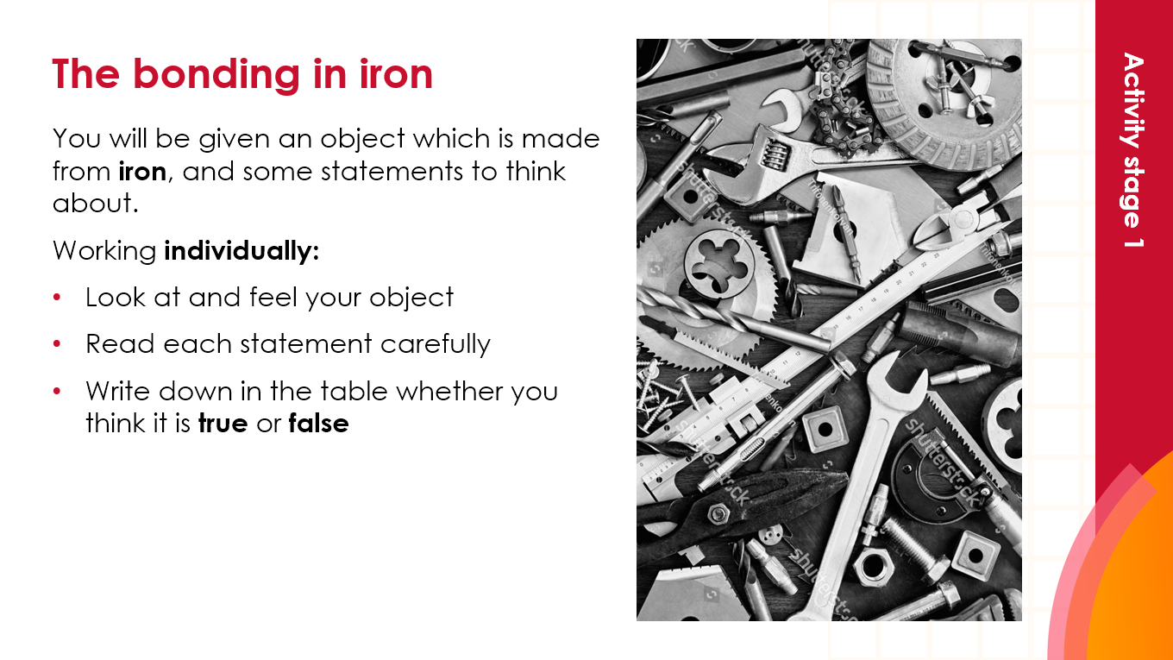
Student sheet: true or false table with space for group response. | Presentation: slides include learner-facing instructions, answers, explanations and animations to support challenging misconceptions.

Learning objectives
- Describe the bonding in iron.
- Explain the properties of iron using ideas about bonding.

After using this resource, learners will build on their prior knowledge of metals. They will be able to describe the bonding in iron, using a diagram of metallic bonding. They will be able to explain properties such as thermal expansion, malleability and conductivity using their model.

Teaching sequence

Introduction (slide 2)
- Give each learner a nail or a paper clip to look at and feel as a stimulus to focus their thinking.
- Share with the learners that they will:
- Describe the bonding in iron.
- Explain the properties of the metal using their ideas about bonding.

Activity: stage 1 (slide 3)

Give each learner a ‘Metallic bonding and the structure of iron’ question sheet, which has 10 statements about the structure and properties of iron. Ask them to work individually to:
- Look at and feel their object.
- Read each statement carefully.
- Write down in the table whether they think it is true or false.

Activity: stage 2 (slide 4)

Arrange learners into groups of three to:
- Look at each question in turn.
- Discuss the answers they gave initially and share ideas.
- Decide on a group answer and record this on the table.
- Be ready to share ideas and how they might have changed.

Activity: stage 3 (slides 5–9)

Issue mini whiteboards and:
- Ask each learner to draw a picture to represent the bonding in iron.
- Ask some learners to share their ideas.

Show the models of the structure of iron and highlight these key features:
- The outer shell electrons become delocalised and are free to move through the giant lattice of positive ions.
- The electrons are sometimes shown as a ‘cloud’ and referred to as a ‘sea of delocalised electrons’.
- These models can explain the physical properties of metals: conduction of electricity and heat, expansion on heating, malleability and ductility.

Reflection

Go through the answers in the PowerPoint slides. Demonstrate these ideas and help to challenge any misconceptions using the animations and links to YouTube videos in the presentation.

Commentary
- Use a tactile stimulus to help learners appreciate the objectives for the session.
- While working in groups, ask learners to compare their ideas with others, re-evaluate their initial ideas and develop them where appropriate.
- Ask probing questions to ensure that misconceptions are dispelled and that a correct model takes their place.
- Throughout the tasks, prompt learners to check their understanding.

Equipment

For each learner:
- Nail or paper clip.
- Mini whiteboard.

Scaffolding
- Think carefully about pairings and groupings for this task to ensure learners work effectively to develop their ideas.
- Move around the groups throughout the task to probe understanding and offer support where needed.
- When asking learners to draw a diagram to represent metallic bonding, provide learners with prompts where needed, such as ‘you must include: positive metal ions, delocalised electrons’.
- Pictures, videos and animations are helpful. Some are provided in the lesson slides, available to download here: rsc.li/3botPEO
- Provide learners with a diagram of metallic bonding to add labels to, if necessary.

Acknowledgements

The True or false? activity is an excerpt K Taber, Chemical misconceptions – prevention, diagnosis and cure, Volume 2: Classroom resources, Royal Society of Chemistry, London, 2002, Iron – a metal, 79-84. Find even more diagnostic true or false questions relating to metallic bonding and iron in this resource, available to download here: rsc.li/3CAGdA3

Answers
- Iron has a type of bonding called metallic bonding.

TRUE. Iron is a metal and all metals have a type of bonding called metallic bonding, which is different from covalent or ionic bonding. In metallic bonding, the outer shells of adjacent atoms overlap and the outer shell electrons are free to move through the lattice. The metal consists of metal cations and a balancing number of these ‘free’ electrons.
- The structure of iron is an example of a giant molecule.

FALSE. In iron the positive ions are packed together in a giant lattice, but we use the word molecule to imply that the structure contains covalent bonds, which iron does not.
- In the structure of iron there are positive ions.

TRUE. Because the electrons in the outer shell are free to move through the lattice, they leave behind positive iron ions.
- The atoms in iron are held together by ionic bonds.

FALSE. The bonding in iron is metallic bonding. This is different from ionic bonding because there are no negative anions present.
- In the structure of iron, some electrons can more round the solid.

TRUE. The electrons from the outer shell of atoms are free to move through the lattice of positive ions.
- If iron is heated to a very high temperature, it will become a gas,

TRUE. If iron is heated it will melt. If molten iron is heated to a sufficiently high temperature it will boil.
- Iron can conduct electricity because iron atoms can slip over their neighbours and move through the solid.

FALSE. The iron cations are normally fixed in their lattice positions and cannot move about. It is only the outer shell electrons that are free to move.
- Iron conducts electricity because it contains a ‘sea’ of electrons.

TRUE. The electrons from the outer shells of atoms are able to move about and will pass through the metal when it is connected to a battery.
- Iron expands when it is heated because iron atoms get bigger.

FALSE. When iron is heated the positive cations vibrate and move a little further apart.
- Iron is a silvery grey metal because iron atoms are silvery grey.

FALSE. The colour of iron is a property of the arrangement of cations and electrons. A single atom would not have a colour.

