Covalent structure and bonding

1. Which of the following usually have covalent bonding?

Circle the **two** correct answers.

(2 marks)

**A** compounds of metals and non-metals

**B** compounds of non-metals only

**C** molecules of non-metals

**D** mixtures of two metals

**E** pure metals

1. The electron configuration of a chlorine atom is 2, 8, 7.
   1. Complete the dot and cross diagram for a chlorine molecule. Show the outer shells of electrons only.

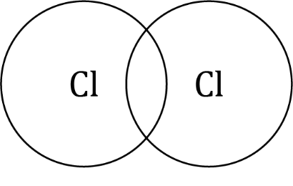

(2 marks)

* 1. Chlorine reacts with oxygen to form the compound Cl2O. The structure of Cl2O is shown in the diagram.

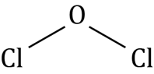

Draw a dot and cross diagram for a molecule. Show the outer electron shells only.

(3 marks)

* 1. i. Predict the state (solid, liquid or gas) of Cl2O at room temperature (25 °C).

______________________________________________________________________________________ (1 mark)

ii. Give a reason for your answer.

_____________________________________________________________________________

_____________________________________________________________________________

_____________________________________________________________________________

_____________________________________________________________________________

_____________________________________________________________________________

(3 marks)

* 1. Explain why the polymer poly(chloroethene) is solid at room temperature.

_____________________________________________________________________________

_____________________________________________________________________________

_____________________________________________________________________________

_____________________________________________________________________________

(3 marks)

1. Covalent bonds are formed when electrons are shared.
   1. How many electrons are shared in a double covalent bond?

______________________________________________________________________________________ (1 mark)

* 1. The electron configuration of an oxygen atom is 2, 6. The electronic configuration of a carbon atom is 2, 4. Draw a dot and cross diagram to show a carbon dioxide molecule, CO2. Show the outer electrons only.

(2 marks)

1. The diagram shows the dot and cross diagram for propanal.

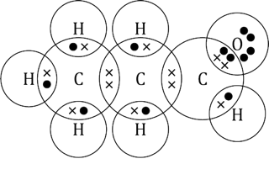

* 1. Complete the diagram to show the displayed formula for a propanal molecule.

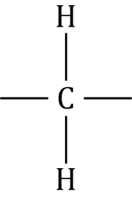

(2 marks)

* 1. What is the molecular formula for propanal?

______________________________________________________________________________________ (1 mark)

* 1. The table shows different ways of representing an ammonia molecule. Add ticks (✓) and crosses (x) to describe what the representations show.

|  |  |  |  |  |
| --- | --- | --- | --- | --- |
| **Does the representation show:** |  | Full displayed formula of ammonia showing a central nitrogen atom connected to three hydrogen atoms through single bonds. | Dot and cross diagram of an ammonia molecule showing a central nitrogen atom surrounded by three hydrogen atoms. The outer shell of each hydrogen atom overlaps with the nitrogen outer shell and there is a dot and a cross in each of the three areas of overlap. The outer shell of nitrogen also has two dots separately. | A computer image of a blue ball connected by three blue and white sticks to three white balls. |
| the types of atoms in the molecule? |  |  |  |  |
| the number of each type of atom? |  |  |  |  |
| how the electrons are shared? |  |  |  |  |
| the 3-D structure? |  |  |  |  |

(4 marks)

1. Different covalent substances have different structures. They may be simple molecules, polymers or have giant covalent structures.
   1. Complete the table to predict the structures of substances X, Y and Z.

|  |  |  |
| --- | --- | --- |
| **Covalent substance** | **Melting point /°C** | **Type of structure** |
| X | About 4000 |  |
| Y | –101.5 |  |
| Z | 120–130 |  |

(3 marks)

* 1. Name the type of attractions that are overcome when a simple molecular covalent substance melts.

_____________________________________________________________________________________ (1 mark)

* 1. Explain why a simple molecular substance cannot conduct electricity.

_____________________________________________________________________________

_____________________________________________________________________________

(1 mark)

[Total: 29 marks]

Which question(s) did you get wrong? Why?

What will you do next time you’re asked a similar question?