Hanukkah doughnuts: interpreting practical instructions

Learning objectives
- Interpret different forms for communicating practical instructions.
- Convert practical methods between different forms.
- Evaluate the advantages and disadvantages of different forms of practical instruction.

Introduction

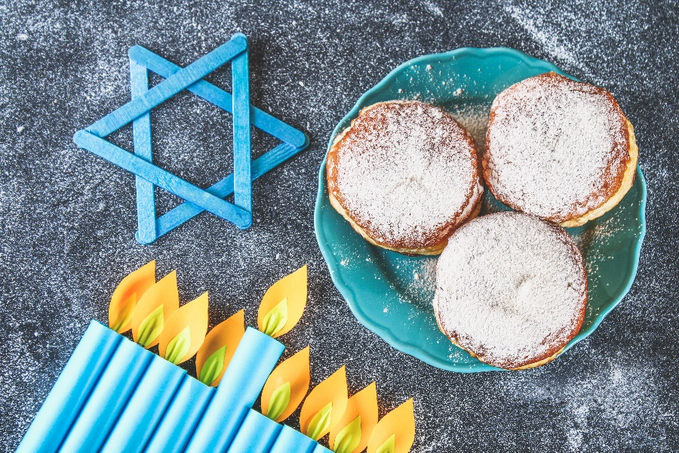
Hanukkah doughnuts (sufganiyot) are a sweet cake enjoyed during this Jewish festival of lights, celebrated from the 25th day of Kislev, usually falling in November/December.

Recipes for making the doughnuts can be found in hundreds of cookery books and on thousands of websites. However, these recipes usually assume some prior knowledge of cookery.
© Oyla Detry/Shutterstock

More detailed instructions can be provided in a similar way to how science practicals are written – numbered lists of imperative statements, clearly identifying apparatus.

A third way to provide the instructions is integrated instructions – a combination of concise text and diagram-based instructions.

This activity is designed to develop your skills in interpreting different forms of instruction, identifying advantages and disadvantages in the different forms, and/or converting between different forms.

Your teacher will instruct you how to approach this activity.

Hanukkah doughnuts: recipe form

Ingredients
- 500 g plain flour
- 5 g dried yeast
- 2 tsp sugar
- Pinch salt
- 30 g butter
- 1 egg yolk
- 150 ml water
- Caster sugar for dusting
- Vegetable oil to fry

Instructions

Mix the yeast, sugar and salt into the water. Add the remaining ingredients and mix to a smooth dough. Knead the mixture for about three minutes on a lightly floured surface, then cover and to prove for 30 minutes. Roll out the dough to about 3 cm deep on a lightly floured surface. Cut out 4 cm dough rounds and allow to rise for about 20 minutes. Heat about 7 cm of oil in a pan to 190°C. Fry each doughnut for 40–50 seconds on each side until golden brown. Drain the doughnuts on kitchen paper and dust with caster sugar.

Hanukkah doughnuts: science practical written form

Materials and apparatus

500 g plain flour

5 g dried yeast

2 tsp sugar

pinch salt

30 g butter

1 egg yolk

150 ml water

caster sugar for dusting

vegetable oil for frying

mixing bowl

spoon

scales

rolling pin

tea towel

saucepan

dough cutter

timer

thermometer

Instructions
- Add the yeast to the water in a bowl and mix with a spoon.
- Add the flour, sugar, salt, butter and egg yolk to the mixture.
- Stir the mixture with the spoon until a smooth dough is formed.
- Sprinkle a little flour on a surface.
- Knead the dough for 2–3 minutes.
- Place the dough in the bowl and cover – leave for 30 minutes.
- Sprinkle a little flour on a surface.
- Roll out the dough to about 3 cm deep using a rolling pin.
- Cut out 4 cm rounds of dough using a dough cutter.
- Leave the rounds to rise for about 20 minutes.
- Heat about 7 cm depth of oil in a sauce pan up to 190°C – use a thermometer to measure the temperature.
- Fry the doughnuts on each side until golden brown – about 40–50 seconds per side.
- Remove the doughnuts to kitchen towel to drain.
- Coat the doughnuts in caster sugar.

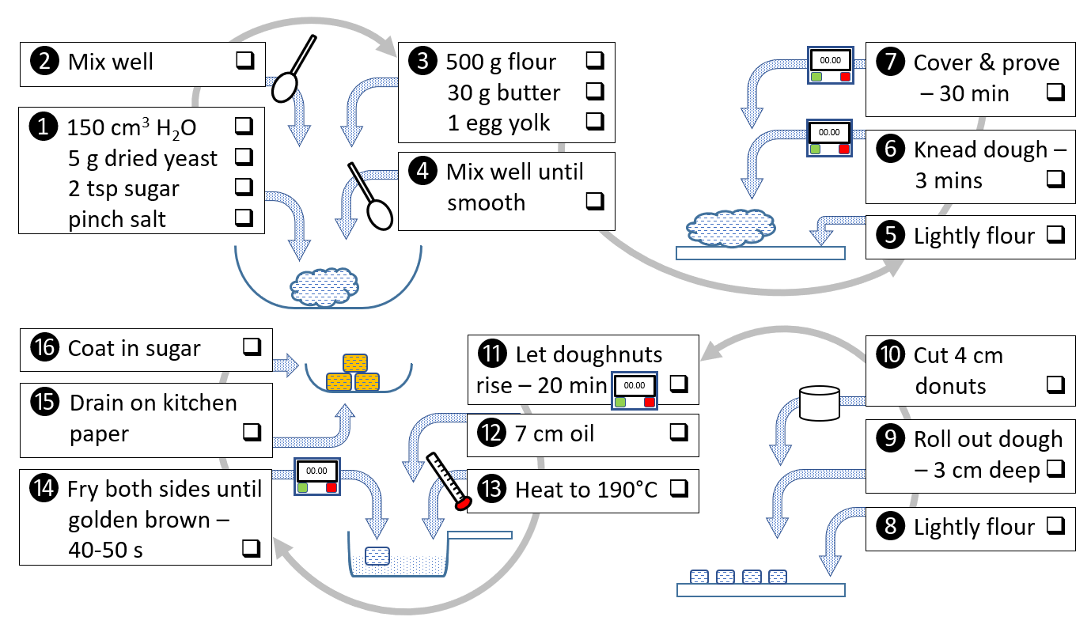
Hanukkah doughnuts: integrated instruction form

Interpreting practical instructions
Practical form | Advantages | Disadvantages
Recipe form
Science practical written form
Integrated instructions form

Use this table to record advantages and disadvantages of the different practical instruction forms for making Hanukkah doughnuts.

