F2 Counting protons, neutrons and electrons

Revision: atoms and subatomic particles

1. Complete the table to show the relative mass and relative charge of the subatomic particles.

|  |  |  |
| --- | --- | --- |
| **Subatomic particle** | **Relative mass** | **Relative charge** |
| Proton |  |  |
|  | 1 |  |
|  |  |  |

1. A silicon atom contains 14 protons, 15 neutrons and 14 electrons.
2. Explain why the overall charge on the atom is zero.
3. If protons have a mass of ‘1 atomic mass unit’ what would be the mass of the whole silicon atom in ‘atomic mass units’? Explain your answer.
4. Draw two **labelled** diagrams of the silicon atom in question 2:
5. assuming a ‘plum pudding’ model
6. assuming a ‘nuclear’ model
7. Comment on the similarities and differences between your two diagrams in part c.

New content: counting subatomic particles

The atomic number of an element defines the number of protons in the nucleus. The atomic number is usually shown on a periodic table, although the position of the number within a cell can vary.

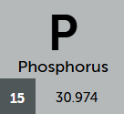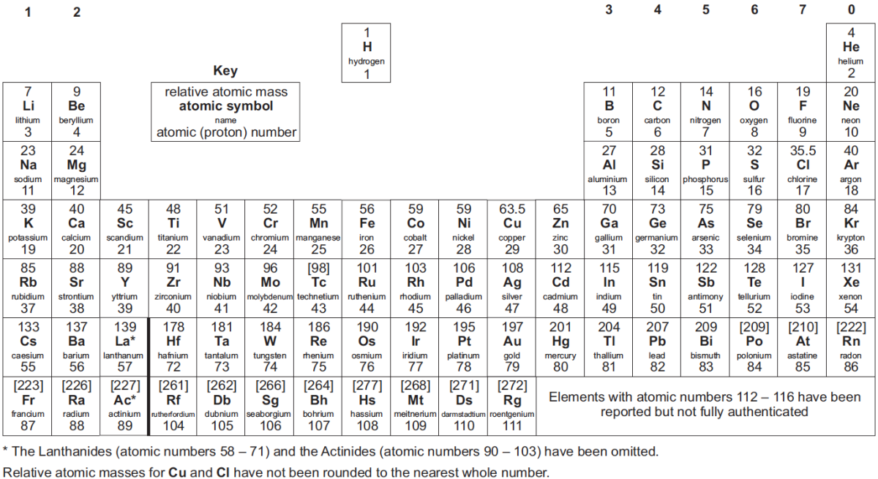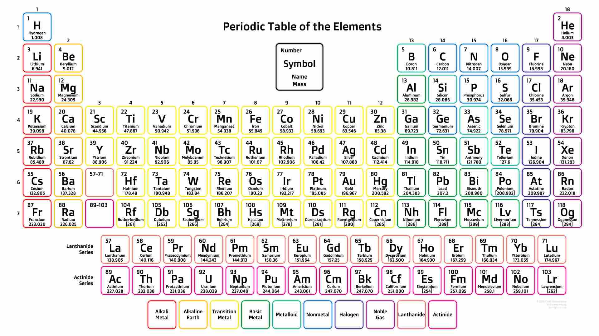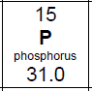

The atomic number of phosphorus is 15, meaning there are 15 protons in the nucleus. Be aware of variations in the display of this information on different periodic tables.

1. Use your periodic table to find:
2. the element with 26 protons (give the element name and symbol)
3. the element with two more protons than silicon (give the element name and symbol)
4. the number of protons in a silver atom
5. the number of protons in the element that has most protons (and give the name of the element)
6. the element with the fewest number of protons in the nucleus
7. the element with half the number of protons of titanium (give element name and symbol)
8. a pair of elements, differing by one proton, where the element with most protons has lower mass (give the element names and symbols)