Spot the bonding

The diagrams below show a range of chemical substances and models.

For each diagram either write:
- the name(s) of the type(s) of bonding present
- ‘none’ (if there is no chemical bonding)
- ‘don’t know’ (if you are unsure)

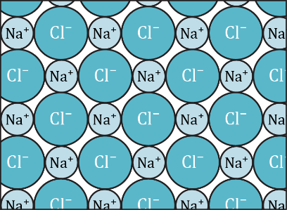 | 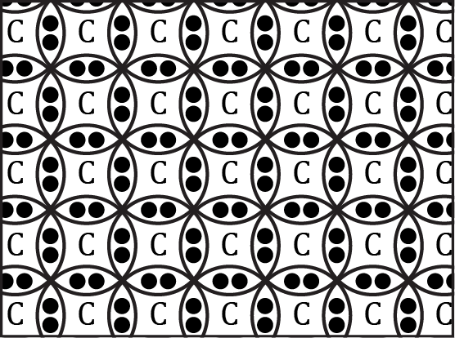 | 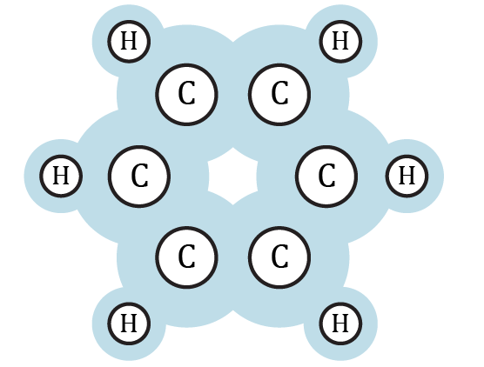
1. Sodium chloride lattice | 2. Diamond lattice | 3. Benzene molecule
_________________________  _________________________  _________________________ | _________________________  _________________________  _________________________ | _________________________  _________________________  _________________________
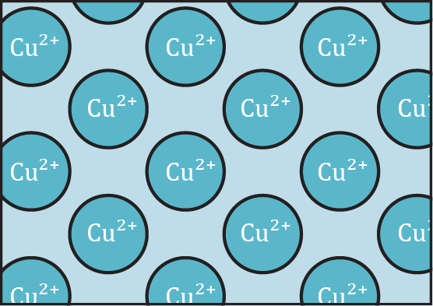 | 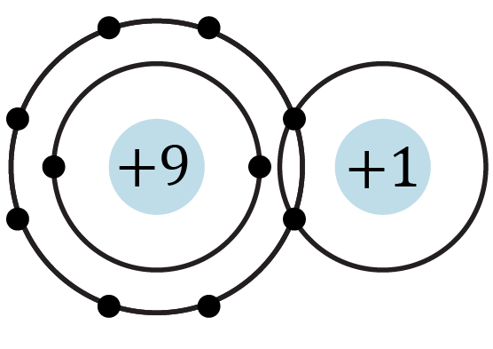 | 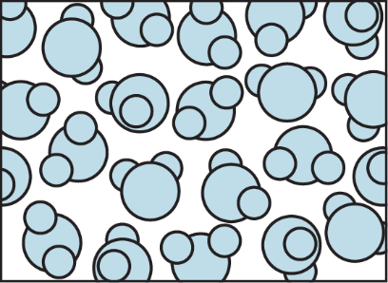
4. Copper metal lattice | 5. Hydrogen fluoride molecule | 6. Liquid water
_________________________  _________________________  _________________________ | _________________________  _________________________  _________________________ | _________________________  _________________________  _________________________
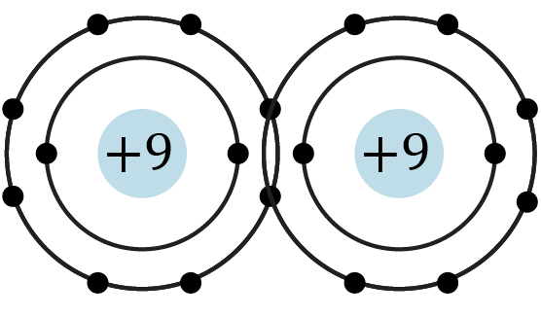 | 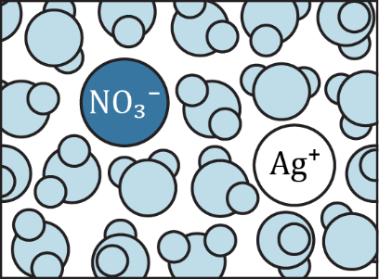 | 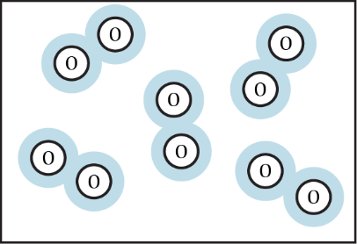
7. Fluorine molecule | 8. Silver nitrate solution | 9. Oxygen gas
_________________________  _________________________  _________________________ | _________________________  _________________________  _________________________ | _________________________  _________________________  _________________________

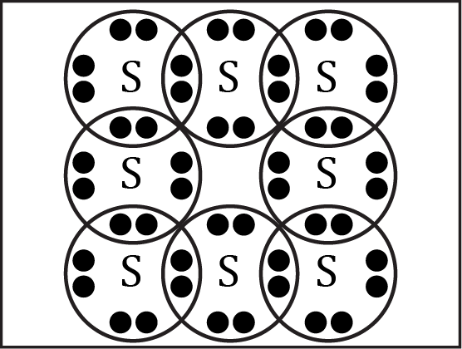 | 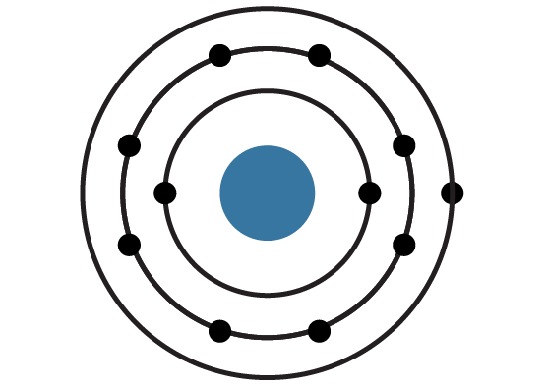 | 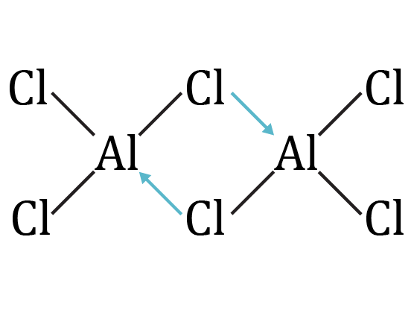
10. Sulfur molecule | 11. Sodium atom | 12. Aluminium chloride dimer
_________________________  _________________________  _________________________ | _________________________  _________________________  _________________________ | _________________________  _________________________  _________________________
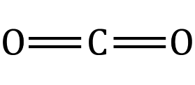 | 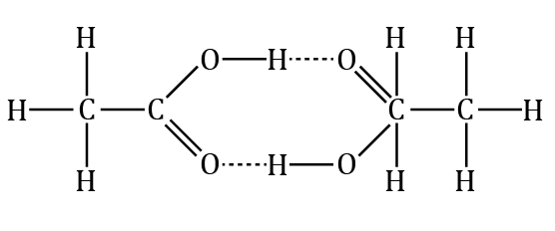 | 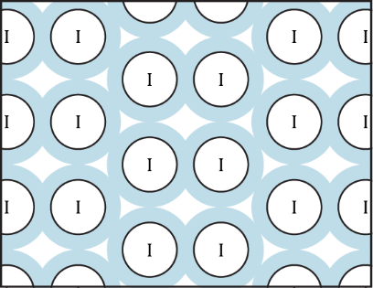
13. Carbon dioxide molecule | 14. Ethanoic acid dimer | 15. Iodine lattice
_________________________  _________________________  _________________________ | _________________________  _________________________  _________________________ | _________________________  _________________________  _________________________
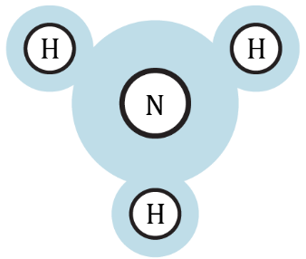 | 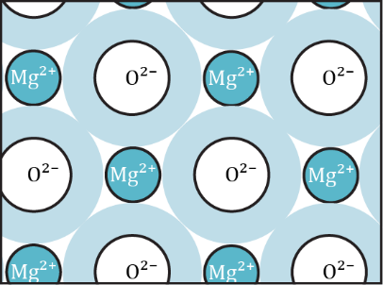 | 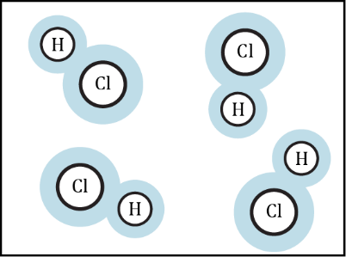
16. Ammonia molecule | 17. Magnesium oxide lattice | 18. Liquid hydrogen chloride
_________________________  _________________________  _________________________ | _________________________  _________________________  _________________________ | _________________________  _________________________  _________________________

